**Hello Sayori Team!** It’s me. Ya boi. Meme. I wanna let yall know that I am very proud of you all. Keep up the great work! <3

Underlying arc

Dates that end with sex

After two dates mc starts to worry about healthiness of Sayori’s sex drive

Mc notices that after Sayori always seems to be stifling tears and be dismissive when mc asks what’s wrong

On third date Sayori is trying get mc to have sex

PLAYER DECISION: Sex, or confront

If sex, then sex, eventually relationship declines. If confront then confront, and Sayori cries and understands mc’s concern for their well being, relationship improves.

Fourth date possibly TBA

Initial lewd: not very detailed, meant to blueball the player and tease what's happening. (more breathe-y giggles for “sound”?)

New sprites/poses/outfits needed

Sayori winking (Made)

Sayori dark blush

Sayori seductive eyes

Theater: Sayori in Soft Pink Sundress (with red and yellow carnations)

Sayori walking in front of MC holding his hand

Child Sayori (Possibly)

Outside Sports/Movie Theater: Sayori in Letterman jacket (From Monika)

Sayori With a Buttoned up Blazer

MC kissing Sayori’s Forehead

New backgrounds needed

Cafe (DDRC) (Sundress)

Movie theater (Letterman Jacket)

The waterfall (DDRC) (Casual Pink Shirt, and Jean Shorts)

Backyard with Tree, White Fence and Swing Set (Young Sayori possibly?)

Date ideas (Some focus on Sayoris depression too)

restaurant (possibly a couple times) (Sundress)

Movie (Letterman Jacket)

outdoor stuff (Casual Pink Shirt, and Jean Shorts)

recreate some childhood too (Young Sayori)

Sayori and MC go to the grocery store to get some food for the picnic in the next event

Outdoor Picnic (Sundress maybe?) some sandwiches, kool aid/fruit punch, some potato or macaroni salad, and a pie will be eaten at the picnic

Different event ideas

During the theater date, the player chooses between a set of movies of which they have varying effects on sayori. Feelsy Movie (Rescuing Lieutenant Frank): Sayori becomes depressed during the film and needs to be comforted during the “sad parts” and damages some of her psyche. Comedy movie (Montenegro Viper: The Adventure for the Ark of the Covenant): The movie entertains sayori for a while, as sayori may remark with “it kept the rainclouds away for a bit.” Romance (The Notecard): Sayori stays quiet most of the movie and begins to cuddle with mc during the movie, and gets “ideas” from a sex scene in the movie. mcand sayori make out during the credits. Horror (The Walls Have Ears) Sayori will say she doesn’t like them before they go in, and will proceed to hide her eyes most of the movie and constantly clutch MC. MC tells himself this was not a good idea. After the movie, Sayori will ask if they can watch something nicer next time.

The MC starts to get concerned about Sayori’s blazer not fitting her at all, and he asks to measure her and she'll act dumb like normal (like just going along with it after the MC says it’s a surprise). (transfer that into a lewd scene possibly). Then in a later scene, the MC surprises her with one that fits, and we can use the CG of him buttoning her up

Another videogame scene where mc and sayori play video games again, but mid way through sayori asks mc if he wants to play outside again. Decision of yes or no. if so, they go outside and roleplay a co-op video game outside

Sayori borrows Monika’s Letterman (Varsity) jacket during the week and conveniently “forgets” to return it. The player finds this out during the movie date when she wears it (on the weekend). On monday at the literature club, Monika asks about the jacket because she hasn’t seen in a week, and Sayori said she’d give it back. Sayori proceeds to get confused on what to say and trips over her words, and she calls for MC to make up an excuse for her. The MC is then given a choice whether to reprimand her and tell to give it back, or to tell Monika that Sayori just wants it for a little longer. If reprimand, Sayori will feel bad she disappointed MC, and start to cry once they get home. If excuse is made, Sayori will say just to MC that she feels like a horrible friend, and start to cry once they get home. Either way, she will need hugged and comforted from MC.

A dream sequence where sayori is on the news and is the weather woman. She talks about how the forecast is going to go from thunderstorms to mostly cloudy with light showers. The next day, the MC then gets a choice to tell her or not when he sees her. If not then nothing happens. If so, sayori confesses to the creator that things haven't gotten much better, but she still loves and trusts the mc. She then starts to cry, starts to say self deprecating things. Comforting then needs to happen.

MC wants to play videogames with Sayori, the player picks a co op game and they start. After a few minutes, Sayori pauses and says she would like to go play outside. MC has a choice whether to go outside or not. If not, they video games, and cuddle a little. If so, the go outside, start playing catch. They get into a rhythm, but Sayori loses focus after MC has thrown and she gets hit in the forehead. She will then start to sob, MC will pick her up, comfort her, hug her, and kiss her forehead.

3.0 Bad Ending: Sayori arrives one day with a scarf around her neck. When MC asks her what's wrong, she is incredibly defensive about it. MC eventually convinces her to take the scarf off, revealing a red ring around her neck, and all that implies. She follows up by saying she can’t handle it anymore, and wants to move away to escape the rainclouds, effectively breaking up the relationship.

This makes me sick to my stomach (But in a good way) -Sgrigz

***ACTUAL SCENE SCRIPTS***

In regards to MC: No quotes means that MC is thinking it

Lines between dialogue represent a new textbox

Words meant to be in italics will be in italics

Underlines are basically Stage Directions

[Player Name] in dialogue will indicate usage of the player’s name

Screen changes typically ensue the black fade left to right and right to left unless stated otherwise.

***Scene 1 Prelude***

scene bg {bedroom darkened}

show sayori 1be

s 1be “...”

s 1bv “...”

s 1bt “...”

s 1by “...{i}someday I’ll wish upon a star{/i}…”

# Scene 1/Event 1

show sayori 5d at t11 zorder 2

"...Maybe I shouldn’t have pointed out her mistake, but I had to tell her before she started spreading misinformation about penguins."

s "That doesn’t matter!"

s 5c "What matters is what happened!"

mc "Okay, I’m sorry, continue."

s 1a "So he took me to the biggest hill, and he let me hop on his back."

s 1r "We sledded down that hill for hours, it was so much fun!"

s "Then, he officially named me ‘Queen of The Penguins’."

s "So, how ‘bout them apples? You’re officially dating a queen!"

show sayori 1a at t11 zorder 2

"I really don’t want to take this happy moment from her, so I had to come up with a response and change the topic."

mc "That’s so cool, my girlfriend is the Queen of The Penguins..."

"...Does that make me the King?"

"As we get to school, I remember that I had to ask Sayori something important."

show sayori at thide zorder 1

hide sayori

scene bg corridor

with wiperightscene bg bedroom

with wipeleft

#MC wakes up

"{i}Whew{/i}."

"What a night!"

"Sayori seems to still be asleep."

"It’s been 4 months since Sayori and I..."

"You know..."

"...Anyways, after what happened last night, I really should do something nice for her."

"I’ll make her breakfast in bed! I hope she’ll like it."

scene bg kitchen

with wipeleft

"Hmm, what should I make? Or, better yet, what do I have?"

"Sayori likes chocolate chip pancakes, right?"

"I rummage through my cabinets for some pancake batter."

mc "Jackpot!"

"I quickly put my hand over my mouth and stay quiet."

"I hope I didn’t wake her up..."

"I mix up the batter with some water as the stove heats up."

"After the pan is hot enough, I begin to make her pancake."

"I make hers before I make mine."

"I’m used to barely eating in the morning, since most days I brush my teeth for breakfast."

"After a few minutes, the pancake is done. It’s a little burnt on one side, but it looks fine to eat."

"I put the pancake on the plate."

"I pour a glass of orange juice for Sayori, and bring her plate and glass back up to her on a tray."

scene bg bedroom

with wipeleft

show sayori 1a at t11 zorder 2

s "Oh, hey, [player]."

s "I was just-"

s 1m "Oh my god... Are those chocolate chip?"

s 4r "That’s my favorite!"

show sayori 1q at t11 zorder 2

"I anxiously wait for her to take a bite of the pancake."

show sayori at h11 zorder 2

s "I LOVE IT! It’s so nice and fluffy!"

mc "I’m glad you like it!"

mc "Anyways, you were saying something?"

s 1b "Hm?"

mc "It sounded like you were saying something at first."

s 1k "Oh, it was nothing."

"When have I heard this before?"

mc "Sayori..."

s 4i "Don’t worry so much!"

s 1j "I was saying that I was just getting ready."

"I struggle for words. I guess I was overreacting."

mc "Sorry, Sayori..."

s 1d "Aww. Don’t worry about it."

s 1t "It still means so much to me that you look out for me!"

mc "Well, in any case, we’ll be late for school if we don’t leave soon."

s “Hey, wait, one thing before we do…”

“Curious, I turn back toward her, then walk up to her.”

“Suddenly, Sayori plants a long kiss on me, and I gladly accept it.”

“However she starts getting particularly handsy, and she places her hand on my waist.”

“Reluctantly I stop the kiss.”

mc “Eheheh, easy there, cowgirl.”

mc “We’ll have plenty of time for this later, but we have to get going.”

“Sayori blushes and then clears her throat.”

s “Eheheh~”

s “Okay, let’s go then!”

show sayori at thide zorder 1

hide sayori

scene bg house

with wipeleft

show sayori 1c at t11 zorder 2

s "[player], can I tell you about my dream last night?"

mc "Yeah, I’d love to hear about it."

s "I dreamt that I was in the arctic."

s "I was wearing my normal school uniform, but I wasn’t cold at all."

s "I looked around and then, suddenly, out of nowhere,"

show sayori at h11 zorder 2

show sayori at h11 zorder 2

s 4n "A bunch of penguins came appeared and started to walk toward me!"

s "Then the leader of the penguins,"

s "Who was like, my height,"

s 4o "Came up to me and introduced himself as Reginald and he talked with a British accent, and he told me,"

s " ‘You, Mistress Sayori, are worthy to be our queen!’ "

show sayori at h11 zorder 2

show sayori at h11 zorder 2

s 4x "I told him that just ‘Sayori’ was fine, and that I was super happy."

s 1o "I asked him then if that meant I had to marry him."

s "He said, ‘Of course not, darling. You just need to prove yourself to be the best at sledding.’ "

s "He took me by the hand, and we went over to the biggest hill in Greenland!"

mc "I’m sorry to burst your bubble Sayori, but..."

mc "Penguins don’t exist in the arctic, and they definitely are not in Greenland."

mc "And Greenland is most certainly NOT the Arctic!"

show sayori 1c at t11 zorder 2

mc "Hey, Sayori?"

mc "I was wondering... Would you like to go somewhere after school?"

mc "As a date, of course."

s 4s "Of course I would! A date sounds nice!"

s 1y "I’ll see you soon, then, huh?"

mc "Yeah.. I’ll see you then."

"We exchange a quick kiss on the cheeks before going to our classes."

show sayori thide zorder 1

hide sayori

scene bg class_day

with wiperight

“Math.”

“One of my {i}favorite{/i} hours of the day.”

“I usually just sleep through the hour, but a big test is coming up next week, and my grades in this class need a face lift.”

“I can’t help but let my mind wander a little.”

“God, my first ever actual official date.”

“Never in my life would I ever imagine it would be with Sayori…”

“Never in my life would I ever imagine doing a lot of the things i’ve done with Sayori..”

“Especially..”

“{i}Huh?{/i} A Note?”

“It's from Sayori, she slid it under my elbow while I was distracted by myself.”

“I turn to look at her.”

show sayori wink at t11 zorder 2

”She’s winking at me…”

“It now suddenly feels like I’m in the Mojave desert.”

“I feel a bead of sweat form on my forehead as I recall last night’s events.”

mc “{i}Gulp.{/i}*”*

“I unfold the paper to read what she wrote.”

show sayori at thide zorder 1

hide sayori

Paper effect, note appears similar to the poems in the base game

(on note)

Hey [player],

Thanks for a wonderful Sunday evening! Oh, and for letting me sleep over and making me breakfast! I really just wanted to say that I’m really looking forward to tonight! I hope it’s just as fun as last night! ;)

-Love,

Sayori <3

P.S: Where are we going for the date?

After the note is clicked away, Sayori’s sprite disappears again

“I look back at her.”

“She’s writing in her notebook like nothing happened.”

“I decide to write back to her.

MCs note;

Well if I tell you THAT, it’ll ruin the surprise! Just wait patiently for the time to come, I promise it’ll be worth it.

* [Player name]

“I slide the note to her just like she did.“

“I watch as she reads the note.”

show sayori 3c at t11 zorder 2

“She looks my way and pouts when she’s done reading.”

show sayori at thide zorder 1

hide sayori

“We go back to listening to the teacher as quickly as possible.”

“I can’t begin to imagine the hell the teacher would give Sayori and I if she caught us passing notes.”

“And especially what we’re talking about in them!”

mc “{i}Shudder{/i}

scene bg corridor

“Sayori and I head to the clubroom together like most days.”

“On our way we talk a little bit about the night ahead of us.”

show sayori 1a at t11 zorder 2

s “So where were you planning on taking us again?”

mc “Hmmm.”

“How shall I give the big reveal?”

menu:

“Playful”:

$ meeting_place = “corridor_1”

“Upfront”:

$ meeting_place = “corridor_2”:

if meeting_place == “corridor_1”:

# I have no idea how to put points, i’ll ask skull for that -jan

scene bg corridor

“I take a brief second to think about how to word it.”

mc “Well…”

mc “It’s a place…”

mc ” ”Where you can drink-”

s 4n “The bar!”

mc “What? It’s n-”

s 1j “ [player], we’re too young for that!”

mc “No, it's not the bar, Sayori.”

mc “You didn’t let me finish.”

s 5a “Sorry.”

mc “It's a place where you can drink hot cocoa.”

s 1m “Oh!”

s “I get it now!”

show sayori wink at t1 zorder 2

s 1m “...”

s 5d “...”

“She whispers”

s 3c ”It’s the cafe, right?”

“I whisper back.”

mc “It’s the cafe.”

elif meeting place == “corridor_2”:

scene bg corridor

mc “It’s the cafe.”

s 1r “Oh, cool!”

s 4q “I’ve always thought that was a cute place!”

s 1a “Can’t wait for tonight!”

#{Neither choice has any effect on the rest of the route}

#[Narrative reunites here]

show sayori at thide zorder 1

hide sayori

“Before we know it, we’re at the clubroom.”

“...”

“The door’s closed?”

“There’s a note on the door.”

“It's from Monika.”

“I take the note out of the door to read it.”

show poem (poem_note)

#we need to make a seperate .rpy for this poem

#also we may need to put all the directions for poems, cause i have no idea what im doing-jan

poem_custom = poem

author = “monika”,

title = “Literature Club Cancelled”,

text = “””\

Dear Sayori, Yuri, Natsuki, and [player],

#Sorry for not getting to you all personally, but I have to inform you that the Literature Club will be cancelled today. This is due to personal reasons I am currently unable to say. However the club should return tomorrow!

#Sincerely,

#Monika

show sayori 1b at t11 zorder 2

s “Well? What does it say?”

mc “It says the Literature Club is cancelled today.”

s 4p “Aww, what!”

s “Why?”

mc “Monika said it was just personal stuff.”

mc “We can ask her what it was next time we run into her”

s 4k “True.”

s “I hope everything is ok with her.”

mc “So what now?”

s 1b ”Believe it or not, this actually works out for me. ”

s 5a “I could use the extra time to get ready for our date tonight.”

“Extra time?”

“Is she planning something?”

“She doesn’t take that long to get dressed into something casual when she’s excited…”

mc “Fair enough. Ready to walk home?”

s 1r “Of course! Let’s go!”

show sayori at thide zorder 1

hide sayori

scene bg house

with wiperight_scene

s 1c ”Hey, just to let you know, I may take a bit to get ready.”

s 1d “Just meet me there, okay?”

s ”If I’m not there in time, just get me a big hot cocoa with whipped cream, alright?”

mc ”Duly noted.”

show sayori at thide zorder 1

hide sayori

“We give each other a small kiss before we return to our homes to change and get ready.”

scene black

with dissolve_scene_full

“I put on some casual clothes and a slight hint of cologne I happened to find.”

“Following Sayori’s wishes, I head out for the cafe without her.”

scene bg (unused house)

“As I wait for Sayori, I find myself wondering why she wanted extra time to get ready.”

“I also realize that this is our first “official” date, since the festival didn’t turn out too well, and I don’t count her coming to my place every Sunday as dates.”

scene bg black

with dissolve_scene_full

“As I lose myself in thought, I’m suddenly jolted back to reality as a pair of hands cover my eyes from behind.”

s “Guess whooo?”

mc “I know it’s you, Sayori.”

scene bg house(unused)

show sayori 1a(custom) at t11 zorder 2

s “So, how do I look?”

mc ”You look amazing.”

s 1q(custom) “Really? I’m so glad!”

mc ”So should we head in?”

s 1a(custom) ”Yeah, let’s go!”

“We head into the cafe, which used to be a house, but was bought and repurposed..”

scene cg custom Sayori

“We head up and take a seat on the terrace, where I think the view will please Sayori.”

“A waitress asks us what we want, I order a caramel latte, and Sayori gets her hot cocoa.”

“I try to think of something to say while we wait for our drinks, but nothing comes to mind. Weird, I never had a problem talking to Sayori before.”

“I need to say something to break the awkward silence that is growing between us…”

“Hold on…”

“Is that perfume?”

[PLAYER CHOICE]

**{SMOOTH} +=1**

mc “Sayori.”

mc “I think you look nice today.”

mc “It means a lot that you dressed up and everything for this.”

s “Awww, thanks.”

s “Since this is technically our first date, I wanted it to be special.”

s “That’s why I decided to wear this old thing.”

s “I haven’t worn it since the Homecoming incident.”

s “Homecoming incident?”

“What does she mean by-”

“{i}Oh.{/i}”

“{i}That.{/i}”

“I still have no idea how they were able to get a live squid in there…”

s “I also convinced Yuri to give me some exotic perfume she never used.”

s “She’s really into aromatherapy or something, and said this stuff would be perfect for a date.”

s “I think it was called Jazz Man?”

**{NORMAL} += 0**

“I take a light whiff of the air.”

mc “Sayori?”

s “Yes, [player]?”

mc “Did you put on perfume for this?”

s “Haha, yeah, I did.”

s “I thought it was appropriate for the occasion.”

s “And I wanted to try out a perfume Yuri gave me.”

s “She told me she never got to try it out, and just gave it to me!”

s “She said it was some exotic flower.”

s “Jazz man, or something like that?”

**{OBSERVANT} -= 1**

“I smell an unfamiliar scent in the air, it seems to be coming off of Sayori.”

“*sniff*”

mc “You smell different than usual today Sayori, is that a new perfume?”

s “Umm, what?”

s “Yes...Yuri gave me one…”

mc ”Oh…”

s (worried) ”Wait, have you memorized my ‘normal’ smell?”

mc ”Umm…”

“Sayori laughs awkwardly”

s ”It’s okay, it’s nice that you have this attention to detail.”

mc “What’s the scent?”

s ”Yuri said something about a jazz man?”

mc “Jasmine?”

s “Yeah, that!’

**{Narrative convenes back here}**

s“So.”

s “Do you like it?”

mc ”Yeah, it suits you well.”

s ”Thanks, ehehe…”

{IF OBSERVANT WAS CHOSEN}

“Thankfully, the waitress breaks the awkward conversation by arriving with our drinks.”

{IF NORMAL/SMOOTH WAS CHOSEN}

“Soon after, the waitress arrives with our drinks.”

**{Narrative convenes again}**

mc “So how’s your day going?”

s “My day was great!”

“Something about the way she said that…”

“I don’t want to pursue it, for fear of ruining the moment.”

s “I’ve been waiting for this all day!”

mc “Me too.”

“I grasp for a topic to keep conversation from stalling.”

mc “Do you remember the day you first introduced me to the literature club?”

s “Yeah, it seems so long ago, doesn’t it?”

mc “It sure does.”

“We sit in silence for a moment.”

mc “Back then,”

mc “Did you think we’d end up in this relationship?”

s “Honestly, I thought you were probably going to end up with Monika or Yuri.”

s “But ever since we started dating…”

s “Those rainclouds haven’t been looking so dark lately…”

scene cg Sayori Custom (Afternoon)

with wiperight

#wouldn’t it be better to fade for this

“As we finish up our drinks, I notice that it’s getting late.”

mc ”You ready to head home?”

s ”Yeah, sure.”

scene bg residential_day (night)

with wipeleft

“We walk home hand-in-hand.”

“Even though I only recently saw Sayori as more than a friend…”

“I feel like I always have, and just now realized.”

s “Thank you, for a wonderful date.”

“Something in the way she spoke doesn’t seem right.”

“It’s giving me the same feeling as when she was talking earlier.”

“She’s hiding something from me again.”

“But what do I do?”

**{PLAYER CHOICE: MAKE SURE EVERYTHING IS OK--OR--SAy GOODNIGHT}**

* **{MAKE SURE EVERYTHING IS OK} += 2**

mc “Hey Sayori…”

s ”Yeah?”

mc ”Are you sure you had fun?”

s ”What do you mean?”

mc ”Something about the way you said some things earlier...”

mc “It didn’t sit right with me.”

s ”Don’t worry about me [player].”

s “I was just nervous was all.”

“If there’s one thing I learned about her in the past few weeks of being closer with her, it’s that not everything is as it seems…”

mc ”Tell me what’s really wrong.”

s ”It’s nothing, really.”’

s “I promise I was just nervous.”

mc ”We both know that’s not true, Sayori.”

s ”Please, just drop it.”

“I can tell through the tone of her voice that whatever it is, she finds it incredibly distressing.”

“I’ll save it for another time.”

mc ”I’m sorry, Sayori.”

mc ”Goodnight, then, I guess.”

s “No, wait!”

s “Can I…”

s “Stay at your place again, [player]?”

mc ”Yeah, sure, just go change into something a bit more comfortable first.”

s ”Okay!”

mc ”Want me to wait for you in your house, my house, or right here?”

s ”You can wait at your place, I...actually have something to do.”

s “I’ll be over in like thirty minutes, okay?”

mc “Hm? What do you have to do?”

s “It’s nothing you have to worry about, I promise.”

s “See you in a little while, okay?”

“I shrug my shoulders.”

mc “Sure thing. See you.”

show sayori at thide zorder 1

hide sayori

scene bg bedroom

with wiperight

“I wait about a half hour before Sayori enters my house like any other Sunday.”

show sayori 1ba at t11 zorder 1

s “Hey, [player]!”

“And she has a mysterious bag with her?”

mc “What’s in the bag?”

s 1by “Oh, it’s nothing, really…”

s 4ba “Just some homework we both haven’t done yet.”

mc “Oh...okay.”

mc “So I assume you wanna get to work on that now?”

s “Uh-huh.”

“I have to admit I’m a little worried about what she was keeping mum about earlier.

“But I also admit that handling someone’s feelings, especially someone in Sayori’s condition, is a pretty foreign concept to me.”

“I decide that the best thing would just be to get this homework finished, and then sleep it off.”

mc “So, what’s first on the agenda?”

s “Math, naturally.”

“{i}Where’s the nearest cliff?{/i}”

s “I actually got a lot of it done in class, but there’s this one that’s been tripping me up, I hope we can put our heads together to figure it out.”

“I sigh involuntarily.”

mc “Alright, let’s see...number 22...the square root of x over 2 plus 4 equals the cube root of 2x plus 8…”

“…”

“.....”

“...I think I’ve gone brain dead already.”

s “Hey! [player]! Snap out of it!”

mc “Uh, Sayori, do you think you’d wanna do something else?”

s “[player], we have a test coming up soon, we need to focus.”

mc “I know I know, but we just got done with a date.”

mc “Isn’t it a little weird to wash down a nice date with homework?”

mc “Not exactly my chaser of choice.”

s “[player], we’re too young to drink.”

mc “It’s just a figure of speech.”

“Sayori thinks on it for a few moments.”

s “Yeah, okay. We can do something else for now.”

mc “Cool, thanks.”

mc “So, any ideas?”

s “Well, there is one thing I’d kinda like to do…”

mc “Uh…”

“I have a feeling I know where she’s going with this, but honestly…”

“I’m not exactly in that kind of mood.”

“For some reason, being around Sayori has gotten me all nostalgic.”

“...”

“There’s something!”

mc “Or!”

mc “H-how about we play a game from when we were kids!”

s “O-oh...okay, that sounds fun!”

“She seems disappointed, but quickly forgets about it.”

“I think she actually likes the idea.”

“I go to my bedroom closet and open the door, then try to climb my way upward in order to reach the board games from my childhood.”

“Kind of ironic that they’re so high up, and partially inconvenient.”

s “What do you have in there, anyway?”

mc “Hm, let’s see…”

mc “We got...Connect 4, Candy Land, Chutes and Ladders, Battleship…”

mc “And that’s about it. Take your pick, I’m cool with whatever.”

s “How about...Battleship?”

mc “That’s perfectly fine with me.”

“I power my way to the top, then stumble from the pressure of everything pushing me down.”

“I trip and fall forward onto my face, but luckily I land on a pile of old clothes and bedsheets.”

mc “Pfffth, crap!”

s “[player], are you alright?!”

mc “Y-yeah, I’m fine, this closet was just never meant to be opened or interacted with by humankind.”

“Regaining my balance I decide to brute force everything, and in one swift motion rise to the top of the closet and grab the Battleship box, which was luckily on the very top of the stack of games.”

mc “Yes, got it!”

s “Good job!”

“Sayori and I sit on the floor of my bedroom, then I open the game and sort out all the pieces. Sayori wants to be red so I take the blue pieces.”

“I read the small rulebook pamphlet that’s miraculously still in the box after about a decade and I refresh myself on a few of the rules and relay them to Sayori.”

“I finish reading and look up at her.”

mc “Any questions, Sayo--”

“I look up at her and see a bit of a saucy expression on her face.”

mc “W-w-why are you looking at me like that?”

s “I have an idea.”

“{i}I’m almost too nervous to ask…{/i}”

s “So, I know that you didn’t wanna...you know...earlier, but…”

s “I was thinking that we could make this game a little bit more interesting?”

mc “Define…{i}interesting{/i}.”

s “Well...I was thinking that maybe...after every time we each sink one of each other’s boats…”

s “We could take off an article of clothing?”

“...”

“I don’t have the mental capacity to fully register this suggestion.”

mc “Y-you mean like...strip poker?”

s “Yeah exactly! But like...Strip Battleship, instead! Ahahaha~!”

mc “S-Sayori, I don’t…”

mc “Where did this come from?”

mc “I never imagined you acting this way.”

s “I...I’m sorry...do you not like it?”

mc “Well I didn’t say that, it’s just...super unexpected.”

mc “But...heh, screw it, this could be fun.”

“I’m signing myself up for some level of trouble if I’m not careful.”

“Guess I should just play some top notch Battleship!”

“...”

“Sayori and I each make sure that we have an equal number of clothes to be taken off.”

“I had to put on a light jacket to even things out, so we each had on five articles of clothing to match the number of ships.”

“Sayori counted her bow, and I insisted that was the first thing she’d be forced to remove.”

“We begin playing Battleship, and true to the rules we’ve established, each time I get a ship sunk, I have to take something off, and every time Sayori loses a ship, she also has to take something off.”

“It ends up being a lot more fun than I expected, and despite the circumstances, the sexuality of the situation kinda gets diffused by how much fun we’re having picking on each other.”

“That is until I sink Sayori has nothing but her bra and panties on, and I sink her aircraft carrier.”

s “Ehehe~, it’s your choice, [player], what do you wanna see first?”

“Sitting here with nothing but my boxer shorts on, I think she can tell I’m getting very excited.”

“I’m really not super sure how to respond.”

“I saw Sayori nude not super long ago, but this level of playfulness starts to take a toll on my male instincts.”

mc “B-b-b-b…”

“I’m stuttering like an idiot.”

s “Ehehe~! Spit it out!”

mc “Boobs…”

mc “I MEAN, BRA.”

mc “T-take off your bra, next, please, madame, if you don’t mind.”

s “Pffft, you’re so silly, [player].”

s “You’ll really get to see how much bigger they’ve gotten!”

s “As you wish, it’s coming off~!”

“Sayori begins to unlatch her bra for my viewing pleasure, but then she stops suddenly.”

s “Oh, but first…”

s “D8.”

“...”

“She sunk my battleship.”

mc “No way, you have to take it off before you make your next move!”

s “Hey I came up with the game, so I say this is totally within the rules!”

mc “That’s so bogus!”

s “I’m waitiiiing~!”

“Damn, she really got me with this one.”

mc “Fine, you win, congratulations.”

“It finally hits me that now I have to take off my boxers and show Sayori my private parts.”

“Which, admittedly, I don’t necessarily have a problem with, but regardless, this is awkward.”

“I slowly stand up and then look at Sayori, biting her lip waiting for me to proceed.”

“The look on her face is getting me very aroused, and I know I won’t be able to conceal my excitement from Sayori.”

“I rip off the band-aid, so to speak, then pull down my boxers and show Sayori everything.”

“Sayori begins to clap.”

s “Bravo, [player], bravo! He’s glorious! Ahahaha~!”

mc “Well, here we are, then.”

mc “Game’s over.”

mc “I’m naked, you’re almost naked.”

mc “Where do we go from here?”

s “I think…”

s “It’s time to do some math.”

mc “What?!?!”

s “Let’s get dressed again, [player], we got homework to do.”

“...”

“I hate everything about this.”

“I didn’t even wanna take things too far tonight, but it’s hard to ignore my urges when you’re so close to the light at the end of the tunnel!”

“Well, I guess she’s right.”

“Better just suck it up and accept defeat like a man.”

$ battleship_played = True

scene bg bedroom

with wipeleft_scene

“A couple of hours go by, and Sayori and I have mercifully completed a majority of the math homework we needed to finish.”

“{i}You wouldn’t believe how much doing math completely kills your sex drive{/i}.”

“She and I make some instant meals together and eat them by candlelight that evening, then eventually end up in bed at around 10:30, as I let the TV in my room run to lull us to sleep.”

mc “You ready to call it a night, Sayori?”

s 1bh “No, not yet.”

s “I needed to say some stuff first.”

s “You were right.”

“I knew it…”

mc “Sayo-”

s 1bf “Please.”

s “...”

s “I just…”

s 1bw “I just don't feel like I deserve it sometimes.”

s “Especially tonight.”

s “I don’t know what I did to deserve you.”

s “All I did was tie you down like an emotional anchor.”

mc “Sayori stop.”

mc “You aren’t a burden.”

mc “If I was in any way unhappy with us being in a relationship, I wouldn’t be here.”

mc “Trust me.”

mc “I love you.”

“Even though I’m not yet used to saying that to Sayori..”

“It feels right.”

s 1bd “I…”

s “I’m sorry.”

s “I love you, too.”

show sayori at thide zorder 1

hide sayori

scene black

with dissolve_scene_full_

“Suddenly, I feel my lips against hers.”

“But I was the one to pull her in for the kiss this time.”(keep this)

“I can feel the passion on her end.”

“I wrap my arms around her and pull her closer.”

“She groans softly, and I can tell she’s enjoying this as much as I am.”

scene bg bedroom

with dissolve_scene_full

show sayori 1by at t11 zorder 2

s “[player].”

s 4bs “That was nice..”

“My face is as red as a beet, and my heart is beating like a drum.”

“I have a strange feeling about this…”

mc “Yeah, that was…”

mc “Special.”(your choice if you wanna keep or change)

* **{SAy GOODNIGHT} -= 2**

mc “Yeah, no problem…”

mc “Well then, goodnight, Sayori.”

s “Actually, I was hoping I could stay over at your place tonight…”

mc “Alright then, but let’s stop by your place so you can get changed.”

“Once Sayori is done changing, we head back to my house.”

“I notice Sayori holding a strange red bag in her arm.”

show sayori 1ba at t11 zorder 2

mc “So, what’s in the bag, Sayori?”

s “It’s a secret.”

show sayori wink at t11 zorder 2

s “For now.”

“As usual, that wink makes me feel like I’m standing on the Sun.”(change)

show sayori 1ba at t11 zorder 2

scene bg bedroom

with wiperight

mc “Alright then, you ready for bed?”

s “Yeah.”

mc “You can have the bed, I’ll take the couch.”

s “Why don’t we just share the bed?”

mc “Uh, yeah. Sure”(your choice)

# Scene 2/Event 2

bg scene bedroom

MC wakes up with eye open visual effect.

“I wake up, groggy as I’ve ever been.”

“Despite this, I still feel good. Proud, in fact.”

“I showed Sayori a very good time yesterday, and we even got some homework done.”  
 “I then remember our little game, then I lift my head up off my pillow and look at the floor to see our game of Battleship still scattered across the floor.”

“I should clean that up soon.”

“But, not right now, right now all I ought to do is appreciate my surroundings.”

“Specifically I should appreciate the ball of sunshine huddled into my shoulder, with her arms wrapped around mine like it’s a teddy bear.”

“I feel so warm inside seeing her so comfortable. And I’m the reason for that.”

“If that doesn’t make a person feel good, I don’t know what would.”

“I observe Sayori and appreciate the light she’s radiating.”

“There’s so much purity coming from her it’s enough to intoxicate someone.”

“I smile at my girlfriend, who’s still lying there lightly snoring.”

scene cg bed sayori

“There’s only one word to describe her.”

“Amazing.”

“I never realized how cute Sayori looked until now.”

“I mean, I always knew she was cute,”

“But I wasn't conscious of it until now.”

s “Mmfff..”

“Sayori stirs.”

scene cg sayori bed one eye

s “Hey there~”

“God.”

“I recall last night’s events, and the night before?”

“Despite us not going all the way last night, our impromptu game of Strip Battleship was…”

“Undeniably sexual in nature.”

“{i}What’s going on?{i/}”

“{i}I’m not even that attractive!{/i}”

mc “Good morning.”

s “*{i}giggles{/i}*”

s “Good morning to you, too.”

“This position we’re in…”

“It feels so nice.”

“I never want to leave.”

“It’s been nearly a year, and I still can’t believe I ended up with Sayori of everyone.”

“But I wouldn’t trade her for the world.”

mc “I’m surprised to see you up so early.”

s “Oh really? What time is it?”

mc “Let me check.”

“I take a brief glance at my wrist watch…”

“...”

“That I apparently never took off…”

“And also forgot I even had.”

“It’s 8:30, class starts in 45 minutes.”

mc “Sayori, I hope you have your uniform, because we’ve got to hurry.”

s “Haha, yeah…”

s “About that..”

mc “Please don’t tell me…”

s “Yup.”

s “Gotta go back to my place to get my stuff.”

scene black

“We don’t even have enough time to have breakfast or brush our hair before running off to school.”

scene bg corridor

“I’m here after school like almost every day.”

“The club’s already started.”

“I can hear Sayori inside talking to Monika about something.”

“I can’t make out what they’re saying, though.”

In “I enter the club room to see what everyone’s up to.”

scene bg club_day

show monika 1i at t21 zorder 2

show sayori 1g at t22 zorder 2

m “So the reason I had to put the club on hiatus was--”

s “Oh!”

s “Hi, [player]!”

m “Oh! Uh, hey, [player].”

m “Sayori, we’ll talk later, okay?”

s “Oh, okay!”

show monika at thide zorder 1

hide monika

“Monika hurries off to go talk with Yuri about something, leaving me and Sayori alone.”

mc “Sayori..”

s “Yes?”

mc “I forgot to write a poem today..”

s 4c “Uh oh!”

s “I would give you mine for the day, but..”

s 5b“It’s pretty personal to me.”

mc “Wait, how did you write one?”

s 1c “Huh?”

mc “You slept at my place last night, how could you have written a poem?”

“I almost immediately regret saying that.”

“I can practically feel the other girls staring at me.”

“I don't even need to look at them to know that they’re whispering.”

“Sayori doesn’t seem to notice them.”

s 1x “Oh!”

s 1r “I got that done in class before I got here!”

mc “I guess I don’t have a poem today then.”

s 1a “It’s ok, the others will probably understand.”

“I half expect one of the girls,”

“Specifically the one with the pink hair who shall remain anonymous”

“To mockingly yell something along the lines of “Yeah we will!””

“…”

“So that didn’t happen.”

“We all get ready to share our poems, at least those of us who *wrote* one.”

show sayori at thide zorder 1

hide sayori

#Screen black left to right

#BG is still the doki’s literature club

#what, i don’t get what you mean-jan

“I opt out of reading poems today.”

“I watch Yuri read Sayori’s poem,”

show yuri 1c at t21 zorder 2

show sayori 1a at 22 zorder 2

“Yuri seems to really like it…”

“I try to tune in, but I get a visit from a little certain someone.”

“A certain small-framed someone.”

show yuri at thide zorder 1

hide yuri

show sayori at thide zorder 1

hide sayori

show natsuki 1e at t11 zorder 2

n “Slacking off again?”

mc “No, I’m just tapping out for the day.”

n “If that’s what you tell yourself.”

n “But rumor has it you didn’t write a poem today.”

“Of course she overheard…”

mc “Yeah?”

mc “What about it?”

show natsuki 1d at t11 zorder 2

“A devious grin breaks across her face.”

“I immediately get nervous. That smile can’t mean anything remotely pleasant for me.”

n “A little birdie also told me Sayori slept over at your place the last couple nights…”

“I break out in a cold sweat.”

n “So tell me…”

n “What exactly {i}were{/i} you doing last night?”

mc “I..”

“I’m put on the spot.”

“I don't even know how to properly respond to that.”

**{CHOICE}**

**{TELL THE TRUTH—or—AVOID THE QUESTION}**

**{TELL THE TRUTH} += 0**

mc “Well, uh…”

mc “Sayori and I have just wanted to spend a lot of time together lately.”

mc “We’ve been getting really...close.”

“I lower my voice as much as possible.”

“I don’t want anyone else hearing this…”

“At least not yet.”

“I lean in, and so does Natsuki.”

mc “One thing kinda just..”

mc “Led to another, and, we…”

“Natsuki steps back.”

show natsuki 1h at t11 zorder 2

“She knows what happens next.”

“Not another word needs to be shared.”

“I follow suit to find her red as a tomato.”

“We just sit in silence for a few moments.”

show natsuki 1q at t11 zorder 2(change this according to what we do in scene 1)

n “I…”

n “I won’t tell anyone.”

“It’s strange, getting such a response from Natuski.”

“I’m used to her general brash attitudes.”

“She whispers something.”

n “No offense, but I gotta do this.”

n “Everyone else will get suspicious.”

“Suspicious?”

“What does she-”

**{Avoid the Question}+= 0**

**“**Oh boy.”

“I’m not in the mood today.”

mc “What’s it to you?”

n 4l “I just wanna hear if the talk of the town is true at all.”

n “Did you and Sayori do...{i}that{/i}?”

“She said the last bit a little louder than the rest.”

“Perhaps intentionally…”

“I turn red.”

mc “I-I uh..”

mc “We were just..”

“I surrender.”

**Narrative runites here**

n “Ha!”

n “I knew it!”

n 1v “You and Sayori were totally making out last night!”

**IF CHOSEN HONESTY:**

“Oh. So that's what she meant. “

“My face turns beet red.”

“The other girls turn towards us.”

mc ”I-It’s not what you guys think! We only had a sleepover, we’ve been doing that since we were kids!”

n 1d ”Suuuuurrreee. Is that what they’re calling it now-a-days? A sleepover?”

show natsuki 1d at t21 zorder 2

show yuri 2r at t22 zorder 2

y “Natsuki!”

“Yuri is visibly angry.”

y “That’s unbelievably rude!”

y “[player]’s and Sayori’s personal life is none of your business!”

y “It doesn’t matter how intimate they became, it’s-”

n 1f “And there you go.”

n “Ruining my fun again.”

n 1d “I wasn’t serious, I was just teasing him!”

n “Maybe you need to learn how to take a joke.”

#Yuri-saltsanity

#what do you mean-jan

y “Maybe you need to shut up and act your age once in a while.”

“I start to stand up.”

“I don’t feel too good…”

“Monika practically sprints over.”

show natsuki 1d at t31 zorder 2

show yuri 2r at t32 zorder 2

show monika 4b at t33 zorder 2

m “Ladies! Ladies!”

m “That’s enough!”

m “You should {i}not{/i} be talking like this, about anyone!”

m 4k “Especially in front of their faces!”

“Due to my sensory overload, I completely forgot Sayori was involved.”

show natsuki 1d at t41 zorder 2

show yuri 2r at t42 zorder 2

show monika 4k at t43 zorder 2

show sayori 1f at t44 zorder 2

“She shuffles into the group.”

“She looks like she’s about to cry.”

“The girls dive back into arguing as Sayori tugs on my sleeve.”

show natsuki at thide zorder 1

hide natsuki

show yuri at thide zorder 1

hide yuri

show monika at thide zorder 1

hide monika

show sayori 1f at t11 zorder 2

s “Hey..”

s “Can we please leave?”

mc “But what about everyone else?”

s “They’ll cool down eventually..”

s “They’ll understand why we left…”

s “But please, we need to go..”

“I nod as I take Sayori’s hand in mine and leave the clubroom.”

scene bg corridor

with wipeleft

“We both walk together, still holding each others’ hands.”

“She just stares down at her feet as we walk.”

mc “Sayori.”

“Sayori just grumbles.”

mc “Sayori~”

“I say it with a more playful tone, but she just grumbles a little louder.”

“I sigh.”

mc “Sayori, I know that what happened in the club is bothering you.”

mc “It wasn’t your fault.”

mc “It wasn’t really any one person’s fault.”

mc ”It was just a dumb tease that went overboard a little.”

“Sayori barely squeaks out a response.”

s “[player], i-it was because of me.”

s “I showed Natsuki my poem and she knew it was about you.”

s “She teased me a little bit, too, but I should have known that would have eventually caused her to go to you and tease you, too.”

mc “I may not know if that was 100 percent true or not.”

mc “But even if it was, it wasn’t your fault.”

mc “Besides, Yuri seemed to like it quite a bit.”

mc “I never got to read your poem, you know.”

“She slowly unfolds a little piece of paper she kept in one of her blazer pockets and hands it to me slowly.”

“I take it.”

**Poem appear**

**Warm Inside**

*A gentle breeze flows,  
fluttering in through my window.  
The rising sun leaps & bounds through the cracks,  
It makes me feel warm inside.  
  
He steps outside his house,   
A dull expression of mourning glee,  
I cheer him up every day,  
But it never seems to stay.  
  
It doesn't matter, because when I see his smile,  
his beautiful...  
..Face.  
It makes me feel warm inside.  
  
I just want to see him.  
I want to hold him.  
I want to hug him.  
  
Because he makes me feel warm inside.*

“I start to tremble.”

“I knew she made this for me.”

“I just..”

mc “I just..”

“I can’t control myself as my lips meet hers.”

scene black

with dissolve_scene_full

“I can tell she was surprised by the gesture, as shown by a surprised grunt.”

“She quickly eases into it as we continue to pull ourselves closer.”

“I can feel her breaths quicken.”

“I think she might be crying now…”

“I pull away.”

scene bg corridor

with dissolve_scene_full

s 1k “...”

s “I…”

“We’re both at a loss for words for what seems like hours.”

s 1e “Take me home..”

“She says that in a way I can only say as “whimsical.””

“We both know, and want, what comes later.”

“And we both know it’s my house.”

scene bg custom living room

with wipeleft

“When we get home, we’re both pretty much burnt out.”

“Neither of us have changed out of our school clothes.”

“I flop down onto my couch with an audible thump.”

mc “Bluh..”

“Sayori joins me and we wrap a blanket around ourselves to get comfortable.”

mc “So what do you want to do now that we’re home?”

s “I dunno~”

s “Got any ideas?”

mc “Wanna sleep on the couch?”

“Sayori looks confused.”

s “What for?”

mc “I dunno, just thought it’d be fun, you know?”

s “Oooh! I see what you mean!”

s“Easy cuddles, yeah?”

mc “Exactly!”

“Actually I just thought of that but why ruin Sayori’s fun?”

“I love cuddles.”

**End Scene.**

# Scene 3 Prelude

scene bg {darkened bedroom}

with wipeleft_scene

show sayori 1bf at t11

s 1bf “...”

s 1bg “...”

s 1bk “...”

s 1bk ‘...{i}once in a lullaby…”

scene black

# Scene 3/Event 3

“It’s been about 2 months since I’ve noticed something change in Sayori…”

“Almost every night she comes over to cuddle and sleep.”

“I’m not complaining about that, not at all.”

“In fact, I’ve noticed I’ve been in a much better mood in general since she started to because of that.”

“Can’t figure out why she does. Maybe she’s just so used to it since the first time?”

“Or maybe she’s just so used to me…”

“Again, I’m not complaining.”

“Well, not too much, at least.

“Who am I to deny her, of all people, that sense of joy?”

“I feel myself start to wake back up from my slumber.”

mc “Mhh…”

scene bg bedroom

with dissolve_scene_full

“I open my eyes to look at the clock and calendar.

“It’s nine o’clock on a Saturday.”

“That means no school.”

“Just Sayori.”

“I look over to the other side of my bed.”

“Where she used to be the night before, there’s an empty spot.”

“I start to get dressed to see if she needed to go do something like use the bathroom.”

“I can’t imagine she ran off during the night...”

“Almost as soon as I’m done getting dressed, I hear the fire alarm go off.”`

“I rush to the kitchen to see what happened only to find Sayori crying over some burnt eggs.”

scene bg kitchen

show sayori 1bw at t11 zorder 2

mc “Sayori!”

show sayori 4bm at t11 zorder 2

“Shock replaces her look of depression almost instantly as she looks up from the eggs and toward me.”

s “[player]!”

s “I’m so sorry!”

s 4bp “I just wanted to make you a delicious breakfast like you do for me and…”

“I hug her to calm her down before she gets too flustered.”

mc “It’s okay. The thought is what counts.”

show sayori at thide zorder 1

hide sayori

“I release my grip and toss out the charred eggs.”

“I make some new ones for her and I just how we like them.”

“We sit down at the dining room table across from each other to eat.”

“I start to dig in to my egg, but I don’t even need to look up from my plate to know that Sayori isn’t eating.”

“I hear her silverware tink against the ceramic plate.”

“She’s clearly just prodding at it.”

“Before I even put the egg in my mouth I set my fork down and look up.”

“My suspicions were absolutely correct.”

mc “Something on your mind?”

s“I guess I just, kinda feel bad about earlier is all…”

mc “Don’t worry. You didn’t do any harm.”

mc “I still have the house, after all.”

“She smirks slightly.”

s “Thank you…”

“I can hardly tell if she's hiding her sorrow or if she’s being genuine.”

“I guess that’s progress…”

“We finish our breakfast without a hitch after that.”

“After we’re done, we both plop back on the couch.”

s “So…”

s “What is it you want to do?”

mc “Hmm..”

“I take a second to think.”

s “I heard there’s been a lot of good movies that were released recently.”

mc “Wanna go catch a movie at the theater?”

s “Of course!”

mc “Alright, when should I pick you up?”

s “Let’s see…”

s “There’s one movie that I really want to go see that has a screening at 8. So we can have supper and head out by 6:30?”

mc “Works for me, see you then, Sayori.”

scene bg custom theater

with wiperight

“The dinner went well.”

“If the definition of well is that someone put too much mayo on Sayori’s burger.”

“Oh and they burnt mine, too.”

“But at least we have the movie here.”

mc “So, which movie is it you wanted to see?”

s “Eheheheh…”

s “I…”

s “Actually didn’t have one in mind.”

s “I just wanted an excuse to go out.”

“I instinctively sigh.”

“Classic Sayori.”

s “So, you can pick whichever movie you’d like.”

mc “Hmm...”

“I look around a little bit and see a bunch of the posters, weighing my options.”

“Sayori is looking in the opposite direction of me. She seems to be enamored by a poster of a movie I can’t quite make out since she’s in the way.”

“Though I do see some yellow bricks and some girl’s feet with red shoes on them.”

“Eh, whatever.”

“I continue to search for something good to watch.”

“This theater has a few movies running at 8.”

“But which one would we like to see?”

***Choice: Choose the movie***

**Comedy, Romantic, Something with Horror**

**Comedy (Meme): += 1**

mc “Ooh!”

mc “How about this one?”

“I point at a poster for this old comedy movie from Britain.”

“I’m surprised they even have it playing.”

“Must be the anniversary.”

mc “Sayori!”

“She walks over.”

s “Yeah?”

mc “This look any good to you?”

s “That looks awesome!”

mc “So, that’s a yes?”

s “Absolutely!”

scene black

with wiperight

“We buy our tickets, which are actually surprisingly cheap for the movie.”

“We have enough money left over for a large popcorn and a couple large sodas.”

“Our movie is in theater 13.”

scene bg custom theater screen

with wiperight

“Sayori and I manage to find some really good seating.”

“The theater isn't really packed, even though the movie has a serious cult following.”

“The movie follows an old British king portrayed by an old, but popular British comedian as him and his band of crusaders embark across europe looking for the Ark of the Covenant.”

“Of course with comedic results and antics.”

“I’m in the dead center of the theater, and Sayori is on my right.”

“The opening credits roll.”

s “This looks old!”

s “And British!”

mc “That’s because it IS British.”

“I notice a couple of greasy looking guys a few seats down looking back up at us.”

“They aren’t happy.”

“I turn to Sayori.”

mc “Sorry, could you keep it down a bit for the...”

“I feel the men’s glare burn through my soul.”

mc “Errr… wonderful gentlemen in front of us?”

“Sayori flushes red and nods.”

“I put my arm around her to soothe her out.”

“Seemingly content, the men turn around.”  
 “Despite the rough start to the film, what with the greasy diehard fans, the rest goes really smoothly, actually.”

“Sayori laughs harder than I’ve ever heard her laugh before at some of the jokes.”

“The greasy fellows in front of us gave off a more approving presence in regard to Sayori, as opposed to the more confrontational aura from earlier.”

“It’s almost as if they’re silently saying ‘we’ve converted her,’ amongst themselves.”

“And I can’t really blame them for being happy either.”

“Seeing Sayori genuinely enjoy herself, especially with everything…”

“The rain clouds.”

“The depression.”

“It makes it all seem so foreign.”

“It makes me…”

“...”

“The kiss on the cheek I give Sayori felt instinctual.”

“She falls silent almost instantly, and turns a beet red.”

s “[player]...”

mc “S- sorry…”

mc “I… couldn’t help it.”

s “It’s fine..”

s “Thank you..”

s “But please.”

show sayori wink at t11 zorder 2

s “Keep it down for the men in front!”

$ y_name = Greasy Guy

y “You tell him, sister!”

$ y_name = Yuri

“Their entire group erupts in laughter, as if they were a bunch of drunken knights singing some sort of song in a bar,”

“Well, that also is what’s happening in the movie now.”

“Perhaps life imitates art after all.”

show sayori thide zorder 1

hide sayori

“The movie finally ends, and when the credits roll, Sayori is in tears from the laughter.”

“I can tell she really enjoyed herself tonight.”

“As the credits roll, Sayori and I get up and leave the theater and head for the lobby.”

scene bg lobby background

with wipeleft

“Sayori is still giggling 10 minutes after the movie ended.”

s “Hahah, that movie was amazing!”

s “I really had a good time tonight!”

s “I can’t tell you the last time I laughed that hard!”

“She takes a moment to collect herself”

s “Woo-ee!”

s “This may be odd to ask, but…”

s “Is it ok if we go back to my place?”

mc “I don’t see a problem with that.”

mc “So, sure.”

scene bg sayori_bedroom

with wipeleft

“Almost as soon as we get through her room door, Sayori and I plop into bed.”

s “Hey, uh, before we get to sleep…”

s “I want to thank you for the wonderful evening.”

s “I really had fun.”

s “I felt at ease watching that movie with you.”

“I wrap my arms around Sayori.”

mc “I…”

mc “I don’t know what to say…”

s “Don’t say anything more…”

“I feel her start to clutch for my shirt.”

mc “No, not tonight..”

mc “Let’s just cuddle.”

“I can’t help but feel like she didn’t like my answer.”

s “Okay.”

“That answer doesn’t sit well with me. But I take it.”

mc “Goodnight, Sayori.”

s “Goodnight, [player].”

s “I love you.”

**End scene.**

**Romantic(scoped): += 1**

“I take a moment to scan the posters.”

“I see one for a romantic movie that came out just last week.”

“My rep could be ruined if I actually pay money to go watch this, but at this point, being the only guy in an all girls literature club, I think I’m pretty secure with my masculinity.”

mc “Sayori.”

mc “What do you think about romantic movies?”

s “I’ve never seen one before.”

s “But I’d be willing to try it out, if you want to!”

mc “Alright, then, it’s a deal.”

scene black

with wiperight

“We get the tickets and a tub of popcorn.”

“I’m not too sure on this one, she might like it, or she might not. Who knows?”

“We are located at theater 15.”

scene bg theater screen

mc “Theater 15, here we are”

“It didn’t take us long to find our screen, and we’re sat down in our allocated seats within five minutes, even with Sayori going to the bathroom beforehand.”

“The theatre is fairly crowded, this is a popular movie, after all.”

s “So what’s this movie about?”

mc “Well, I don’t know the details, but I think it’s about a poor woman who falls for a rich man, but social differences get in the way of their relationship.”

s “Sounds depressing, I hope they get a happy ending…”

mc “There’s only one way to find out!”

“With that, the lights dim, the obligatory “oooh” rings out among the audience, and the movie begins.”

“We’re about twenty minutes in now, and the plot has begun to thicken.”

“Sayori has clearly taken a liking to a character called Goldwoman by the way her eyes light up every time he comes into frame.”

“I’m glad she’s enjoying herself, although she’s strangely silent for a girl I know to be bubbly beyond belief.”

“I guess she’s just that into it.”

“Suddenly, a sex scene erupts from almost nowhere.”

“I look over to Sayori next to me.”

“She seems shocked, but gradually her expression returns to one of subtle appreciation.”

“The scene lasts a surprisingly long time.”

“A few minutes in, I feel a nudge on my arm.”

“I turn my head to Sayori once more.”

“She is looking straight at me with a sly grin and a deep red tint, visible even in the darkness of the theatre.”

“She flashes a small wink, then returns to watching the movie with a look of intent upon her face.”

“Does she mean…wow.”

“I can feel my face heating up and my heartbeat racing, and I almost choke on my own saliva.”

“She appears to notice my hands fumbling, as I hear a quiet giggle from next to me.”

“I had no idea she could be so forthcoming.”

“We return to quietly watching the movie.”

“Certain romance scenes occasionally pop up here and there, often accompanied by slight nudges from Sayori.”

“Her entire mood changes, however, at the end of the movie, where the protagonists have their happy ending.”

“I look over to see Sayori lightly sobbing.”

“Sensing her emotion, I wrap an arm around her and place the other hand on her head, slowly petting her soft hair.”

“Her sobbing quietens as I do so.”

“After a few minutes, she looks up at me with glistening eyes and gives me a little nod, signifying that she feels a little better.”

“I remove my hand from her head and release her from the embrace.”

“We sit side-by-side, leaning on each other’s shoulders, as the last few minutes of the movie play out.”

“The movie is over and the end credits roll.”

“Sayori seems to have cleared herself up, and finishes the process by giving me a brief hug and a light squeeze.”

“We walk out of the theatre and back into the foyer, where we each use the bathroom then head out.”

scene bg theater lobby

with wipeleft

mc “So, what did you think of it?”

s “I really enjoyed it. It’s not so much what I’m into but it was a nice break from the norm.”

“Huh, that was...a genuine and well-structured answer!”

“What did this movie do to her..?”

mc “Glad to hear it. Shall we be off?”

“Sayori nods”

s “Oh, by the way, I wasn’t nudging you for no reason, you know…”

“She flashes her now infamous sly grin.”

“Once again I feel the heat of entire universes being born upon my face.”

mc “Yeah, let’s go..”

“Sayori giggles and walks beside me.”

scene bg residential_night

with wipeleft

“We stroll along the illuminated sidewalk, arms interlinked and shoulder-to-shoulder.”

“Sayori giggles every so often, with a slight blush across her cheeks, while I remain silent with one arm around her.”

s “Hey, can I stay at your house tonight?”

mc “Sure, but how come?”

s “Because.”

mc “That isn’t an answer…”

s “Yes it is!”

mc “Whatever.”

“I decide to drop the subject, I have no qualms about her staying over, and carrying on this conversation would only make things awkward later on.”

“We continue to walk together, exchanging a few words here and there.”

scene bg kitchen

with wiperight

“It doesn’t take us long to reach my place, and we step inside into the warm air.”

scene bg bedroom

with wiperight

s “Hey, about that movie..”

mc “Yeah?”

s “Some parts were pretty lewd, right?”

mc “Yeah..?”

“I’m starting to sense where she’s going with this.”

s “We could try-”

“I decide to stop her there.”

mc “I’m afraid that’s a no from me, I’m just not feeling up for it right now. I’m sorry.”

s “But-”

mc “You’re welcome to share a bed, but nothing more, nothing…”

mc “...lewd”

s “Okay…”

“She looks a little down, but I’m sure some cuddles will help fix that.”

“We both climb into bed after changing and otherwise getting ready.”

mc “Goodnight, Sayori.”

s “Night, [player]!”

**End scene**

**Something with Feels(Skull/Sub): += 1**

“I glance at the posters.”

“Nothing in particular strikes my eye in any way.”

“Eenie…”

“Meenie…”

“Minie…”

“Moe…”

“Hm, this one is actually pretty well known.*”*

“I heard it was a wholesome life story of a man with an intellectual disability.”

“Even I know the quote, “Life is like a box of chocolates.””

“...”

“Eh.”

“What's the worst that could happen?”

“I approach Sayori and point at the poster.”

mc “Hey, Sayori, how does this movie sound?”

s “What’s it about?”

“Probably should have told her that before asking.”

mc “It’s a story of a mentally disadvantaged man trying to lead a normal life. Sound good?”

s “Okay!”

“Sayori flashes her million-dollar smile.”

“Unlike most other things, it doesn’t lose a penny of its value despite the fact that it’s seen everywhere.”

mc “Alright, in we go then.”

“I calmly stroll into the lobby, and Sayori gleefully skips beside me, almost bounding with a spring in her step.”

“I can’t help but smile at her bubbly nature

[fade out/into new scene]

“We take our seats just as the pre-movie advertisements finish. As a glimpse of some cheesy horror flick fades out of the screen, the title card plays”

“As the first half an hour of the movie go by, Sayori never takes her eyes off the screen.”

“That is, except to reach for more popcorn”

“The movie doesn't seem all that interesting, really”

“The main character is, as the poster said, about a mentally disadvantaged man trying to lead a normal life.”

“It seems like an alright movie, and the casting was pretty good.”

“That being said, a lot of the movie seems aimless, and he keeps chasing the same girl who constantly rejects him.

“That hits a little too close to home with the manga I read”

“As I halfheartedly enjoy the movie, I glance over to sayori every few minutes.”

“She seems kind of torn up about this, but I don't want to bother her.”

Mc “At least she seems to be really enjoying this movie”

“I say to myself, unthinkingly”

“Sayori doesn't even seem to notice I said anything, and at this point is even leaning forward in her seat”

“Once the credits begin rolling, I glance over at sayori yet again”

“Is she…?”

Mc “Woah, Sayori. Are you- crying?”

“Sayori sniffles a little and wipes her eyes”

S “N- no. The movie was just really sad!”

“Thinking back, the movie was definitely on the sad side, but I wasn't even close to crying”

“As we walk out into the lobby, Sayori seems to have rebuilt some of her good mood”

Mc “So, it seems like you really enjoyed it, huh?”

S “Well, it was okay, I guess…”

“I raise my eyebrows”

Mc “Sayori, you were {i}crying{/i} at the end of it.”

S “Only a little! And besides, how come the movie didn't have any effect on you?”

“Seeing how much Sayori seemed to enjoy the movie, I hold my tongue”

Mc “I liked it, I guess I just found it hard to relate with the protagonist.”

“Sayori grins”

Mc “What’s so funny?”

S “Well, I would have thought that you of all people would relate to the struggle of a girl constantly rejecting you”

Mc “I’ll have you know you're the first person i've ever asked out, and you said yes. So, I’ve got a perfect record in the dating world”

“I smirk”

“Sayori rolls her eyes and grins again, pushing me playfully”

“As we head home, however, Sayori starts to look more and more like she did right after the movie.”

Mc “Hey, do you want to stay the night at my house again?”

S “Yeah, if that's okay.”

“I look at sayori with confusion”

Mc “Of course you can stay, why would you think I don't want you to?”

S “I- I’ll tell you when we get back to your house.”

“We walk the rest of the way home in silence”

“We reach my front door an I walk in, with Sayori following close behind me”

Mc “So, what happened during the movie?”

S “ Well, I guess the main character just got to me.”

“I think for a second. Why would a mentally challenged person be relatable to Sayori?”

Mc “What do you mean?”

S “It just felt like there was someone out there who knew what its like”

S “But it also ended up reminding me of it too.”

S “I already knew there were others out there with problems like mine, but seeing someone deal with them like that was like a reminder”

“It finally clicks”

Mc “I- I understand.”

“Sayori looks like she’s about to cry again”

“I move over and put my arm around her”

S “I’m just being stupid.”

S “I shouldn't be acting this torn up over some movie”

Mc “It's fine, we all have our problems. Besides, there were a few other people who were crying at the end of the movie, too.”

“Sayori looks at me, confused”

Mc “Well, probably not for the same reasons as you. The movie was pretty sad though.”

Mc “In any case, dont worry about it.”

“We sit on the couch for a while and Sayori calms down.”

S “So, do you want to go to bed yet?”

Mc “That sounds great.”

“We make our way to my bedroom and flop onto the bed.”

**End Scene**

**Horror (Ballin): -= 1**

“Hm….

“How about…”

“No, no, that’s lame.”

“Hm, this one could be interesting.”

“Does Sayori like horror, though?”

“Has she even seen a horror movie?”

“What’s the worst that could happen?”

“I can just show her something better if she doesn’t like this one.”

mc “Well then, how about this one, Sayori?”

s “A horror movie?”

s “I don’t really like those, because they can be a bit too scary for me…  
 s “But if you’re with me, I think I can handle it!”

“We buy our tickets and head over to get some snacks.”  
 “I hear some rather heavy rainfall begin outside, cursing myself for not bringing an umbrella.”

mc “So what do you want to get? Classic popcorn, or something else?”

s “Ooooh, they added mini cookies to the menu, can I get those?”

mc “Sure thing.”

“I buy the cookies, popcorn, and drinks.”

$ y_name = clerk

y “Enjoy your movie.”

mc “You too.”

“Realizing my mistake, I blush and rush over to put extra butter on my popcorn while hoping the clerk didn’t notice.”

$ y_name = Yuri

“We enter the auditorium, find our seats, and get ready for the movie to start playing.”

“The movie itself isn’t particularly good or scary.”

“It’s about a group of teenagers who wander into the woods looking for a wizard but find that a demon haunts it and the demon kills all but one.”

“It’s filmed in one of those {i}oh these are my phone recordings that some random dude picked up and played{/i}styles and has a lot of jumpscares.”

“The acting isn't even that good, either.”

“Half the times the ‘demon’ attacks one of the kids sounds like they’re laughing.”

“And the demon looks like some guy in a black skinsuit crawling on all fours.”

“ I feel Sayori cling to my arm and jump every time something mildly scary happens, so I guess it’s somehow scary?”

“I don’t know, maybe I just don’t get it.”

“Maybe I just don’t have a high enough IQ to enjoy this movie

“I feel Sayori push really hard against my side when the movie comes to a close as the sole survivor of the group is implied to be killed.”

“Once the movie is over, we head out of the auditorium and into the foyer.”

mc “So how’d you like the movie, Sayori?”

s “The demon looked like it was going to kill me in the end, I was scared.”

mc “Really? The demon of all things?”

mc “I thought that was the least scary part of the whole movie.”

s “Yeah well it was to you!”

s “You’re braver than me!”

mc “So?”

mc “Still doesn't change that the movie looked like it had a budget of 4 dollars.”

mc “Maybe 5 for the skin suit the “demon” wore.”

#Sayori-specialface c(with customsprite varsity jacket)

#what

s ”You meanie!”

s ”Let’s just go home, I’m scared now.”

mc “Alright, sorry.”

“I start to worry that I was being a little too harsh on Sayori earlier.”

scene bg residential_night

with wiperight

“I’m about to walk Sayori back, so I give her my jacket to shield from the rain.”

“It’s not much, but it seems to help.”

s “Actually… can you sleep over at my house tonight?”

s “Y’know… I just want to make sure nothing happens to you.”

“I would ask if she was still scared, but it’s a question that I’m already well aware of the answer to.”

mc ”Sure thing, Sayori, I don’t mind spending the night.”

“As we head over to her house, I notice that she keeps on looking around nervously.”

“Lightning flashes and I hear the crack of thunder about 4 seconds after.”

s “EH!?”

mc “What?”

“Sayori shouts out, started. Upon her realization it was just thunder, she calms down a bit.”

s “Oh… it’s nothing.”

s “I’m not scared anymore, so there’s no reason to be worried!”

mc “Come on, Sayori…”

“She looks away for a minute.”

s “Okay… so maybe I still am…”

mc “Here.”

“I put an arm around her and pull her close to me.”

mc “I’ll protect you from any horrifying low budget monsters that try to attack us, alright?”

s “T-thank you, [player]...”

“Shortly after, the walk concludes.”

“Sayori unlocks the door to her house and turns the light on.”  
 #put the proper background here skull you’ll remember it or at least you better you fucking moron

#which background-jan

“Or, tries to anyway.”

“She flicks the light switch a few times before realizing that nothing’s actually changing.”

s “Umm…”

mc “Storm must have knocked the power out.”

“From what I can see of Sayori’s face, she’s definitely not comfortable regarding this information.”

“I cling onto her a bit tighter and get my phone out, using its screen as a flashlight.”

mc “Let’s just go to bed. The power will be back up by tomorrow morning.”

s “O-okay…”

“We walk up the stairs to her room together.”  
 “You really do start to notice every creak and noise that comes out of your movements.”

“Once in her room, she gets comfy in her bed.”

mc “Better?”

s “Much better!”

mc “Well, I’m going to go sleep on the couch downstairs.”

mc “Yell if you need something.”

s “Wait!”  
 s “You don’t really have to sleep downstairs, do you?”

“I realize what she’s proposing, and why.”  
 “I wouldn’t really object, but her bed is kind of small…”

Ah, what’s the worst that could happen?”

mc “Alright, fine.”

mc “Here, scoot over.”

“She shuffles over slightly, and it’s really not enough room, so she turns over on her side.”

“I lay next to her, also on my side to conserve room and put an arm around her.”

mc “Goodnight, Sayori.”

s “Goodnight, [player].”

“We lay silent for a few minutes.”

“Random noises start going off and I can tell by Sayori’s breathing that it’s not helping her fall asleep.”

mc “Hey, listen…”  
 mc “Turn around.”

“She shuffles a bit to be turned to me.”

“I kiss her forehead and pull her closer to my chest.”

mc “Nothing will happen to you, don’t worry.”

mc “I’ll take care of whatever there is.”

mc “I promise.”

s “Thanks…”

“Sayori slurs her appreciation.”

“Within the next few seconds, she’s fast asleep.”

“I finally settle down and get my rest as well.”

# Scene 4/Event 4

Scene bg protagonist_bedroom

With_dissolve_scene_full

**“**My eyes flutter open”

mc "that might be the best sleep I’ve ever had”

“ I say that quietly, just in case Sayori is still sleep”

“I suppose I didn’t realise how tired I was last night,”

“I gently roll over to check”

“Still sleeping soundly”

mc "God, you’re adorable”

“I notice Sayori stirring”

“Best not push my luck any more, Time to quietly get up”

“I get out of bed, have a quick shower and get dressed”

mc "What should I make for breakfast…”

mc "oh I know!”

“I recently learned to make this really special type of pancake”

“It’s called Okonomiyaki”

“They’re more of a meal food rather than a quick breakfast”

“But I’d like to treat Sayori to something special”

mc "Let’s get cooking!”

“The recipe is easier than I remember, and before long I have a plate of Okonomiyaki pancakes”

*Writers note: I wasn’t sure as to whether or not this was a school day or a weekend, if it’s a weekend then oof my bad as I am writing this as though it’s a week day*

“Hmm, Sayori isn’t down yet.”

“I suppose she must have been equally tired, if not more.”

“She put in so much effort last night for our little date, I wouldn’t be surprised if Sayori slept until midday”

“But we need to get to school.”

“I head upstairs and into my room, where Sayori appears to be slowly waking up.”

mc "Sayori…”

mc "You gotta get up, we gotta eat breakfast and go”

“Sayori grumbles something unintelligible.”

S “Hmmf mff… nn breakfast mmf...”

mc "Sayori?”

“Suddenly, and without warning, Sayori springs to life!”

S “I’M AWAKE!”

S “Breakfast!”

“Sayori yawns”

S “Woah sorry…”

S “You startled me a little.”

S “Hehe...”

S “ I’m sleepy”

mc "I think you spent all your energy on waking up.”

mc "Go take a shower, same as last time”

mc "Be quick though, breakfast is waiting”

S “Okayyyy!”

“I hope she doesn’t take too long…”

“I want the pancakes to be at least warm by the time we eat them.”

“...”

“On second thought, this is about making Sayori happy…”  
“It’d be pretty sad if the only way to do that was to make some pancakes…”

“...”  
“I’ll make today great, as best I can!”

“Before long Sayori comes down from upstairs, dressed and ready to eat.”

S “What’s for breakfast?”

mc "I made something called Okonomiyaki,”  
mc "They’re basically like-”  
S “Oko- Okoya- Okoyakonoma?”

S “You made me a tongue twister for breakfast!”

mc "Don’t worry Sayori”

mc "They’re basically just healthy pancakes”

mc "Besides, they’re my treat!”

S “Huh?”

S “What did I do to deserve a treat?”

mc "Well, you just put in so much effort during our date last night…”

mc "I mean, we had such a great time.”

S “Awww [player], you really didn’t have to..”  
S “But if it’s food I can’t say no!”

*Writers note: Sorry about the okonomiyaki thing, this can be changed if you want, but I had it in my head because I recently learned how to make them. On a nother note, I’m assuming that this is a western society, because of the way the mod is so far and also the original game.*

“After a quick breakfast we head out to school”

“For once, I actually think we’ll be on time”

“And Sayori seems positively chipper today”

S “That was so yummy, [player]!”

S “Can you make them again sometime?”

mc "Sure…”

mc "Only if you learn how to say it”

S “C’mon that’s mean!”

S “Oka- Mako- yaki mangos…”  
“I chuckle softly”

“*Yaki Mangos”*

mc "You’ll get there eventually sayori”

“Sayori smiles”

“We arrive at school on time for once.”

“Sayori and I go our separate ways until the dreaded hour known as math.”

*Writer’s note: I was unsure as to whether or not Sayori and mc share any classes, so I left space for a short moment of interaction between the two in the case of there being a need for extending the scene, or adding more context.*

“Come time for math, my mind is already in a place of pure dread.”

“However, I think being stuck in that class with Sayori at least next to me will make things more tolerable.”

“I walk into the classroom and take my seat where I typically sit, expecting Sayori to sit by me in her usual spot.”

“A few moments later she walks in and smiles at me.”

“I smile back, but instead of her sitting by me, she drops a note on my desk, then takes a spot on the other end of the room.”

“Aw, what the hell!”

“Finally I open the note and read what she wrote for me.”

{Note says…}

“[player],

I’m gonna sit somewhere else for math today. This is for your own good. I know you need to pay attention for the test coming up. XOXO.”

“{i}Son of a…”

“Sayori’s either the most thoughtful person I know, or the most devious.”

“School is as boring as ever today.”

“Not only that but I had to study during morning break.”

“Luckily, it’s lunch now.”

“I wonder where Sayori is…”

S “[Player]!”

“I turn around and see sayori, lunch in hand, waving violently at me.”

“I wave gently in return and make my way over to where she is standing.”

S “Hi [player]!”

mc "Yo, Sayori”

S “Wanna go for a walk before the bell rings?”

“My brain already hurts from studying”

“I have a feeling that walking will make that worse”

“But I feel like I need to treat sayori today…”

*Writer’s note: Depending on what ya’ll think, we could add a choice here: Going or asking to sit somewhere and rest. I don’t fully mind.*

***Choice 1, Go with Sayori***

mc "Sure thing Sayori, where do you want to go?”

S “I’m not quite sure…”

S “Just somewhere around the campus would be fun!”

S “Like an adventure!”

S “Wandering wherever we want to go!”

mc "Sounds great, Sayori!”

“Sayori and I grab each other’s hands and begin wandering around the school.”

“For once Sayori seems really laid back.”

“It’s odd how in normal conversation with Sayori, there was a degree of stress and tension in how she acted that I didn’t notice until now.”

“Sayori leads me to a bench under a lone tree in the middle of our school campus.”

“I’ve never really been here due to my unfortunate love of indoors…”

“And free library Wi-Fi…”

S “How has your day been so far [Player]?”

mc "Not too bad Sayori, how has your day been?”

“This is a weirdly normal conversation for Sayori”

S “Actually not bad.”

“There’s an eerie degree of surprise in Sayori’s voice when she says that.”

S “I mean, school’s boring…”

S “But nothing bad has happened!”

S “And I actually understood math for once!”

mc "Sayori, is there any reason you might be feeling so happy?”

mc "I mean, not to be negative but…”

mc "I rarely see you this… well, actually happy.”

S “... but I’m always happy.”

mc "Correction: you’re always positive!”

mc "And that is really great!”

mc "But there’s a difference between happy and positive,”

“Sayori thinks for a moment…”

“I hope I didn’t say anything wrong…”

S “I guess you’re right!”

S “And to answer your question, I suppose I’m happy for a few reasons…”

S “The main one is I’m so proud of myself for everything last night…”

mc "As you should be, Sayori!

mc "You did awesome!”

S “It took a lot of preparation you know!”

mc "I could tell, it was really something”

mc "How did you manage all that?”

S “Well…”

S “I had some help… hehe “

“Before I have time to ask questions, the bell rings.”

“Sayori and I hug, and go to our separate classes.”

***Choice 2: Choose to rest***

“I hope this doesn’t upset Sayori too much,”

“But personal health is important…”

“Probably?”

mc "listen Sayori,”

S “What’s up?”

mc "I really don’t feel great right now so, an adventure isn’t really the ideal thing for me right now.”

mc "I hope that’s ok!”

“Sayori looks at me blankly for a moment”

S “I have an idea!”

mc "Sayori-”

S “You wanna go to the library to relax right?”

mc "I mean… yeah?”  
S “Follow me!”

“Sayori leads me gently to the library and the up some stairs”

“I’ve never been up here”

“I see teachers come up here all the time though…”

“So I hope this isn’t a restricted area…”

“We come to a set of doors labeled ‘Reading Room’”

S “In here!”

“We walk in a quiet room.”

“It’s the same build as the library the books here are more academic”

“It seems the only people up here are teachers and third-year students studying for college placement exams”

mc "Wow”

S “It’s pretty soothing right?”

S “come this way!”

“She leads me into the corner of the room”

“The shelves here are packed with books that haven’t been touched for years”

“Except maybe by teachers”

S “Right here!”

S “Sit, the carpet is nice!”

“I’m in awe”

“We’re alone here with the best view of our town that I’ve ever seen”

“...”

S “C‘mon’”

“Sayori Pulls me down onto the floor”

mc "hey the carpet is pretty nice”

“Sayori Snuggles up to me”

“I put my arm around her”

mc "How has your day been so far sayori?”

S “Actually not bad.”

“There’s an eerie degree of surprise in Sayori’s voice when she says that.”

S “I mean, school’s boring…”

S “But nothing bad has happened!”

S “And I actually understood math for once!”

mc "Sayori, is there any reason you might be feeling so happy?”

mc "I mean, not to be negative but…”

mc "I rarely see you this… well, actually happy.”

S “... but I’m always happy.”

mc "Correction: you’re always positive!”

mc "And that is really great!”

mc "But there’s a difference between happy and positive,”

“Sayori thinks for a moment…”

“I hope I didn’t say anything wrong…”

S “I guess you’re right!”

S “And to answer your question, I suppose I’m happy for a few reasons…”

S “The main one is I’m so proud of myself for everything last night…”

mc "As you should be, Sayori!

mc "You did awesome!”

S “It took a lot of preparation you know!”

mc "I could tell, it was really something”

mc "How did you manage all that?”

S “Well…”

S “I had some help… hehe “

“Before I have time to ask questions, the bell rings.”

“Sayori and I hug, and go to our separate classes.”

***Back to regular script***

“Ughh…”

“School is finally over.”

“Time for the Literature club!™”

*Writers note: The ™ sign is a joke, we’ll remove it for the final product.*

“I show up at the clubroom a little early.”

“But it looks like Monika and Natsuki are here as well.”

“I swing open the doors and walk in cheerfully.”

“Monika is the first to greet me.”

M “Hello, [player]!”

M “You seem awfully chipper!”

mc "Haha, thanks.”

“Natsuki turns to me like she’s only just now noticed me.”

N “Oh hey, [player].”

mc "Umm hey, Natsuki,”

“Sheesh…”

“She seems a little agro today.”

“Best to steer clear I suppose”

“Without warning Sayori and Yuri walk in simultaneously.”

S “Hey guys!!!”

y “Good afternoon, everyone.”

“After everyone has greeted each other, we get on to doing our respective activities.”

“I was gonna talk to Sayori, but it seems like she’s preoccupied talking to Yuri about perfumes…”  
“Not gonna lie, didn’t see that coming.”

mc "God, I’m lucky to have her.”

“I whisper that quietly to myself.”

“I should write a poem about her.”

M “You doing okay, [player]?”

mc "Ah!”

“I was so stuck daydreaming I didn’t notice Monika sneaking up on me.”

mc "Yeah I’m fine thanks…”

“Monika chuckles.”

M “Try blinking!”

M “Aha, I’m just kidding.”

M “But Sayori would probably be a little uncomfortable if she noticed you staring like that.”

mc "You make a good point.”

“You know, maybe it’s okay to talk to Monika about Sayori and I.”

“I mean she’s Sayori’s best friend.”

“And probably the most trustworthy person in the club.”

mc "Well you see it’s just…”

M “Mhmm?”

mc "Sayori and I went on a date last night and, well it was really good.”

mc "She had perfume, and nice clothes as well.”

mc "Like she really put in a lot of effort.”

mc " I suppose I’m just so proud of her, you know?”

“Monika laughs softly.”

M “You know, [player]...”

M “That is the most adorable thing I’ve ever heard.”

M “Hehe~!”

M “I’ll let you in on a little secret…”

M “I’ve been giving Sayori tips on dating and fashion.”

M “I’ve even lent her a few clothes to try out…”

“That explains the ‘help’ Sayori referred to earlier.”

M “She’s not too good at returning stuff you know.”

mc "How so?”

M “Well, I once let her borrow this really nice jacket from me.”  
M “It was a varsity jacket of mine.”

M “She’s probably forgotten about it by now, hehe.”

M “It really suited her, but I’m unsure as to whether she would actually wear it.”

mc "Huh…”

“A varsity Jacket… like the one she wore last night?”

“Monika would be a slightly bigger size to Sayori due to the…”

“Chest area…”

“And the one from last night was slightly too big for her…”

mc "Monika, I don’t think that Sayori forgot about the jacket…”

M “What makes you say that?”  
mc I think she wore it on our date last night.”

“I send Monika a picture of Sayori from the night before”

M “Ahh…”

M “That’s the one,”

M “This might be a little awkward but...”

M “N-no I can’t really ask for it back, can I…?”

M “I mean I would love it back, but I don’t think that would be fair.”  
mc "I can ask for it back if you want, Monika.”

M “I suppose it’s up to you.”

M “I won’t stop you, but it was your idea.”

*Writers note: There will be a choice here when the script is completed, but due to the complexity of writing an arguement that would likely involve all the club members I’m gonna have to ask for some help with that, so this draft is the version where mc doesn’t confront sayori.*

**{CHOICE}**

**{CONFRONT SAYORI—or—DONT CONFRONT SAYORI}**

**{DONT CONFRONT SAYORI} += 1**

mc "...I know you probably want your jacket back, Monika.”

mc "But if it could at least wait until tomorrow,”

mc "Sayori is legitimately happy today, and I don’t want to wreck that by starting an argument.”

M “...”

M “Y-yeah that seems fair…”

“Something about Monika’s tone tips off to me that she’s a little disappointed.”

M “You enjoy the rest of the club today!”

“Definitely not the right call if I wanted to satisfy Monika...”

“But I’m glad she wasn’t openly angry about it.”

“The club went on without any more apprehensions.”

“And overall it was a pretty good day!”

S “Ready to walk home [player]?”

mc "Let’s do it, Sayori!”

mc "See you tomorrow, everyone!”

S “Bye-bye, guys!”

“After the girls give us their respective farewells, Sayori and I wander back home, having our usual cheerfully silly conversations.”

“When we reach the front of my house later than expected.”

S “[player]?”

mc "Yes, sayori?”

S “If it’s ok with you I think I’ll stay at my own house tonight.”

S “I mean it’s been a while since I’ve actually slept in my own bed.”

Mc "Sounds good, just let me know if you need anything be sure to let me know, ok?"

S "Yeah, ok. I'll see you tomorrow [player]!"

"And with that, I head back home to wrap up my day."

**{CONFRONT SAYORI} -=1**

$ confront_about_jacket = True

mc "Yeah I hear you, I’ll go talk to her as soon as I can.”

M “I’ll come with you”

“Me and Monika walk over to where Sayori is sitting, humming to herself while reading.”

“In truth I’m pretty nervous about this.”

“But it’s the right thing to do.”

mc "Hey, Sayori we gotta talk about something.”

S “Is everything okay?”

mc "Yeah, it’s nothing too-”

M “No it’s not really okay, Sayori.”

mc "Uhh, Monika?”

“She takes one quick glance at me”

S “I haven’t done anything wrong have I?”

mc "No you just-”

M “You took something from me and I want it back!”

“Wow, Monika is getting pretty aggressive.”

“She’s making it sound like Sayori robbed her.”

S “What are you talking about?”

S “I’d never take anything from you!”

“Monika grabs my phone from my hand and opens it up to the photo I’d shown her a few moments ago.”

M “What about this, Sayori?

S “Huh?”

S “That’s [player] and I on our date night!”

“Monika points to the jacket.”

M “I believe that belongs to me.”

“Sayori thinks for a second.”

S “Oh!”

S “That’s right…”

M “So? How come you haven't returned it yet?”

S “Well, I, uh-”

“Sayori looks down dejectedly and mumbles.”

S “I forgot.”

M “That was a really expensive jacket, Sayori! I need to get it back soon.”

S “I promise I’ll get it back to y-you.”

“Sayori looks like she’s about to cry.”

Mc “Hey, Monika. I think she got the message, you don't need to lay into her so much anymore.”

“Suddenly Natsuki walks over to see what the commotion is.”

N “What’s going on?”

M “Well, Sayori borrowed my really nice varsity jacket and wont give it back.”

S “Hey! I'm not trying to keep it from you, I just keep forgetting to return it!”

Mc “Yeah, Sayori wouldn't steal anything from you.”

M “Is there really a difference, if I don't get it back either way?”

N “I dont think it's the same thing, it's not like she meant to steal it, she’s just a forgetful person.”

“Yuri begins to walk over, seemingly bracing for impact.”

M “Exactly. It's my favorite jacket, and I don't want to have to get a new one..

Y “I think Monika has a point too, Intentionally or not Sayori isn't giving something of her’s back.”

“Oh great, Yuri’s siding with Monika.”

N “Sayori will give it back at some point, how long has it even been since she borrowed it?”

Y “It's not about how long it’s been, it’s about personal property. Monika let her borrow it for a night, not indefinitely.”

N “She could at least show some decency and not start a fight over a jacket’s imaginary late fees.”

M “Excuse me? I have been patient for {i}months{/i}.

“I cast a glance at Sayori, who buries her face further into her hands.”

“Both Yuri and Natsuki fall silent too.”

Mc “Okay seriously, that's enough, Monika. It's definitely been too long, and I’ll make sure the jacket gets back to you tomorrow.”

M “I really hope that you’re more responsible than Sayori, [player].

“I sigh and look at Sayori again, gesturing for her to say something to Monika.”

S “I- It’s fine. I’ll bring you your jacket tomorrow, I promise.”

M “You promise?”

“There’s a look of embarrassed defeat on Sayori’s face.”

S “Yeah.”

Mc “Well it looks like that’s finally settled.”

“Me and Sayori head outside afterwards, as the meeting seems to have reached an unspoken early end.”

“We walk back home in silence, avoiding discussing the fight.”

“As we make it back to our houses, I turn to Sayori”

Mc “Are you okay? I know Monika laid into you pretty hard back there.”

S “I-I’m fine. I guess I’m just a little shaken up. I don't know how I forgot it wasn't my jacket.”

Mc “Don’t worry about it. We’ll give Monika back her jacket tomorrow and it'll all be fine.”

S “Yeah, you’re right. I should go, I- have a lot of homework to catch up on.”

Mc “Alright. Call me if you want to come over and study at my house.”

“Sayori’s already halfway down the street and I hear a quiet “okay””

“I sigh and open my door, heading inside.”

“Today has been rough, and I still have things to do. I can't worry about Sayori all the time.”

“For now, it’s dinner and homework.”

# Scene 5/Event 5

"The rest of the week passes by without anything noteworthy happening. It is now Sunday."

"Unlike most days, Natsuki actually texted me and Sayori."

n "Hey, can I hang out with you guys today?"

"Sayori is overjoyed by the idea."

s "My best friend and boyfriend are going to hang out together!"

mc "Best friend?"

s "Now that we're dating, Natsuki gets to be my best friend!"

"I mean, I can't really argue with that."

mc "Hey, haven't you known Natsuki longer than me?"

s "No, I don't think so. I met her in fifth grade."

mc "Really?"

s "Yessir! We were both looking for coins under the vending machine!"

mc "Well, I guess- {i}what?{/i}"

s "Yep! I remember it like it just happened..."

#scene change; Sayori's perspective employed here.---

"Okay, so, [player] wants me to get him a cookie, and I'll get some apple juice..."

"I open my mini purse and stick some coins into the vending machine."

"One of the coins starts to slip, and it falls."

"It bounces off my shoe and directly under the vending machine."

s "Aww, man!"

"I get down on the floor and start attempting to snatch it up."

"However, I feel another hand or something grab for the coin as well."

"I start to scream softly."

"To my surprise, the other side also screams, and the hand quickly retracts."

"Oh god, I don't have to look over there, do I?"

"I slowly look over, awaiting the monster on the other side..."

"Only to see some bright pink hair staring back at me."

s "Hello?"

n "H-hi..."

s "I'm Sayori! What's your name?"

"I extend a hand to the girl."

"She at first flinches, but eventually reaches to shake it."

n "I'm Natsuki..."

"What were you doing under there?"

n "I wasn't fishing for coins or something, if that's what you think..."

"I smile."

"This girl's a really bad liar."

n “Um, well it was nice meeting you. Sorry for trying to take your money.”

“Dang, she left. I really wanted to talk to her more.”

“Oh well, I’m sure I’ll see her around.”

#back to mc ---

s "And that's how we met. Even though she escaped my clutches that day, I still found her again another time!"

mc "Wow. When was that other time?"

s “Maybe I’ll tell you some other day.”

"I swear, Sayori seems to remember the most trivial things at times."

"Before I can give further comment, or ask how she met some of the others, a mass of pink shows up at our door."

"Sayori goes to answer it."

"The two say some things to each other I can't really make out."

"They both walk over to me."

n "So, me and Sayori thought over it, and we want to play Never Have I Ever for the first game tonight."

n "And the loser... has to wear whatever the other two wants him- or, wants them, to."

"I roll my eyes."

mc "Are we seriously doing this?"

"I don't know why Sayori thought inviting Natsuki over one day was a good idea."

"I mean, of all the games to play, 'Never Have I Ever'?"

"It's like she's asking for all 3 of us to be embarrassed."

s "Come on, it'll be fun."

n "Pfft, clearly he's just chicken. It's alright, you don't have to play if you're scared."

"Oh, is {i}that{/i} how she wants to play it?"

mc "Scared? Me?"

mc "Keep Dreaming. I'm in."

s "Yaaaaay!"

"Sayori wraps her arms around me, happy."

"I swear, it's the little things that make her happy."

n "Everyone know the rules?"

"Sayori and I nod."

"With that, the three of us stand shoulder to shoulder at the end of the hallway."

"Natsuki seems to have chosen an extra long playing field."

n "Anyone want to start?"

"Seeing my easy advantage, I step forward."

mc "Never have I ever stayed up until three AM to finish a video game."

"Natsuki chuckles."

n "How do you get any sleep, Sayori?"

s "It's okay! I don't sleep very early normally, anyway..."

n "Whatever. I guess that means it's my turn."

n "Never have I ever done a cartwheel!"

"Natsuki and Sayori both take a step forward."

"I feel like she's toying with me."

"Sayori goes next."

s "Never have I ever..."

s "Stolen a cookie from Natsuki!"

"She walks forward, proud of herself."

n "Hey! That's against the rules!"

n "... isn't it?"

mc "I don't know. Seems perfectly legal to me."

mc "I smile."

mc "It may put me behind Sayori, but seeing the slight anger on Natsuki's face is worth it."

n "Alright, fine. [player], it's back to you."

mc "Sweet."

mc "Never have I ever..."

"I stop to think."

"I don't want to pull the masturbation card just yet..."

"Partly because I have a functional sense of shame, and partly because I don't want to learn something about these two that I didn't want to know."

"I need something else specific to my gender, maybe..."

mc "...used a urinal."

"I take a step forward, smug."

n "Oh yea, well, never have I ever been in a woman's restroom!"

"Natsuki and Sayori both step forward."

mc "You realize that this still puts Sayori in the lead, right?"

n "..."

"I hear what I assume to be a low growl out of Natsuki."

"I can tell I'm getting to her."

n "Sayori, your turn."

s "Never have I ever played a guitar!"

"Sayori alone steps forward."

mc "Sayori, I've never seen your guitar..."

n "Neither have I..."

s "Ehehe... I probably shoved it under my bed, or into a closet..."

"I shrug it off and take my turn without prompting."

n "Never have I ever kept my hair dye-free."

"All three of us step forward."

"Wait, all three of us?"

"Sayori and I both stare at Natsuki."

n "What? It's completely natural, I swear!"

"Well, that's a waste of a turn."

"Natsuki realizes that this was a target attack and decides to fire back."

n "Never have I ever read a Manga 3 times!"

"Natsuki alone steps forward, putting me behind her and the now tied Sayori."

"Sayori, realizing this, tries to come up with something."

"I pity her, as she was never really the competitive type."

"Although, I guess that's a good thing."

"Her attitude seems a lot more carefree than mine or Natsuki's."

"I guess ignorance truly is bliss."

s "Never have I ever failed PE class!"

"She takes a step forward, a bit more proud than she needs to be."

mc "You don't seem to lack athletic ability, Sayori."

s "No, but it was my first period class."

s "They don't let you in late..."

"That makes a bit more sense."

"Natsuki and I stay back, putting Sayori back in the lead. Then Natsuki, then myself."

mc "Never have I ever swallowed a spider!"

"I strut to Natsuki's position, confident."

s "Eek!"

"Natsuki's face is one of pure disgust."

mc "I lost a bet when I was nine. I guess it helped me out, in the end."

n "Boys are so gross."

"Natsuki begins scheming."

n "Never have I ever put on lipstick!"

"All three of us step forward."

n "Wha- really?"

"Natsuki looks at me."

mc "Different bet this time."

mc "You never said where the lipstick was applied."

mc "I had to draw a rather phallic shape on my forehead and leave it on for three hours."

n "..."

s "Anyway!"

s "Never have I ever been shoved in a locker!"

"Both Sayori and Natsuki step forward."

n "Keep that up Sayori. Keep the eagle in its nest."

"Wait, what?"

"What kind of expression is that?"

"It almost sounds like a code word..."

"Ah, I'm sure it's nothing."

"What to do next...?"

"Natsuki basically stole my wank card."

"How about..."

mc "Never have I ever been locked in a closet for an hour!"

"Me and Sayori step forward."

"Back on equal footing with Natsuki. Sayori now has a two-step lead."

"Hopefully, that's not going to come back to bite us later."

"We're now almost through the hall."

n "Never have I ever... gotten a cupcake thrown in my face!"

"Sayori and Natsuki both step forward."

mc "... is there a story here?"

s "Ooh, Ooh, can I tell it?"

"Before either Natsuki and I can answer, Sayori starts up..."

#POV change---

n "Well, here they are!"

n "I wanted to thank you for being my friend by making you these, so... here."

"Aww, this is sweet!"

"Natsuki brought me some cupcakes for our sleepover today!"

s "Thank you, Natsuki!"

"I say, and grab one."

"I take a bite. It's... really good, actually."

s "I like it!"

n "I knew I was a good baker!"

s "It could be better, though..."

n "Really?"

"Natsuki takes a bite out of her own cupcake."

n "How?"

s "Simple."

"I then take the cupcake and push it in her face."

s "It doesn't have enough Natsuki in it!"

n "Hey!"

"Natsuki laughs, and reacts by getting revenge using her own cupcake, and my face."

"She then grabs another one from her tray and starts chasing me around with it."

"I run, but all my laughing catches up to me and I eventually double over."

"She takes it and puts it on top of my head like a hat."

s "Woah, Natsuki..."

n "I didn't go too far, did I?"

s "...this cupcake makes a really good hat!"

"We both laugh."

#PoV is back to normal---

n "Hey, I never said that last line!"

s "You totally did!"

mc "I hate to cut the theatrics short, but it's your turn, Sayori."

s "Oh yea!"

s "Never have I ever gotten a cupcake shoved in my hair!"

"Sayori takes a three step lead."

n "Sayori, come on, eagle in the nest!"

s "What? He's still behind."

n "DON'T SAy THAT OUT LOUD!"

"...I feel like they're conspiring."

mc "What's going on?"

n "Okay so..."

n "We may or not have come up with a plan to put you in last..."

n "Because we really wanted to see what you looked like in one of Sayori's dresses."

"... seriously?"

"That's the game plan?"

mc "Well, now I have to win."

n "Not if I have anything to say about it!"

"Natsuki doesn't know the mistake she's made putting my dignity on the line."

mc "Alright, let's play that game."

mc "Never have I ever..."

mc "Read a hentai doujin!"

"All 3 of us step forward."

"..."

mc "..."

n "..."

s "..."

"A powerfully awkward silence fills the room."

s "I was... curious one day, people talk about them in chat rooms all the time, so..."

mc "I do it... rarely, but sometimes..."

"Natsuki refuses to explain herself as I and Sayori do. She instead shoots me a look."

mc "Desperate times, Desperate measures."

n "Yea, yea."

n "Never have I ever slept in a doghouse!"

"Natsuki alone steps forward, beginning to close the gap between her and Sayori."

s "Never have I ever won a game of Never Have I Ever!"

"Sayori takes a step forward and completes the game."

"I don't have the heart to tell her that's probably against the rules."

"At this point, I'm three steps away from the goal. Natsuki is two steps away."

mc "Never have I ever taken items from the top shelf of a store!"

"I step forward."

n "Ah come on, that was low!"

mc "You know a lot about low, don't you Natsuki?"

n "Oh yeah? Never have I ever looked for coins under a vending machine!"

"Damn, that one had exposition to it, too."

"Natsuki takes her step forward."

"I've got to make sure this next one is perfect..."

"Never have I ever slept next to Sayori!"

"I made sure my wording was perfect as not to imply anything lewd."

"Me and Natsuki are neck and neck..."

"Until she takes a step forward."

"I pause."

n "Be careful with your wording."

n "I've slept next to Sayori too. We've had sleepovers before."

n "Not in the same bed, but it still counts!"

"... my own wording trick got me."

"I stand there, one step from the goal, Natsuki and Sayori having already crossed it."

"Natsuki puts on a face so smug it's blinding."

n "Well, Sayori, you know what that means!"

n "Go pick out your favorite dress!"

s "I'll be right back!"

"Great..."

"Sayori comes back, dress in hand, and I excuse myself to the restroom to put it on."

"As soon as I come out, a camera flash blinds my vision."

mc "Hey, no one said anything about pictures!"

s "Come on, [player]! Can I just put some make up on you? You'd look so cute!"

n "Stand still, you're making the camera blurry! Remember, you've gotta wear that the rest of the night!"

**"Good grief..."**

# Scene 6-7 Prelude

scene bg {darkened bedroom}

with wipeleft_scene

show sayori 1bk at t11

s 1bk “...”

s 1bu “...”

s 1bv “...”

s “...{i}If happy little bluebirds fly…”

# Scene 6-7/Event 6-7

"As my eyes slowly open, I stretch slightly and take a deep breath."

"It takes a moment to realize that I'm lying in my bed."

"More importantly, however, is the person lying next to me."

"I look down to see Sayori resting her head on my chest, suddenly conscious of the soft breathing against it."

"It's not the first time me and her have shared this bed, but it is the first time I took the time to really enjoy this feeling."

"It's as if a strange sort of {i}fuzzy{/i} feeling is coming from where she's laying on me."

"I really can't get enough of it."

"Originally, the plan was to wake her up, and get done with our morning activities, but maybe staying like this would be best after all."

"I close my eyes and continue to enjoy the feeling."

"Soon enough, I feel Sayori begin to stir against me."

"She pokes my face a few times, probably to see if I'm awake or not."

"I fake the idea that this action disturbed me from my slumber. After all, having Sayori realize that I watched her sleep... not the best idea."

mc "Wh-what...?"

"I say, trying my best to sound drowsy."

s "Good morning, [player]!"

"Sayori sounds full of energy already."

"I didn't take her for a morning person, she was almost always late for school..."

"Although maybe that has something to do with how things are changing."

mc "Ohayou, Sayori."

mc "Can I go back to sleep now?"

s "Ehehe, that's funny, I was thinking sort of the same thing..."

"That's kind of shocking. Although, actually, no it isn't."

s "I really don't want to get out of bed..."

s "... so maybe we can just, you know, lay here together?"

mc "Is {i}cuddling{/i} the word you're looking for?"

"I stop to think."

"Should I really go through with this?"

menu:

"Agree to it.":

$ SayoriVar += 1

"Normally, I would despise saying that word."

"But, strangely, offering to do it with Sayori doesn't at all phase me."

"In contrast to how I would normally act, Sayori's ecstatic about the idea."

s "Yay! I'd love to!"

"Not resisting, I turn to lay on my side, facing Sayori. I wrap my arms around her and she does the same to me, burying her face in my chest."

"..."

"What normally happens after this?"

"I'm reminded that my aversion to this type of thing in the media means that I have no idea what the hell I'm meant to do next."

mc "Hey, Sayori?"

s "Yeah?"

"She turns her head up slightly to look at me."

mc "What exactly are we supposed to do?"

s "..."

mc "I mean, you probably know more about this than I do, don't you? What normally comes next after this?"

"Sayori seems to think about this question for a moment."

s "Nothing, really."

s "Maybe just some talking with each other? Not much else except enjoying the moment."

"To say I'm not doing the latter would be a lie."

"Sayori's hair, despite just waking up, looks as it always does."

"Though that's probably because she doesn't fix her hair in the morning."

"Not that I mind, though; there's something about this look that's really homely."

"Having her bright blue eyes staring intently at me, too, is a great feeling."

"If the eyes are the window to the soul, she's staring directly into mine, and it's enjoying the attention."

"Plus, the hugging itself isn't bad, either."

"And I totally got lucky, having a girlfriend that sleeps in underwear."

"Erm..."

"Anyway, the point is that \"enjoying the moment\" isn't all too difficult."

"I only hope Sayori likes it as much as I do."

s "[player]?"

mc "Yes, that's me."

s "Is it weird to say I don't want this to end?"

"Well, that answers that question."

mc "No. Actually, I completely agree."

"And I wasn’t lying to her. Barring hunger and thirst, if staying like this was an option, I would take it."

"Except it does get kind of boring. Maybe I could actually try talking with Sayori about things."

mc "Hey, Sayori?"

s "Yeah?"

mc "What do you think the meaning of life is?"

"Base level, but it at least gets a discussion going."

s "Hmm."

s "I think it’s whatever makes you happy!"

"…"

"I really should have expected that."

"Philosophical questions don’t seem like Sayori’s area of expertise."

"Although in a cosmic sort of way, she might be right."

mc "Okay, maybe philosophy isn’t a good place to start…"

mc "How about a more practical question?"

mc "What should we do when, {i}or if{/i}, we actually get up?"

s "Hmm…"

"Sayori seems to be taking the effort to actually think this one out."

s "Well, we should start out by having breakfast…"

"…Never mind."

s "After that… maybe play some more video games?"

mc "You liked them that much?"

s "Yeah, it’s fun when I don’t feel really stupid…"

"I’ll try to avoid the puzzle games, then."

mc "I’ve got plenty of games that won’t make you feel dumb."

s "Yay!"

mc "Hmm… what else? Just video games and food all day?"

s "Maybe we can go see a movie when it gets late?"

mc "Yeah…"

"I don’t have the heart to tell Sayori that all the movies that are out right now look awful, especially because she probably has one in mind."

"I wouldn’t mind seeing it with Sayori though."

s "And then, we can do the best part!"

mc "And that is?"

s "Going back to bed, so we can cuddle like this again! I can’t wait for that!"

"Refuse.":

mc "Sorry, Sayori, but we’ve got things to do today."

"She looks sad at first, so I decide to cheer her up."

Hey guys it’s me, Meme. From beyond the grave, I wanna let you all know im fucking proud of all the work you’ve got done so far, and to not feel discouraged if you’re in a creative block. That’s what killed me off, so NEVER GIVE UP! Godspeed you magnificent bastards, I love you all no homo.

With Warm Regards,

Meme

{Here we go!}

scene bg bedroom

with wipeleft_scene

“Upon Sayori and myself finally deciding to get out of bed, we go about our morning routine of brushing our teeth...”

“(At the same time)”

“Using the bathroom…”

“(Obviously not at the same time)”

“Taking quick showers…”

“(Unfortunately not at the same time)”

“Then going to the kitchen and making breakfast.”

scene bg kitchen

with wipeleft_scene

“After eating our breakfasts of scrambled eggs and toaster waffles, we get situated in the living room and play video games like she had asked.”

scene bg living_room

with wipeleft_scene

“We have a lot of fun, before her short attention span kicks in and says…”

s “I’m getting bored.”

mc “Well, that’s a shame. It’s almost as if I’d seen that coming.”

s “What are you trying to say, meanie?”

mc “I just had a feeling you wouldn’t wanna make this a full day thing.”

s “Is that so wrong? Maybe I wanna explore other options!”

mc “I guess you’re right, nothing wrong with that.”

“Sayori gives me a warm smile, and I smile back.”

mc “So, what do you wanna do for the rest of the day?”

s “Ooh, I know!”

s “Let’s watch that movie with the scarecrow in it!”

mc “...Batman Begins?”

s “No, not Batman. The one with all the little singing dudes who were happy about the witch being dead!”

s “And the girl with the ruby red shoes who makes friends with a robot!”

mc “Sayori…”

mc “Are you talking about {i}The Wizard of Oz{/i}?”

s “Oh, yeah, that’s it! Let’s watch that, it’s like my favorite movie!”

mc “First of all, Sayori, how can you call it your favorite movie if you don’t even know the name?”

mc “Better yet, how do you not know what it’s called?”

mc “Freaking everyone knows what the Wizard of Oz is.”

s “Well, I dunno, I just remember loving it a lot. And that song the girl sang at the beginning.”

mc “Oh, yeah, I know what song you’re talking about.”

mc “Because it’s literally one of the most popular songs in any movie ever.”

s “You don’t have to be a meanie about it.”

mc “Hahaha, sorry, Sayori.”

s “It’s okay. So can we watch it together?”

mc “I don’t own it. And even if I did, I don’t really like it that much, sorry.”

s “Uuuu, you’re no fun.”

s “So, what {i}do{/i} you wanna do today?”

mc “Hmmm…”

“That’s actually a tough question.”

“You know...there’s something that’s come to mind, but I need a favor from someone first.”

mc “Give me a second, Sayori, I have to go call somebody.”

scene bg bedroom

with wipeleft_scene

“I need to make a phone call to somebody and get them to distract Sayori for a little while.”

“Now...who to call…”

menu:

“Who do I call?”

**“Monika”: -= 1 (Bad option)**

“She seems like the most trustworthy of the bunch.”

“I give the club president a phone call and she picks up.”

m “Hello?”

mc “H-hey, Monika, good afternoon. How do you do?”

m “Ahaha~, why are you talking like that [player]?”

mc “Uh-um, n-no reason.”

“Yeesh, I guess I’m still subconsciously nervous about talking to Monika.”

“After all, I don’t think I’ve called her on her phone before. I hope I’m not intruding on anything.”

“She seems like she has a lot of important stuff going on.”

m “So, why’d you call?”

mc “(Ahem) Well I kinda need your help with something at the moment. Are you busy?”

mc “I-I mean I’d understand if you are, m-maybe I should ask someone else, s-sorry for bother--”

m “Whoa, hey, [player], calm down! I don’t have anything going on right now. So what can I help you with~?”

“Phew, that’s a relief.”

mc “So, I want to surprise Sayori today by taking her to a picnic in the park, but I don’t want her to see me preparing all the food.”

m “Hehe~, now is that because you want it to be a surprise or because you don’t want her to eat anything prematurely?”

mc “It’s Sayori and food. You do the math.”

mc “S-so, I just need you to go to her house, then call her acting like there’s something important you need her help with.”

m “Then you want me to distract her for about an hour while you make all the picnic goodies, right?”

mc “Yes, exactly!”

mc “S-so, can you help?”

m “Absolutely! I’m all for romantic gestures and surprises. Just let me know when you’re ready.”

mc “Right now would be perfect. Just remember to call her as soon as you get to her house.”

m “You got it. Good luck~!”

mc “Thank you so much, see ya!”

“We end the call there.”

“This should be fun. Should only be about a five to ten minute walk for Monika to get to Sayori’s place, so in that time I’m going to mentally plan all the foods I want to prepare for us.”

“Let’s see, finger sandwiches, rice, fruit salad, and I think I have a little bit of sparkling apple cider tucked away somewhere in the kitchen.”

“{i}Non-alcoholic, of course.”

“Alright, this should work. Now I just gotta wait another four to eight minutes for Monika to reach Sayori’s house and--”

“Eh? My phone vibrated.”

m “{i}I’m at Sayori’s place, I’m gonna call her now :)”

“{i}Holy CRAP, that was fast!”

scene bg living_room

with wipeleft_scene

“I return to the living room to see Sayori, as expected, on the phone.”

s “Oh, you’re at my house? Well gosh, that’s sudden, sorry I’m not there!”

s “Important literature club business?”

s “Uh, sure, but how long do you think it’ll take? [player] and I are trying to make plans.”

s “An hour, seriously? Um...well, if it’s as important as you say then I guess I don’t have much choice.”

s “Okay, I’ll be right there. See you.”

“Sayori hangs up the phone and looks at me, having just emerged through the threshold of the living room.”

s “Hey, I’m really sorry but Monika needs me for something! I’ll be gone for a little bit.”

s “But I promise we’ll come up with something when I get back, alright?”

mc “No problem, Sayori, do what you gotta do.”

mc “I’ll just brainstorm while you’re gone.”

“Sayori agrees, then walks toward my front door.”

“I wonder what Monika has planned to keep Sayori distracted for a whole hour.”

“But she’s just about the smartest person I know, I have no doubt she’ll be good on her feet.”

(they had lesbian sex)

“Sayori waves goodbye to me, and the nanosecond I hear the door shut, I dash into the kitchen.”

$ distraction = ‘Monika’

**“Yuri”: += 0 (Neutral option)**

“Yuri seems like a romantic person, I’m sure she’s willing to help.”

“Wait, am I mixing up romance with romanticism?”

‘Whatever, I’m sure Yuri will do fine anyway.”

“I give her a call, and wait about ten seconds before she picks up.”

y “H-hello?”

mc “Hi, Yuri, how goes it?”

y “Oh! Hi, [player]. I’m having a decent day, how about yourself?”

mc “I’m good. I was actually hoping for a favor if you weren’t busy.”

y “Hm, I had planned to start reading this new novel I’d bought recently but I suppose I can help you if you need me.”

“Hm, I kinda feel bad.”

“Yuri tends to not find much enjoyment out of much more than her reading, and if I ask her for a favor I’ll be depriving her of that.”

mc “O-on second thought, maybe I should ask someone else for help.”

mc “See you, Yuri--”

y “W-wait, hold on! I’m happy to help, don’t feel like you’re depriving me of anything.”

y “I assure you, I have quite a bit of time on my hands, I can delegate any time I want to read.”

mc “Well damn, it’s like you read my mind.”

y “Huhuhu~, I can sense the way my friends feel.”

y “So, what is this favor of yours?”

mc “Oh, right, that.”

mc “So, I want to surprise Sayori today by taking her to a picnic in the park, but I don’t want her to see me preparing all the food.”

mc “And I was hoping that you could spend some time with her to distract her for a little while so she’s not with me.”

y “...”

y “Y-you want me to...distract Sayori?”

y “Isn’t that a bit…deceitful?”

mc “I’d think it more along the lines of being a romantic gesture.”

y “If you say so…”

y “Unfortunately, I’m not sure I’m the person for the job.”

y “I’m not exactly a very good liar.”

mc “You don’t have to lie, necessarily! Just tell Sayori you’d like to see her at her house.”

mc “She’s your friend, I can’t imagine that’s much of a lie.”

y “Hmm…”

y “I suppose you’re right.”

y “Okay, then, I’ll lend you a hand.”

mc “Marvelous!”

mc “Er, I mean…”

mc “Cool!”

y “Huhuhu~, so what would you like for me to do?”

mc “Well, I’d like you to go to Sayori’s house and then call her, telling her you’d like to see her.”

mc “Then she’ll go see you, and you can just spend some time with her. Offer to make her tea or something.”

y “I understand. I’ll leave my house whenever you need me to, just say the word.”

mc “Right now would be perfect, I’ll probably need around an hour to make all our food.”

y “I’ll leave now, then, and I’ll call her once I reach her house.”

mc “Thank you, Yuri, you’re the best!”

y “Oh? I’d think Sayori would be the best considering all this trouble you’re going through to surprise her.”

mc “Heheh, you got me there. Well, thank you again.”

y “You’re welcome, [player].”

“Awesome. So I just gotta wait maybe ten minutes for Yuri to get there, then I can get started.”

“In the meantime, I’ll mentally plan all the foods I want to prepare for us.”

“Let’s see, finger sandwiches, rice, fruit salad, and I think I have a little bit of sparkling apple cider tucked away somewhere in the kitchen.”

“{i}Non-alcoholic, of course.”

“Alright, perfect. Now I just need to wait about another nine minutes or so for Yuri to get into position.”

“...”

“{i}I should phrase that better.”

“In any case, I return to the living room and spend the remaining time with Sayori.”

scene bg living_room

with wipeleft_scene

s “There you are, where’d you go?”

mc “I was just taking care of something...with my dad.”

s “Ohhh, okay. What did you talk about?”

mc “Uh…”

“Crap.”

“{i}Lie, [player]! Lie like your life depends on it!”

mc “Just boring stuff, like my funding while they’re away.”

s “Oh. That’s no fun.”

“Success!”

“Sayori and I snuggle together on the couch for a few minutes, minding our own businesses on our phones, and I realize that Yuri should be calling Sayori in a matter of moments.”

“Finally, the expected phone call arrives.”

s “Oh, Yuri’s calling me.”

“Sayori answers.”

s “Hello?...Hi, Yuri! What’s up?”

s “O-oh, you’re at my house? Um...sorry I’m not there right now, but I can come right over!”

s “New tea? Sounds good! Can [player] come too?”

mc “Uh…”

s “Why not?...Ohhh, I get it.”

s “Hehe~, yeah he can be like that sometimes.”

“What in the…”

“Hey! I can be like what?!”

s “Well, I’ll be right over there. See ya!”

s “I’m sure you heard. I’ll be at my house for a little while.”

s “Sorry, Yuri says no guys allowed!”

mc “I’m crushed…”

“I’m being facetious, but admittedly I am wondering what she said about me...this wasn’t part of the plan!”

s “Be back later! After that we can think of more stuff to do today!”

mc “Sure thing. Have fun!”

“Sayori walks out the door.”

“Part of me wonders what Yuri has planned to keep her occupied for such a long time…”

{daydream sequence; maybe some kind of screen effect to emphasize}

scene bg sayori_bedroom

with wipeleft_scene

s “Say, Yuri, I’m feeling kind of weird.”

s “Is there something in this tea you gave me?”

y “Oh no, of course not!”

y “It’s just the tea itself.”

y “It’s chamomile. You should be falling asleep in approximately eight seconds.”

[Show sprite of Sayori falling with a thud sound effect]

y “Hehehehe…”

(Then they have lesbian sex)

{end daydream}

scene bg living_room

with wipeleft_scene

“My mind goes to weird places sometimes…”

“Oh well. To the kitchen!”

$ distraction = ‘Yuri’

**“Natsuki”: += 1 (Good option)**

“She isn’t exactly the most agreeable person but she is Sayori’s best friend so she should be able to keep her occupied.”

“I call her up, and in a moment she answers.”

n “[player]? What’s going on?”

mc “Why are you talking so quietly?”

“Seriously, she sounds like a mouse.”

n “Uh, no reason.”

“She speaks up, finally.”

n “What’s going on?”  
 mc “So here’s the deal, I wanted to surprise Sayori with a picnic but I need to make the food in private so she doesn’t find out.”

mc “And that’s where you come in. I need your help to distract her while I prepare all our food.”

n “Oh! That sounds cool!”

n “Sure, I’ll help you out. What do you need me to do?”

mc “Great! I just need you to go to her house and tell her you wanna see her, then she’ll go over there.”

n “Hm…”

n “Hey, I’ll do you one better. I’ll ask her if she wants to bake something with me, then we can bake at her house and you can take some goodies with you on your picnic.”

mc “Natsuki, you’re a genius!”

n “I’m the best, don’t you forget it.”

mc “Well actually Sayori’s the best, it’s why I’m doing all this for her.”

n “Grrr…”

mc “I-I mean, you’re both equally the best.”

n “That’s more like it. Now, just give me a minute to gather my baking supplies and go over to Sayori’s house.”

mc “Sure thing. Aaaaaand, BREAK!”

n “Pffft, dork.”

“And with that she hangs up the phone.”

“This should be awesome. And having some of Natsuki’s cupcakes should make our picnic that much sweeter.”

“...piss off, cheesy inner monologue.”

“In any case, I return to the living room and spend the remaining time with Sayori.”

scene bg living_room

with wipeleft_scene

s “There you are, where’d you go?”

mc “I was just taking care of something...with my dad.”

s “Ohhh, okay. What did you talk about?”

mc “Uh…”

“Crap.”

“{i}Lie, [player]! Lie like your life depends on it!”

mc “Just boring stuff, like my funding while they’re away.”

s “Oh. That’s no fun.”

“Success!”

“Sayori and I snuggle together on the couch for a few minutes, minding our own businesses on our phones, and I realize that Natsuki should be calling Sayori in a matter of moments.”

s “Oh, Natsuki’s calling...Hello?”

s “Hey Natsuki!”

s “D…”

s “DID YOU SAy CUPCAKES?!”

“My eyes go wide as Sayori nearly launches herself off the couch with the speed of a space shuttle.”

s “Oh, we have to bake them first?”

s “Aw, dang it, I thought they’d be finished already.”

s “Oh well, baking with you sounds like tons of fun, I’d love to!”

s “Sure, I’ll head right over to my place.”

s “‘Kay, see ya soon!”

“She hangs up the call.”

s “I’m gonna go bake some cupcakes with Natsuki!”

s “Hey, do you wanna come too?”

mc “Oh, uh...n-no thanks, I don’t think I’d enjoy that very much.”

s “Whaaa?! What’s not to enjoy about baking cupcakes?!”

mc “Uh...I don’t...like…”

mc “...Natsuki.”

s “Wait what? You don’t like Natsuki? Since when?!”

mc “Wait, no, that came out wrong. I do like her, I just don’t know if she’d want me there if she only invited you.”

s “Ehh?! But that’s so different from what you said at firs--”

mc “Hey, let’s not talk about this. Just go have fun with Natsuki, and bring us back some cupcakes, okay?”

“Sayori lightens up and puts on a smile.”

s “Yeah, okay.”

s “I’ll see you soon then!”

mc “See ya!”

“Yeesh, that was a close call.”

“My BS’ing chops could use some refining.”

“With cupcakes in Sayori’s near future she bolts out the front door back toward her place while she awaits Natsuki’s arrival.”

“Once she’s out of sight, I jump off the couch and dash to the kitchen.”

$ distraction = ‘Natsuki’

scene bg kitchen

with wipeleft_scene

“I retrieve bread, rice, and veggies, then start to build our lunch.”

“Cutting all the square bread into little triangles proves to make applying the meat and veggies a little bit difficult.”

mc “Wait, what the hell am I doing?!”

“I realize it’s much easier to make the sandwiches on full square pieces of bread, and then cutting them into triangles.”

mc “Stupid idiot, party of one.”

“For some reason, self deprecation motivates me.”

“I finish the sandwiches in a flash after realizing the easier way to go about it, then I put a pot of water on the stove to make rice.”

“Once the water is boiling, I empty a bag of rice into it and continue to make rice like I’ve always done.”

“Finally, the fruit salad.”

“I pull apples, grapes, and oranges out of the refrigerator and start cutting, pulling, and peeling in order to create a presentable assortment.”

“I finish the fruit salad, then pull a can of whipped cream out of the fridge to complement it.”

mc “Sayori will like that the most, I think.”

“Everything is finished in about forty minutes.”

“Hm, maybe I could’ve taken my time just a little bit.”

“But I guess now I have time to look for…”

mc “Oh, crap.”

mc “I don’t think I own a picnic basket.”

mc “Stupid [player], stupid, stupid, stupid!”

mc “(Sigh) It’s fine. I have beach bags I can use.”

“I go to a closet in the hallway and grab a bag I can place all my food into.”

mc “Alright, I think that’s good.”

if distraction == ‘Monika’:

“I sit in the living room catching my breath after that panic picnic preparation and wait for Sayori to come back.”

“As Monika promised, it took almost sixty minutes exactly for Sayori to walk back into my house.”

“If nothing else, you can call Monika trustworthy.”

s “Ugh, that was so {i}boring{/i}!”

s “I get that I’m vice president and everything but did she really need me for that?”

mc “W-what was it all about, anyway?”

s “Stuff about advertising for the club and coming up with more activities for club meetings, regular stuff, but it made me wanna fall asleep.”

mc “Yeesh, that’s...unfortunate.”

“I pull out my phone, a little cheesed at Monika.”

“I send her a text.”

mc {i}”What the heck, Monika, I said to distract Sayori, not bore her to tears!”

“A moment later she replies.”

m {i}”It was deliberate. Trust me, itll make your surprise that much better x3”

“Hm, I wonder what she means.”

“Maybe Sayori being bored will get her more excited about this picnic?”

“If that’s the case then she did a good job.”

elif distraction == ‘Yuri’:

“I sit in the living room catching my breath after that panic picnic preparation and wait for Sayori to come back.”

“The very moment my butt hits leather, Sayori walks in the front door, looking extra energetic.”

s “Yuri makes suuuch good tea! I feel on top of the world!”

“She stands in the center of the living room twirling like a ballerina.”

s “{i}I’m walking on sunshiiine, whooo-ooa!”

“...This isn’t what I expected, but I can’t say I’m not enjoying it.”

mc “What was in that tea she gave you?”

s “Caffeine, sugar, more caffeine, and {i}more sugar!{/i}”

“This is remarkably different from the daydream I had...”

elif distraction == ‘Natsuki’:

mc “I wonder how much longer they have on those cupcakes.”

“I go to the living room and lie down, then close my eyes to rest.”

mc “I think this is going well. I just hope she comes back soon.”

“...”

“...”  
 scene black

with dissolve

mc “URNGKH!”

“I realize I was asleep, and I’ve now been awoken by...a cupcake?”

“There’s icing all over my face and a cupcake inside of my mouth.”

mc “Gahh…”

mc “Sayori!”  
 s “Ahahahaha~!”

s “You should’ve seen the look on your face!”

s “Wait, I can show you!”

“She shows me her phone and a video of me, asleep, with her arm, cupcake in hand, approaching my open mouth, then stuffing it, icing first, inside of my mouth.”

“I want to be mad, but I have to admit she got me.”

“Plus the icing tasted good so who am I to complain.”

mc “You little prankster, come here!”

s “Ahhhhhh! Ahahaha~!! Nooo~!”

“I chase Sayori around the living room as a measure of revenge, then she stops.”

s “Wait!”

“Finally she walks to the kitchen counter, places the tray of fresh cupcakes on top of it, then continues running again.”

s “Catch me if you can, meanie~!”

“I oblige, then chase her around the living room some more, until I corner her, lift her over my shoulder like a fireman, then playfully drop her onto the couch.”

s “Hehehe...you got me~.”

“Quickly she lifts her head and gives me a peck on the cheek.”

mc “That was a nice reward.”

s “That wasn’t the reward, that was for me.”

s “This is your reward.”

“Sayori pulls me on top of her and passionately starts to kiss me.”

“As tempting as it would be to take it a step further, I decide to end it there, then continue with our day like I’d planned.”

mc “Hey, Sayori, I have a good idea about what to do today.”

s “Really? What is it?”

mc “Uh...one sec.”

mc “I run to my bedroom and grab a sleeping mask, then bring it back to Sayori.”

s “We’re taking a nap?”

mc “Ahaha, no silly. Here, put this on, and on top of that close your eyes so you won’t be able to see.”

s “Are you sure about this?”

mc “Come on, don’t you like surprises?”

s “Uuu, yeah I guess I do. Okay, I’ll play along, [player].”

“Sayori beams brightly at me, then with her smile still shining bright I put the sleeping mask over her eyes.”

s “Wow, it’s pitch black!”

mc “Ahaha, perfect. Now, hold my hand, we’re going outside.”

s “Wait, what?! Is that safe?”

mc “Hey you said you’d play along!”

mc “Besides, don’t you trust me?”

“Sayori hesitates just a bit more this time around but she produces an answer.”

s “Alright, fine, I trust you.”

mc “Perfect! Let’s go!”

“With Sayori’s eyes covered, I grab her hand and lead her to the kitchen with the picnic bag, hoping not to shake it around too much so’s to not give away the surprise.”

“Finally, we approach my front door then exit my house.”

scene bg neighborhood

with wipeleft_scene

“With Sayori’s arm interlocked with mine we gingerly walk toward the park close to our neighborhood.”

“I haven’t been there in a long time other than just passing through to get to the store or something, and I haven’t been there with Sayori in an even longer time.”

“Sayori still seems nervous about walking outdoors with her eyes closed.”

“Honestly, now that we’re actually doing it I can’t really blame her, but I trust myself enough to not let her--”

s “WHOA!”

mc “Oh gosh, Sayori!”

“Sayori seems to have tripped over a crack in the cement but I was able to pull her back to her foot before she could faceplant.”

s “[player], this is really difficult!”

mc “Hang tight, we’re almost there.”

“We make a right turn and then walk another quarter of a mile before we arrive at the park.”

“I lead us to a nice patch in the middle of the grass, and Sayori takes notice.”

s “Hey, are we on grass now?”

mc “Uh-huh. Just stand right here, and don’t take the mask off until I say so, okay?”

s “(Sigh)”

s “Okay…”

“She seems to be losing some patience, but I think it’ll be worth it.”

“I unpack the bag, pull out the blanket, spread across the ground, then individually place the sandwiches, the salad, the rice, and a non-alcoholic beverage around the fabric terrain.”

if distraction == ‘Natsuki’:

“I also place the cupcakes front and center for Sayori to see.”

“Taking one final look at the presentation and making sure everything is in a good spot, I turn and look at Sayori.”

mc “Okay, you can take it off!”

“Rapidly, like she was trying to set a world record, Sayori rips the mask off and slings it away with no regard for the fact that it’s mine.”

“I can ignore that for the adorable expression Sayori has on her face at this moment.”

s “[player]...”

s “Ahhhh~! This is so awesome!”

s “I love it I love it I love it!”

s “But wait, when did you even have time to prepare all this?”

mc “Well, I had a little bit of help.”

if distraction == ‘Monika’:

mc “That’s why Monika dragged you away to take care of “important club business,” because I asked her to help me distract you while I made all of this.”

elif distraction == ‘Yuri’:

mc “That’s why Yuri wanted to see you at your house. I asked her to help me distract you so you wouldn’t suspect anything I was doing.”

elif distraction == ‘Natsuki’:

mc “That’s why Natsuki asked if you wanted to make cupcakes with her today, so that you’d be too preoccupied to know I was preparing all of this for us.”

s “[player]...”

s “I...don’t know what to say…”

s “You did...all of this…for me?”

s “A-and...our friend actually wanted to help?”

s “I...I don’t...I don’t deserve all this…”

“Sayori starts to sob lightly.”

“I go over to her and wrap my arm around her shoulder.”

mc “Of course you do. And of course she wanted to help.”

mc “You spend so much of your energy trying to make us all happy as can be.”

mc “It’s only natural we try to return the favor, right?”

mc “Nobody deserves it more than you.”

mc “You’re an angel and a blessing.”

mc “I love you so much, Sayori.”

s “(sniffle) I love you too, [player].”

s “No number of “thank you”s could be enough to tell you how much this means to me.”

mc “Just one is enough, trust me.”

mc “Now, let’s have lunch.”

mc “I worked really hard on this.”

“Sayori and I sit down on the blanket and start to eat our lunches.”

“She’s got nothing but good things to say about the food I made, which makes me happy.”

“Pretty soon after, Sayori speaks up with a mouthful of sandwich.”

s “Mmf, [player], ‘ou ‘anna ‘lay a ‘ame?”

mc “Chew and swallow, Sayori, chew and swallow.”

“She does so, then giggles.”

s “Sorry! I was trying to say, do you wanna play a game?”

mc “Oh, sure! What’d you have in mind?”

s “How ‘booooout I Spy?”

mc “That’s a little childish, isn’t it?”

s “Hey, I Spy is fun! You just have to get creative with it!”

mc “Hm, okay, why not.

“Taking a look around the park, I can see that we’re surrounded by a lot of stuff.”

“I have a feeling Sayori could get tricky with this.”

if battleship_played:

s “Oh, and by the way…”

s “If you get an answer wrong, you have to take off some clothes.”

mc “W-w-w-what?!”

s “Ahaha~! I’m joking, we’re in public!”

mc “O-oh.”

s “Come on, let’s play.”

{Commence mini-game from here}

{Preferably use Dreams of Love and Literature during it}

Sayori descriptions:

# Strings are separated by commas. Read this as…

# The first string is the object you need to find,

# Second string is what comes after “I spy “,   
# Third string is what comes after “A hint? Well… “

#

# The last two are dummy objects that you can click on, but don’t actually have a prompt tied to them (and thus don’t have hints either).

# Format: object,prompt,hint

kite,something red,Mine got stuck in a tree!

apple,a fruit,I’d be terrified if I were a doctor!

big rock,something heavy,Good luck pushing that!

big tree,something tall,I want you to climb it later!

soccer ball,something round,I’m not sure what your {i}goal{/i} is asking for a hint on this one.

bird,something flying,I hope it doesn't poop on us!

balloon,something yellow,Don't let it pop!

banana,something bent,Don't slip on one!

fire hydrant,something important,I've dreamed of being a firefighter growing up!

sayori,what you loved to play with,{i}*giggles*{/i} It's a living thing!

plane,something fast,It's basically a magical bus!

rabbit,someone cute,It's definitely not me! {i}*giggles*{/i}

cherry,DUMMY_OBJECT,DUMMY_HINT

lamp post,DUMMY_OBJECT,DUMMY_HINT

{ back to the script }

s “That was fun, wasn’t it?”

mc “Yeah I have to admit, it was a good time.”

mc “You always have good ideas, Sayori.”

s “Oh, stop. You’re the one who planned this whole thing out.”

mc “Hey I’m sure you’d do the same thing for me.”

s “...”

mc “Sayori?”

s “[player]...”

s “Do you really think I’m thoughtful enough for that?”

mc “W-what are you talking about?”

s “You planned out this amazing day for me without hesitating even a bit.”

s “You committed to taking me on a picnic as soon as the idea popped into your head.”

s “I just don’t think I have the motivation you do.”

s “I don’t think...I’m as good to you as you are to me.”

“...”

mc “Sayori, you really don’t have to think that way.”

mc “I did this because I love you and wanted to do something special for you.”

mc “I-I-I wasn’t trying to make you feel bad...I’m sorry if I did.”

“Is it possible that this picnic was too extravagant?”

mc “But Sayori, you’ve already done plenty of amazing things for me! For instance, that poem you wrote about me for the Literature Club not too long ago!”

s “That’s different, [player], that was an assignment.”

mc “Still, you didn’t have to write about me, but you did anyway. I’m touched by that.”

s “Well to tell you the truth…”

s “You’re the only good thing about my life right now.”

s “Of course I’m gonna write about you.”

s “I have nothing else going for me at all.”

mc “Sayori, if that’s how you feel, then I’m in the same boat.”

mc “If I wasn’t with you then I have no idea where my life would be right now.”

s “I think you’d probably be dating someone else.”

mc “Oh yeah? Like who?”

s “Monika, probably.”

s “She’s got so much going for her, and I’m sure that if you were dating her, she’d be thoughtful enough to make you a picnic like this…”

s “Or throw you surprise birthday parties…”

s “Or cook food for you without burning it!”

s “[player], why do you even like me?!”

if confront_about_jacket == True:

s “All I do is mess things up and make everyone mad like with Monika’s jacket!”

s “Or Natsuki and Yuri’s argument about us in club!”

else:

s “All I do is mess things up and make everyone mad like when Natsuki and Yuri started arguing about us!”

s “I’m a complete failure, you shouldn’t want to be with me!”

mc “Sayori!”

mc “Please please please relax!”

“I pull Sayori toward me and shush her as she sobs into my shoulder.”

s “You shouldn’t want me, [player].”

mc “Yes I should, and I do.”

mc “I’ve never once been upset with something you’ve done.”

mc “When you burned the eggs, I didn’t care. I was happy you wanted to make me breakfast.”

if confront_about_jacket == True:

mc “When Monika got mad at you for the jacket, I defended you.”

mc “When Natsuki and Yuri got into that fight, it wasn’t your fault whatsoever!”

mc “Nothing that happens is as bad as you make it out in your head, Sayori, you don’t need to feel so bad.”

s “I’m even bad at knowing when to feel bad…”

s “I hate this endless cycle, [player].”

s “I hate how my head works.”

s “I just want it to stop forever.”

mc “I’ll help you, Sayori. There are steps we can take. Nothing is impossible.”

“Sayori stays silent, simply getting her breathing back to normal after a few minutes of crying.”

“I want her to relax, I really do.”

“I stroke her along the length of her back to calm her down, and I kiss her on the top of her head.”

“I whisper to her…”

mc “You can do this, Sayori. I believe in you.”

“Sayori squeezes me tighter.”

“We lie there for what feels like hours, with nothing but the sound of animals and kids playing in the park.”

“As we do so, she speaks up for the first time in quite some time.”

s “I think I’m ready to finally go.”

{It’s assumed she means, “go home”, but perhaps she means “go” in another way (Oof)}

“Agreeing with her, I take her hand and help her up off the floor.”

“Together we clean and pack up our picnic, then head back to my house.”

{H-scene goes here}

{Set-up: arrive home from picnic, Sayori wants to repay MC and also satiate her needs, therefore, sex, naturally}

{Will do this down the line somewhere}

# Scene 8 Prelude

scene bg {darkened bedroom}

with wipeleft_scene

show sayori 1bv at t11

s 1bv “...”

s 1bk “...”

s 1by “...”

s 1by “...{i}That’s where you’ll find...me…”

show sayori 1by at t31

show sayori 1by at t41

show sayori at thide

hide sayori

# Scene 8/Event 8

{Interlude between h-scene and scene 8 includes a sequence of Sayori in the dark of MC’s bedroom crying, then leaving}

{Scene starts in the morning}

“I open my eyes after an eventful night, and eight well-earned hours of sleep.”

“After what Sayori and I did yesterday, the sheets are noticeably...wetter.”

“I don’t see Sayori next to me, so I assume she’s in the bathroom and will walk back in at any moment, meaning I should probably just wait for her...”

“...Unfortunately, my bodily functions have other plans.”

“I suddenly have to use the bathroom like a wild dog.”

“I stand up, then power walk to the bathroom at the end of the hall, which in this scenario is quite a harrowing journey.”

“I knock on the door to get Sayori’s attention.”

mc “Sayori I hope you’re brushing your teeth because I’m coming in and I need to use the toilet!”

“I open the door, then take myself to the glorious porcelain structure.”

“I perform my activities, and breathe a deep sigh of relief after a pretty agonizing 45 seconds.”

“My mind is so focused on the relief, that it takes me a few moments to realize…”

mc “Oh, Sayori isn’t in here.”

“I don’t know why I said that out loud. Perhaps to prove to the ghost that lives in the shower drain that I’m not crazy.”

“Regardless, I finish using the bathroom, then leave.”

“I go back to my room to see if Sayori returned from wherever she was while I was doing my business.”

“She isn’t.”

mc “Huh.”

mc “Sayori?”

“I call her name out, expecting a response, but get none.”

mc “Sayoriii!”

“I do the same, slightly louder, but receive the same emptiness.”

“I’m certainly confused, but I realize, she must’ve gone home to get something.”

“In that case, I expect she’ll be back in the next 20 minutes.”

“I decide to adjourn to the kitchen to make us some breakfast for when Sayori comes back.”

“Considering what she told me yesterday about not feeling like she does enough for me, I choose to not make anything too special.”

“Eggs and toast should be sufficient.”

“I’m thankful that my cooking skills have become at least passable over the last few years, otherwise I’d be in a lot of trouble.”

“As I finish making our food, I check the time.”

“I started cooking about ten minutes ago.”

“Hopefully Sayori comes back soon.”

“I consider calling her, but I feel like she doesn’t want to be treated like a child all the time.”

“I decide to wait, while taking small bites of my food.”

“Eating by myself isn’t an issue to me, but there’s something that amplifies how depressing it can be when you’re watching steam float off the plate on the other end of the table.”

“Regardless, I choose to wait for Sayori.”

“One minute...two minutes...three minutes…”

“Four minutes...five minutes...six minutes…”

“Seven minutes…eight minutes…”

“Nine...minutes…”

“Um, okay, something feels off now.”

“I still haven’t heard from Sayori and she hasn’t come back.”

“I think I should call her.”

“I decide to go stand outside and get some fresh air, which is certainly needed after last night.”

“Plus, maybe Sayori will be on her way back as I’m calling her.”

“On the porch, I call her phone.”

“It’s ringing, but she doesn’t pick up.”

“I listen more closely, then I hear something faint in the distance.”

“I keep trying to call her phone, but now I’m walking toward the sound I hear.”

“The closer I get to it, the more concerned I become.”

“Because the closer I get to the noise, the more recognizable it becomes.”

“And the closer I get to the noise, the more I realize where I’m headed.”

“Once I finally reach the noise…”

“{i}I’m at Sayori’s front door.”

“My heart drops, because I see Sayori’s phone sitting on her porch, but no Sayori.”

“With no regard for the safety of my own phone, I drop it, then barge into Sayori’s house.”

“I walk inside and start yelling her name.”

mc “Sayori!”

mc “Sayori, are you here? Please tell me you’re here!”

“I dash up to her bedroom and go inside.”

mc “Sayori?!”

“She isn’t here.”

mc “{i}Dammit!”

“I look throughout the rest of her house.”

“No sign of Sayori anywhere.”

“I feel so helpless right now.”

“My girlfriend is missing and I have no way of finding her.”

“I have to do something…”

“Anything…”

“I have an idea, then I run back outside.”

“I spot where I dropped my phone on the concrete.”

“I pick it up and see that the screen is shattered.”

mc “Dammit, dammit, no, not now!”

mc “Come on please still work…”

“I turn it on and unlock it, and thankfully the touchscreen is still responsive.”

“As long as that’s the case, I can deal with this phone issue much later.”

“Right now, I’m in desperate need of help, and I know just who to call.”

if distraction == ‘Monika’:

mc “Pick up, pick up, pick up…”

m “{i}Hello?”

mc “Monika!”

m “{i}Hey, [player], is everything--”

mc “Monika, is Sayori with you?!”

m “{i}N-no, I’m sorry, she’s not. You haven’t seen her?”

mc “Not since last night. When I woke up this morning she was gone, and she left her phone at home, and Monika I’m really scared--”

m “{i}Hey, hey, [player], please try to relax, okay? I’m sure she’s fine.”

m “{i}Listen, do you want me to help you find her?”

mc “Yeah I’d really appreciate that, Monika.”

m “{i}Okay, I’ll be over there in a few minutes, just stay where you are.”

m “{i}We’re going to find her. Everything will be okay.”

mc “Th-thank you, Monika.”

“About eight minutes later, Monika’s in the neighborhood.”

m “I got here as fast as I could, [player].”

m “Tell me, where do you think Sayori could’ve gone to?”

mc “I-I’m really not sure. If anywhere I thought she’d be at her house, or with you talking about the club.”

m “I’m sorry, I wish she was.”

m “Let’s just survey the neighborhood and see if we can find her anywhere.”

m “Maybe we can ask some of your neighbors if they’ve seen her around.”

“I take a few breaths, and I try to suppress my crying.”

“After the talk Sayori and I had at the park yesterday, I struggle to think about where she could’ve gone or why she decided to leave.”

“Monika notices my struggle.”

m “We’ll find her.”

“Monika puts her hand on my shoulder and I nod, determined to find Sayori.”

“Like she suggested, we decide to walk around the entire neighborhood, and I even knock on a few doors of neighbors I’m decently familiar with.”

“Every one of them told me the same thing.

“‘{i}I haven’t seen her.’”

“My tongue grows numb over these several minutes from saying the words, “Thanks, anyway.””

“Every time I get an answer I don’t want, another image of Sayori crying pops into my head.”

“I can’t just let her be all alone out there, wherever she is.”

“I can’t let her be alone with her thoughts like I’m alone with mine right now.”

m “[player], I hope you know you aren’t alone right now.”

“{i}Did she just read my mind?”

m “If you’ve got something to tell me, I want you to.”

“Monika’s being a lot more supportive than she’s ever been before.”

“This change in her demeanor really makes me feel closer to her as a friend.”

“Up to this point, she’s always just struck me as the president of the club, and someone who’s in a league above me, but I’m starting to realize now…”

“She’s only human, like me. She’s capable of being a friend.”

“I’m grateful to her for that at this moment, so I owe her the whole truth.”

mc “Monika, yesterday, on our picnic, Sayori started to feel really down on herself.”

mc “She thought that me doing all of that for her was proof that I’m better to her than she is to me, and it made her feel insecure.”

mc “All I could do was convince her otherwise, because when she has those kinds of thoughts, I feel responsible for making sure she doesn’t have them anymore.”

mc “When she’s not around, I feel like she’s in a lot of danger.”

mc “She’s trapped with her thoughts…”

mc “With her….{i}rainclouds.”

mc “It’s why I’ve constantly tried so hard to make her feel better, and I’ve been willing to do just about anything to get her mind off things.”

mc “Sayori can’t be by herself in her condition.”

mc “I love her and when I started to date her, I vowed to protect her however I can.”

“I realize that tears are pouring down my cheek as I tell all of this to Monika.”

“I can’t say I’ve let myself be vulnerable to anybody like this before.”

“But I know I can trust Monika to be supportive.”

m “[player]...”

m “I don’t think you realize how great of a person you are.”

m “Sayori’s lucky to have you.”

mc “(sniffle) Thank you, Monika.”

mc “I’m just at a loss for what to do now.”

mc “Without her phone on her, and without anyone seeing her, she might as well have fallen off the face of the earth.”

m “I know you don’t want to, but I think it’d be best for you if you went home for a little while.”

m “Just try getting your mind off things, and I’ll go look for her.”

m “I’ll call you if anything comes up, okay?”

“I can’t find it in myself to go home at a time like this, but I feel compelled to trust Monika’s judgement.”

mc “O-okay, Monika. I’ll talk to you soon.”

m “See you later, [player], I’ll do my best.”

m “And hey, who knows, maybe Sayori will be at home now!”

“I have my doubts about that, but I thank Monika for saying anything to keep me reassured.”

elif distraction == ‘Yuri’:

{ In the Yuri branch, Yuri has trouble finding the right things to say to MC and starts to feel bad.}

“I take a deep breath and try to steady myself.”

“Yuri will know what to do.”

“I pick up the phone and dial her number with shaking hands.”

“The phone barely has time to ring before she picks up.”

mc "Hey Yuri.”

y “Hey [player], what’s the matter?”

“I guess even Yuri can read my voice right now.”

mc "Sayori ran away.”

y “What do you mean?”

mc "Well, when I woke up this morning she was gone, I checked my house and hers, and all I could find was her phone that she left on her front porch.”

y “I didn't realize Sayori would do something like that.”

mc "I didn't either. She seemed to be working through her d- problems, pretty well.”

y “Why did you call me, of all people?”

mc "Well, you helped me out a lot with the picnic, and you’re so reliable during meetings.”

y “O-oh, well, thank you, [player]. Do you want my help looking for her?”

mc "If you wouldn't mind, that would help me a lot right now.”

y “I’ll be there as quickly as I can.”

mc "Thank you so much.”

y “No problem, see you soon.”

“Yuri hangs up the phone.”

“About 10 anxious minutes go by before I hear the doorbell ring.”

“I open the door and greet Yuri, before stepping out onto the porch with her.”

y “So, you said you’ve checked your house and hers?”

mc "Yeah, I searched both top to bottom. I can’t think of any reason she would be hiding in her house or mine anyways.”

y “Well, I’ll take your word for it. Where else do you think she could have gone?”

mc "I can’t think of many places she would have gone. Maybe somewhere around town?”

y “I've noticed her around the coffee shop I go to sometimes, maybe she could be around there?”

mc "Yeah, we’ve been there, I think.”

y “Okay, let’s go.”

“We take the familiar path up to the city, and even with Yuri around it feels lonely.”

y “Is this the place?”

“We stand in front of the coffee shop.”

mc "Yeah, me and Sayori have come here a few times.”

“Stepping inside, the store is fairly empty, with only a few people sitting around the small tables.”

“We look around and Yuri even checks the bathroom, but Sayori is nowhere to be found.”

y “I don't think she’s here.”

“My breath catches a little with disappointment, and the worry on Yuri’s face grows.”

mc "H- have any other ideas?”

“Yuri notices my voice shaking.”

y “I’m sure we’ll find her soon. It might be a long shot, but there’s this bookstore I go to sometimes, and I’ve taken her there with me once. Maybe she went there for some reason?”

mc "Yeah…”

“I trail off as we walk back outside.”

“We walk through the busy streets for a while before eventually ending up at the bookstore.”

y “Well, this is the place.”

mc "After you, h- haha”

“I shakily laugh”

“Yuri gives me a faint but worried smile and heads inside, with me following her.”

y “I’ll check this side, you check from the other.”

mc "Okay, sounds good.”

“We check the store, the narrow aisles making covering a lot of ground difficult.”

“Eventually we meet up at the front of the store again.”

mc "Did you find anything?”

“I ask, already knowing the answer.”

“Yuri frowns.”

y “No, nothing. Did you?”

mc "No, I didn't find anything either.”

y “I think we should head back, it's starting to get late.”

mc "What?! We can’t stop looking now, what if she got lost?”

y “I'm not sure she could have gotten lost…”

mc "Well, what if she-”

“I notice how much Yuri is starting to worry”

y “I- I'm sorry I wasn’t of much help today.”

mc "No, you helped me a lot. It would have taken me forever to look through the entire bookstore alone.”

y “Still, I've just been useless all day. I only sped up some stuff a little.”

y “You should have asked Monika or Natsuki for help, I'm sure they would have thought of something better.”

mc "At least you thought of something, all I did was worry.”

y “I’ve been useless all day, [player].”

mc "Don't say that, I--”

“I sigh, defeatedly.”

“It’s hard to listen to Yuri so down on herself.”

“Partly because she’s my friend and I don’t like hearing her say these things, and partly because I feel like I’m talking to Sayori again.”

“But...I’m not.”

“She’s still not here.”

“{i}Why would she do this to me after everything we’ve been through?”

mc "Why do you think Sayori would do something like this?”

y “It’s possible she thought she was still a burden to you.”

mc "Yuri, I've been with her for months now! If she had those problems we would have worked through them together, she’s past that.”

y “All I’m saying is that these things can take a lot of time to work through, I know what it's like.”

mc "Sorry, but you and Sayori aren't the same person! Plus, I’ve been helping her through it this whole time. She’s better than that.”

y “Y- You’re right. I’m sorry.”

y “I really haven't been any help after all.”

“I sigh.”

mc "No, I’m sorry. I shouldn't have blown up on you like that.”

mc "You've been a big help to me just by being here.”

y “Th- thanks.”

mc "I think we should get going now, it's getting dark.”

y “Right.”

“We walk back to my house together and stop at my front door.”

mc "Thanks so much for helping me look for her.”

y “Don't worry about it, this is very important to me too.”

y “And thank you for consoling me earlier.”

mc "Yeah, I can say the same to you.”

“We both laugh weakly.”

y “Well, I should get going right now. I have some things to do at home as well.”

mc "Sure, I’ll see you tomorrow.”

y “Hopefully Sayori will be back by then.”

mc "I really hope so.”

“As I watch Yuri turn the corner, I unlock my front door and step inside.”

“I sigh and flop down on the couch.”

{ In the Monika branch, Monika helps to reassure MC that Sayori will be okay. }

{ I’d say about two pages are needed here to match the Monika branch. Have MC and Yuri search for Sayori around town instead of the neighborhood, like around the library and cafe }

elif distraction == ‘Natsuki’:

{ Natsuki feels scared about Sayori, and MC ends up having to comfort her instead }

{ They look for her around school }

“Like yesterday, I call up Natsuki.”

“She answers pretty quickly.”

n “{i}Hello?”

mc “Natsuki, do you know where Sayori is?!”

n “{i}N-no, I don’t. S-Sayori’s missing?”

mc “Yes, and I have no idea what to do. She left her phone on her porch, I have no way of finding her.”

n “{i}Where have you tried looking?”

mc “Not a lot of places yet...just around our houses.”

n “{i}Maybe she just wanted to be by herself somewhere.”

n “{i}Y-yeah, I’m sure that’s it.”

mc “Natsuki, are you okay?”

n “{i}Huh?”

n “{i}Oh, yeah, I’m fine.”

n “{i}Um, so listen, I know you probably want my help looking for her, so what do you say we meet at school?”

mc “W-why at school?”

n “Well, first of all because it’s right in the middle of where both live.”

n “And second, well…”

n “I’ll tell you when we get there.”

“Without a warning, Natsuki hangs up the phone, leaving me no choice but to follow her instructions and meet her at school.”

“About ten minutes later I’ve walked the familiar walk from my neighborhood to our school, and see Natsuki standing by the front gate.”

n “H-hey, I’m glad you came.”

mc “I should be saying that to you.”

mc “Thank you for helping me out.”

mc “I just can’t imagine where Sayori might’ve gone to.”

mc “After today I owe you big time.”

n “D-don’t say things like that, [player], Sayori’s my friend too.”

n “I want her to be okay, I don’t owe you anything.”

mc “If you insist.”

mc “S-so, uh, I guess let’s go in and start looking.”

n “Y-yeah.”

“Natsuki and I walk around the first floor of the school and don’t find much.”

“We come across some students who have obligations to attend to over the weekends, like designing banners for school events and whatnot.”

“We also come across teachers who have meetings or the like among each other.”

“We keep asking around if anyone has seen Sayori.”

“I’ll admit, a lot of the students are wearing street clothes, and I didn’t recognize many of them because of that.”

“If Sayori was here, I’d imagine some people would also have the same trouble, if not for her big red bow.”

“Thinking about Sayori’s bow makes me smile momentarily, but then I break down a little bit.”

“I stop walking and prop myself up against the wall.”

n “Hey are you okay?”

mc “...”

n “[player], come on.”

mc “I...I can’t…”

n “[player], c-come on, don’t be a dummy.”

n “Look, we haven’t even checked the clubroom yet.”

n “If she’s at school, I’d bet a million bucks that’s where she is.”

“All I can do is nod, and let Natsuki take the lead.”

“We walk up a flight of stairs and walk down the hallway that I’ve become very well-acquainted with this year.”

“Seeing the pep in Natsuki’s step as she leads us toward the clubroom gives me some confidence.”

“She’s doing everything she can to make me feel better, and feel confident that we’ll find Sayori here.”

“She did such a good job, that for a moment there, I was certain that we’d find Sayori in the Literature Club room when we opened the door.”

“Natsuki reaches the door to the clubroom and swings it open.”

n “Sayori! You in here?”

“No response.”

“Just like that, I lose all my faith and I’m back to square one.”

n “She’s...not here.”

n “B-but that’s okay, I’m sure she’s somewhere.”

mc “Natsuki…”

n “We still have the cafeteria to check.”

n “Maybe she’s looking for something to eat.”

mc “Natsuki--!”

n “W-well I guess if she was at your house she wouldn’t have to come all this way for some food.”

n “But it doesn’t hurt to look!”

mc “Natsuki!”

“Natsuki stops dead in her tracks.”

“I’ve never raised my voice like that to her, and it seems like she squirms at the sound.”

mc “I’m...I’m sorry for yelling, but…”

mc “I don’t think she’s at school.”

mc “We’ve checked pretty much everywhere.”

n “Um…”

n “N-not everywhere!”

“Next thing I know, Natsuki’s walking out the door, then wordlessly begins leading me somewhere else.”

“We approach a staircase and climb it, then see a door out to the roof.”

“{i}Does Natsuki really think Sayori would be up here?”

“Natsuki opens the door out to the roof and starts looking around, and only after she’s already walked across the entire surface is when I humor her and walk out there myself.”

n “Sayori!”

n “Sayoriiii!”

mc “Natsuki, she isn’t here.”

mc “What makes you so sure she would’ve come up here anyway?”

n “...”

n “It’s...because…”

n “This is where Sayori and I became friends.”

mc “W-wait, really?”

“Natsuki nods.”

n “This place is special to me. It’s where the best friendship I’ve ever had started.”

n “Before I joined the club, I’d come up here to read manga, then one day, out of nowhere, Sayori showed up.”

n “I had actually recognized her from a time we met at the vending machines.”

n “She was actually really excited to see me for some reason, and we talked for a little while.”

n “That’s when she convinced me to join the Literature Club.”

mc “I...I never knew that part.”

“Now that I think about it, Sayori did say she’d tell me that story later.”

n “Th-that’s why I thought she’d be at school, and why I thought she’d be up here.”

n “I guess I just think more of that moment than she does.”

n “For her, it was probably one of a bunch of happy moments she has every single week.”

n “For me...it was life-changing.”

“This is crazy to hear.”

“I knew Natsuki and Sayori were close, but I didn’t think Sayori meant that much to Natsuki.”

mc “Natsuki, I think you’re wrong about something.”

mc “I guarantee you that moment was as important to Sayori as it was to you.”

mc “Believe it or not, happy memories like that are few and far between for her.”

mc “If this is where she became best friends with someone so near and dear to her, then…’

mc “I think you had the right idea in mind.”

mc “I just really wish she was up here.”

n “[player]...”

mc “Yeah, Natsuki?”

n “I’m scared.”

n “I don’t want Sayori to be missing.”

n “I want to find her more than anything.”

“Natsuki starts crying, and reluctantly I walk up to her and give her a hug.”

“I start sniffling back, and a single tear pours down my cheek.”

mc “I wanna find her too.”

mc “I can’t let her be alone.”

“After Natsuki and I accept defeat at the school, we both decide to go home.”

“It stings to have not gotten anywhere, but at a time like this, where both Natsuki and I are in distress, it’s best for us to take a break.”

## {PATHS RECONVERGE HERE}

“I arrive at home once again, feeling as defeated as any one person can feel.”

“I keep asking myself if there’s something I could’ve done differently.”

“The thought of driving Sayori away stings more than any wasp or scorpion ever could.”

“I lie on my bed, breaking down more and more each passing second.”

“I groan, moan, and bloan, which is not even a word yet I do it anyway.”

“My nose is red, and tears continue to pour down my cheeks.”

mc “Sayori…”

mc “Sayori…!”

mc “Dammit, Sayori, where are youuu?!”

“I must look pathetic right now, but if a bus full of judgmental eighth graders passed through my bedroom right now, I wouldn’t care.”

“There’s nothing in the world that can take me lower than I am right now.”

“A half hour passes at home, and I don’t hear from anyone.”

“The more silence that persists inside my bedroom outside of my involuntary noises, the more hope I lose.’

“What could I have done differently to keep Sayori around?”

“Was I not supportive enough of her?”

“Is it possible I was {i}too{/i} supportive of her?”

“Whatever the case may be, these thoughts continue to haunt me.”

“It seems as though I’m finally experiencing what Sayori refers to as a raincloud.”

“I open my busted phone and go over to my photos.”

“I look at the pictures Sayori and I have taken over the last number of months and years.”

“The innocent look of ignorance inhabits my face in every single one, while on Sayori’s face, I can detect the pain in her eyes.”

“I can’t believe I never knew about her depression before recently.”

“I should have been more attentive.”

“I should have helped her sooner.”

“But now I can’t help but feel like it’s my fault she’s missing.”

“I drop my phone on my bed beside me, then slam my head against my pillow multiple times.”

mc “God dammit, god dammit, god dammit!”

“I’m a miserable creature.”

“I stop hurting myself only to hear my ears ringing…”

“Then when that ringing stops, I hear...a different ringing.”

“It’s my phone!”

“I pick it up, hoping it’s a friend with good news.”

“I look at my screen and see nothing but a phone number with a local area code.”

mc “You gotta be kidding me.”

“Any other day I’d hang it up completely, but at this point, I’ll answer anything.”

“I answer the call.”

mc “H-hello, [player] speaking.”

“...”

“I hear nothing for a moment, and prepare to hang up, that is until, out of the corner of my ear I hear…”

s “[player]?”

“Oh my god.”

mc “Sayori?! Sayori, is that you?!”

s “Y-yeah, it’s me, [player].”

mc “Sayori, where did you go? Why did you leave? What’s going on?!”

“Sayori’s voice is gentle, completely opposite of mine.”

s “[player], do you remember when we were little, and we used to go to that pond?”

“My memories are a tad hazy at this moment, especially, but I manage to reclaim a memory from once upon a time.”

“Then another, then another, then another until the entire anthology of Sayori and myself is as plain as day.”

mc “I think so, Sayori.”

s “Hehe...come find me.”

“The call ends.”

“I sit there motionless, feeling so many things at once.”

“I know Sayori likes to play games, but at a time like this…”

“Still, I know where she is, and I know how to find her again, and that’s more than I was able to say just five minutes ago.”

“I leave my room with all my necessary belongings, then prepare to make the trek back to a place from my childhood.”

“I take a deep breath, and I exit my house.”

“In a sheer moment my mind recalibrates itself to how it was when I was 11 years old.”

“I take a turn out of my street, then walk a block down.”

“I take a right at the big sakura tree (it’s not in season, but I still very distinctly remember the tree itself).”

“Then I walk down the rocky path that leads to the pond.”

“It’s a walk Sayori and I took about a hundred times when we were kids.”

“It’s no small source of memories for me.”

“And to think I never even thought to look for her at this pond…”

“{i}Have we really grown up that much?”

“As I approach the water on the horizon, I look directly forward.”

“In the distance, I see...”

“Sayori.”

“The love of my life.”

“The girl I thought I lost today.”

“I see her, still wearing her pajamas from last night.”

“I take a closer look at her and notice that she’s completely barefoot.”

“I wonder if she was sleepwalking last night.”

“She’s never had that issue in the past.”

“Besides, if she was sleepwalking, would she have gone out of her way to leave her phone on her porch?”

“I put these thoughts aside as I get closer to her, then I stand to her right and see her face.”

“She’s drowning in her own sweat, or tears, or both.”

“Her bare feet are colored dirt brown and concrete black from walking around all day with no shoes.”

“Her hair is a complete mess, and she doesn’t have her bow on.”

“{i}What the hell did you put yourself through today, Sayori?”

“I have to imagine the look of terror I have on my face is alarming.”

“Sayori finally turns her head up toward me.”

“She puts on a smile, then tilts her head.”

s “Congrats.”

s “You win.”

{END SCENE}

# Scene 9/Event 9

“There’s a lot of things going through my head right now, namely in regards to my first action here.”

“I don’t know whether to scold Sayori, or celebrate finding her.”

“Something tells me that Sayori herself doesn’t even know what she expects or deserves here.”

“My brain goes into overdrive. Truth be told, I’m very overstimulated right now.”

“All I can really do is…”

mc “Sayori!”

“I throw myself onto Sayori and start sobbing. I squeeze her in a tight embrace, possibly tighter than any human should hug another human.”

“I can’t tell how Sayori is feeling now, but I realize she isn’t hugging me back.”

mc “S-Sayori…”

mc “I was so scared…”

“Sayori’s arms are still limp at her side.”

“I’ve never seen her look so...drained.”

s “[player]...”

mc “Yeah, Sayori?”

s “...would you please let go of me?”

“I feel like an arrow has gone through my heart hearing this.”

“I do as she asks, but I feel like I’ve reached a new level of worthlessness.”

mc “Sayori...what’s going on with you?”

“She doesn’t answer me right away.”

“I continue to look her in the eye to encourage me to tell me.”

mc “Sayori, I spent all day looking for you.”

if distraction == ‘Monika’:

mc “I asked Monika to help me look for you around the neighborhood.”

elif distraction == ‘Yuri’:

mc “I asked for Yuri’s help to look for you around town.”

elif distraction == ‘Natsuki’:

mc “Natsuki and I tried looking for you around school. She was so worried.”

mc “I’m just having such a hard time trying to understand why you did this, Sayori…”

mc “Ever since you told me about your depression, I’ve done all I could to help you feel better.”

mc “I told you once upon a time that I would make this go away, and I’ve worked so hard to do exactly that.”

mc “I just feel so…”

“Don’t say it.”

“Hear her out.”

“Don’t bring your own feelings into this.”

“Learn from the past.”

mc “Sayori, will you please explain why you did this?”

s “...”

s “...I feel like I’m at the end of my rope, [player].”

s “You’ve let me drag you down for too long.”

s “Compared to what you’ve done to make me happy, I’ve done nothing.”

s “I’m more worthless than the dirt on my feet right now.”

mc “Don’t say that, Sayori!”

s “But it’s {i}true{/i}, [player]!”

s “How can I ignore something so true?!”

s “I used to be so proud of myself for being able to put a smile on all my friends’ faces, but lately all I’ve done is make things worse!”

s “Making other people happy is the only thing that gave me a purpose.”

s “It’s the only thing that I was any good at.”

s “But now even you’ve proven that I was never any good at that to begin with.”

s “That picnic you made for me…”

s “It proved that all I do is burden people.”

s “I’ve tried so hard to convince myself it’s not true, but…”

s “The more time I spend with you, the more I realize how pointless my existence is.”

s “All I do is think about ways to make people happier.”

s “I think about ways to help Monika’s role as club president easier, but all I’m capable of is getting on her bad side.”

s “I think about how I can help Yuri feel more comfortable around each of us, but all that happens is she closes herself off even more.”

s “I think about ways to make the Literature Club feel like a home away from home for Natsuki, but she just keeps getting angrier and angrier at everyone all the time.”

s “It’s all just been a giant mess because of me.”

s “And to top everything off, you go out of your way to plan such amazing days for me. Why?”

s “What have I done for you lately?”

s “I’m no good at anything.”

s “I’m no good to anyone.”

“...”

mc “No, Sayori…”

mc “I’m the one who’s no good to anyone.”

mc “I’ve done everything I can to stop you from having these thoughts and you’re still having them.”

mc “What does that say about me?”

mc “The picnic, the games we’ve played, the endless hours we’ve spent with each other have all been for you, because I love you until the day I die.”

mc “But it’s still not enough to get rid of those damned rainclouds.”

s “[player]...you have nothing to be ashamed of.”

s “There’s nobody and nothing that can make the rainclouds go away.”

s “They’re here to stay.”

s “So if you’d rather spend the rest of your life with a clear conscience and without someone like me weighing you down, then…”

s “I think you should go now, and leave me.”

“{i}What is she saying all of a sudden?”

mc “Sayori, are you... breaking up with me?”

s “...”

s “That’s a strong phrase to use.”

s “I’d rather say that you’re now...relieved of me.”

s “I’m not your responsibility anymore, [player].”

s “Now go, before I keep ruining your life!”

mc “Sayori--”

s “I SAID GO!”

mc “Sayori!”

s “Get out of my head, get out of my head, get out of my head…”

mc “SAYORI!”

s “--!”

mc “We can’t end things like this.”

mc “We’re supposed to have a happy ending.”

s “I...can’t…”

“...”

“My whole world is sitting in front of me.”

“Sayori’s my whole life.”

“What are you meant to do when everything you’ve been responsible for saving is just ready to give up?”

“It would be as if the earth itself stopped spinning.”

“My whole life is flashing before my eyes as I see Sayori ready to throw us away.”

“As it flashes by...I catch a glimpse of the two of us as children, sitting in front of this very pond…”

{flashback to Sayori and MC as kids}

s “Hey, [player], you remember that movie we watched last year, with the farm girl and the lion and the scarecrow?”

s “What was that movie called? {i}The Lizard of Moss{/i}?”

mc “That’s {i}Wizard of Oz{/i}, Sayori. Everybody knows that.”

s “Hehehe~, right, that’s what it was called.”

s “What was your favorite part of that whole movie?”

mc “Honestly, I didn’t really like it all that much. I thought it was kinda boring and cheesy.”

s “Whaaa?!”

s “Come on, [player], why are you so jaded?”

mc “How do you know what that word means, dummy?”

s “Hehehe, because! I have to look up all the words I can use to describe you when you’re being a jerk!”

s “I can’t just use “meanie” all the time, it loses its effects.”

mc “Ahaha, you’re so silly, Sayori.”

s “Ehehe~! So please, [player], can you tell me your favorite part?”

mc “Well, I guess the part when they find out that the wizard was just some dude behind a curtain made me laugh.”

s “Hehe~! I liked that part too.”

mc “Well, I guess I gotta ask now.”

mc “What was your favorite part of it?”

s “...Um, well…”

s “It’s kind of embarrassing.”

mc “I won’t laugh, I promise.”

s “Okay…”

s “I think my favorite part was that song the girl sang super early in the movie.”

s “I wish I knew the words to it.”

mc “We can look it up when we get home.”

s “Okay!”

s “And then do you think we could maybe…”

s “Sing it together?”

mc “Heheh...never in a million years, Sayori.”

{back to present day}

“...”

“The truth is, even though I didn’t like the movie a whole lot, I remember the song really well.”

“To this day, I remember the words.”

“In fact, there are times where I feel like I’m always hearing that song in my sleep.”

“I told Sayori I’d never sing it with her in a million years.”

“Well, given everything that we’ve been through since that day, and everything we’ve been through these last few months…”

“It’s already felt like a million years have passed.”

“...”

mc “...{i}somewhere...over the rainbow…”

mc “{i}Way up high…”

mc “{i}There’s a land that I heard of…”

mc “{i}Once in a lullabye…”

mcs “{i}Somewhere…over the rainbow…”

mcs “{i}Skies are blue…”

mcs “{i}And the dreams that you dare to dream…”

mcs “{i}Really do come true…”

mcs “{i}Someday I’ll wish upon a star and wake up where the clouds are far behind me…”

mcs “{i}Where troubles melt like lemon drops, away above the chimney tops…”

mcs “{i}That’s where you’ll find me…”

s “...”

s “You...said...you’d never sing that song with me.”

s “I...didn’t even think you’d remember it…”

mc “Sayori, of course I remember it.”

s “Because it’s a really popular movie song?”

mc “No...because that song reminds me of you…”

mc “That song is a memory for me.”

mc “A memory of the two of us that I’ve held dear to me forever.”

mc “Sayori, you’ve been in my life since the very beginning, and I don’t want {i}this{/i} to be our bitter end.”

mc “I need you in my life, Sayori.”

mc “I don’t care that you think you’re holding me down, because I’ll always deny it.”

mc “I wouldn’t be able to live with myself if I abandoned you.”

mc “That’s why I’ll always be there for you, and I want you there for me.”

mc “Even if it’s for a million years.”

s “[player]...”

“Sayori leaps onto me.”

“She knows now that she’s always been important to me, and she always will be.”

s “I’m sorry I tried pushing you away, [player].”

s “The rainclouds, they just won’t stop shouting at me.”

mc “Then…”

mc “I guess I’ll just have to shout louder.”

mc “AHHHHHHHHH!!!!!!”

s “Ehehehe~! [player]!”

s “You’re so silly!”

mc “I LOVE YOU SAYORIIIIII!”

s “I LOVE YOU TOOOO!”

s “Ahahahaha~!”

mc “(ahem) Ow, my throat.”

mc “Yeah, not doing that again.”

s “M-maybe I can make it feel better.”

mc “Are you gonna massage my trachea?”

s “Ewwwwww!”

s “No! I was just trying to say…”

s “I wanna kiss you.”

mc “Hehe, yeah, I know.”

“I pull Sayori in, and we kiss.”

“The sense of affection that was missing just a few minutes ago, it’s all come rushing back.”

“It’s true what they say, as cheesy as it is.”

“{i}You don’t know what you’ve got until it’s gone.”

mc “Sayori, do you remember the last time we were here together?”

mc “We were like 15 or something, right?”

s “Oh yeah! We were taking walks by ourselves and then ran into each other here.”

mc “That’s right! I guess neither of us could resist coming to see this place.”

s “It’s always been special to me.”

mc “I wonder why we haven’t visited here in so long.”

s “I always thought you or anyone else would make fun of me if I’d asked.”

s “I think it was special to me, but to anyone else it’d be kinda childish.”

mc “You always could’ve asked.”

s “Yeah...but, we’re here now. That’s something to be happy about.”

“I smile warmly.”

mc “Yeah.”

“I hold Sayori’s hand then walk over to the edge of the pond with her.”

s “Hey, [player]?”

mc “Yeah?”

s “That time we were here when we were 15, do you remember when you dared me to go swimming in the pond even though I didn’t have a swimsuit?”

mc “W-what? That isn’t what happened! You’re the one who dared me!”

s “I’m pretty sure it was the other way around. I called you a pervert because I thought you just wanted me to get my clothes wet!”

mc “N-no way! I didn’t!...wait, did I?”

mc “No, I’m almost certain you dared me.”

s “Hehehe~, well whoever dared the other doesn’t really matter.”

s “What I’m wondering is…”

s “Do you wanna go skinny dipping now?”

“...”

“I think I’m lightheaded.”

mc “B-but Sayori, people might see us! Children live in the neighborhood!”

s “Come on, [player], it’d be so much fun!”

s “What have you got to lose?”

mc “Well, money by virtue of a fine if we’re caught, to start.”

s “Don’t be such a fuddy duddy, [player].”

s “This will be a story you’ll be able to tell people forever!”

mc “...”

mc “Okay, to make you happy...”

mc “Let’s do it.”

s “Hehehehe~!”

“Sayori very hastily removes her clothes and leaves me almost speechless.”

“I’ve seen her naked body a bunch of times by this point but there’s just something so…”

“{i}Magical{/i} about it this time.”

“The sunlight shines off her skin giving her the radiance of an angel.”

“Her smile is so bright it would make Nikola Tesla blush.”

“Her breasts look like something out of a Renaissance painting.”

“To be perfectly honest, I’m not even lost in lust at the moment.”

“I’m simply dumbfounded by the beauty that stands in front of me.”

“I go up to Sayori, lift her chin up toward me, and give her a long kiss.”

s “Ehehehe...what was that for?”

mc “To thank you for being you.”

“Sayori smiles and hugs me, pressing her bare body against the entirety of my person.”

“I clear my throat.”

“If I wasn’t lusting over her before, I certainly am now.”

“I finally take my clothes off as well, and she blushes seeing me.”

“I wonder if she’s having the same thoughts about my nude body cast in front of the sunset that I was having for her.”

s “Hehehehe~, your butt is flat.”

“Guess not.”

“I laugh, then offer to take Sayori’s hand.”

s “Nope!”

“Sayori goes to my side and shoves me into the water.”

“My teeth immediately start chattering, and Sayori laughs at the squeal I let out.”

mc “H-h-hey! You did that to me when we were y-y-younger too!”

s “You know what they say, old habits die hard! Ehehehe~!”

“I stand up from the water, dripping from my neck down to my waist. I reach forward and grab Sayori’s hands and begin to pull her in toward me.”

s “Ahahahaha! Noooo!”

mc “Hey, you’re the one who wanted this! Now c’mere!”

“Sayori continues to laugh uncontrollably as she hits the water and stands in front of me.”

s “J-j-j-j-j-j-jeez, it is r-r-r-r-really c-c-c-c-cold.”

mc “What did I tell you? Ahahaha!”

“Sayori tries to giggle but her body rejects her request and only produces a small squeak.”

“Finally she gets used to the temperature of the water and she and I begin to have a lot of fun.”

“We start splashing each other, then make our way further into the pond and start swimming normally.”

“This goes on for about 20 minutes before we decide we’ll need to leave the water and dry off while the sun is still out.”

“We leave the water and lie next to each other on the grass hoping to dry off as much as possible.”

“I have my arm around her shoulder and she’s snuggling into it.”

“I feel particularly macho as she has her hands on my unremarkable chest.”

“The moon starts to make its presence known as its light shines down on the two emotionally and hormonally compromised teenagers.”

“I look at Sayori and smile. Despite the fact that she felt so hurt today, I’m confident I’ve done a good job at helping her feel good, valuable, and loved.”

“It feels like this is going to mark a new chapter in our relationship.”

mc “It’s a new day, Sayori.”

s “Yeah…”

s ”It is.”

mc “We should go home and get changed.”

mc “And you should call [distraction] to let her know you’re safe. I’m sure she’s worried sick about you.”

s “I will.”

“Sayori and I start walking. Our clothes are pretty damp as we weren’t able to completely dry off but it can’t be helped.”

“As I reach my front door the exhaustion of the day hits me harder than a truck hitting a cute schoolgirl at the beginning of an isekai series.”

s “Hey, [player], I’m going to go take a shower, and then I have a special surprise for you~”

mc “O-oh, g-great.”

“There’s just too much sexual energy emanating from the two of us right now, I don’t know why I even act surprised.”

“Sayori walks inside and goes to shower.”

“I was going to suggest that she shower at her own place so that neither of us would have to wait, but she already took off by the time I was going to speak up.”

“No big deal, maybe I could just shower at her place instead.”

“Besides, I’ll probably have to go over there and grab some fresh clothes for her anyway.”

“She’s been wearing soiled pajamas since last night.”

mc “Yeah this’ll be alright with her I’m sure.”

“I enter Sayori’s house and walk up to her bedroom.”

“Man, it really has been a while since I’ve been here, today’s panic search notwithstanding.”

“It’s probably been a while since either of us have been here, in fact.”

“Sayori’s stuffed cow and bird both greet me with their blank stares as I walk into the room.”

mc “You know, bird, out in the open, I never really liked you.”

“...”

mc “Speechless again, huh? Coward.”

“I chuckle to myself at my dumb joke, then walk over to Sayori’s closet and open it.”

“I try to remember where she puts each type of clothing, but as far as I can tell, everything’s as disorganized as ever.”

mc “No wonder I used to clean her room up for her. It really is distracting.”

“Since it’s such a free for all in there I don’t make much of an effort to find matching pieces of clothing.”

“I just need to grab a shirt, some shorts, and some underwear.”

mc “Do I need to bring a bra?”

mc “...{i}Nah.”

“I’ve retrieved a pair of shorts and panties from this mess, but for some reason finding a shirt is proving harder than I expected.”

“At this point I’m just grasping at fabric.”

“And then I feel something else...something kind of...tough? And...frayed?”

“My curiosity gets the best of me, so I open my hand up to get a better grip on whatever it is I’m feeling, then pull it.”

“It feels really heavy and dense.”

“I put the clothes I had in my right hand down on the floor and grab the object with that hand.”

“Finally after pulling for a few moments, the object begins to see the light of day.”

“I don’t fully register what it is until it’s on the floor in front of me.”

“...”

“What the hell...?”

“{i}What the hell??”

“Is this a nightmare?”

“It has to be.”

“Sayori wouldn’t have this.”

“What sits in on the floor in front of me is a thick brown rope tied into a noose.”

“This can’t be real. My eyes are deceiving me.”

“I refuse to believe what it is I’m looking at.”

“I try to understand the series of events that might’ve led to Sayori having something like this in her bedroom, but my imagination fails me.”

“All I can do is tear up in massive confusion and fear.”

mc “Sayori…”

“I barely produce her name before my voice gives out.”

“I decide to grab the noose again to make sure I’m not just hallucinating.”

“The sense of it on my fingertips forces me to flinch and release short breaths.”

“It’s real.”

“{i}It’s very real.”

mc “Grnghgh…”

mc “{i}DAMMIT. NO.”

“I’ve ended up on my knees, and I begin to strike the floor with my open palms in horrifying anguish.”

mc “{i}WHY?”

mc “{i}WHY?!”

mc “{i}WHYYYY!!!!”

“Several moments of silence pass after my meltdown and I’m now sitting on the floor propped up by Sayori’s bed.”

“I continue to stare at the noose and all it does is stare back at me, taunting me.”

“As I sit there…”

{flash Sayori hanging sprite}

“I think…”

{flash Sayori hanging sprite}

“Of Sayori…”

{flash Sayori hanging sprite}

“Actually…”

{flash Sayori hanging sprite}

“Putting this to use.”

{flash Sayori hanging sprite}

mc “GET OUT OF MY HEAD!”

“I can’t stand this uncertainty anymore.”

“{i}I have to confront Sayori about this.”

“I cease the staring contest with the deadly rope and pick it up, being reacquainted with its weight.”

“I groan as I lift it up and wrap it in a circle and leave Sayori’s bedroom.”

“I know her, and I know this isn’t her.”

“I need to hear her explanation for this.”

**{BAD ENDING STARTS HERE (scene 10 bad var.)}**

(After “{i}It’s very real”

“After staring at the rope for what feels like days, I decide to call the one person who helped me keep a cool head as of late.”

mc “Hey Monika, sorry for calling you this late at night .”

m “No worries [player], what’s up?”

mc “Can you meet me at Sayori’s place? There’s something here I need your help with.”

m “Yeah sure, just give me a couple minutes and I’ll be right over.”

“Much quicker than expected, I hear the doorbell ring.”

“As I head over to answer it, I question if this was the right thing to do after all.”

“Eh, too late to turn back now.”

“I answer the door and greet Monika.”

mc “Good, you’re here. Follow me.”

“I lead her directly to Sayoris room and grab the noose off the floor.”

“She doesn’t look surprised, only angry.”

mc “Why would she do this?”

m “Well, only one way to find out, where is she right now?”

mc “At my house, waiting for me to get her some clothes.”

m “Let’s go.”

“I run back to my house with Monika in tow.”

“Visions of Sayori hanging from the ceiling still taint my mind.”

“Nothing feels real anymore.”

“When was she planning on using this..”

“I can’t even bring myself to even properly address the noose.”

“I practically break down my own front door

“My emotions are too strong now to even really register the trail of flower petals leading up to my bedroom door.”

“I trample over her romantic gesture during my stampede to my room.”

“Nothing matters but making it to Sayori.”

“Nothing matters {i}but{/i}Sayori.”

"I storm upstairs and into my room."  
"Sayori's sitting on the bed patiently."  
"I instantly notice that she's got some special lingerie panties on."  
mc "So... that's what was in the bag, eh?"  
"Sayoris face turns red as she notices Monika behind me and she covers herself with the blanket ."  
mc "I... I would probably appreciate that, normally."

mc "Right now, this just feels like a lie..."  
m "You could’ve asked for help, instead you decided to hide this and make things worse for you down the line.”

m “You couldn’t even do the simple task of returning my jacket on time.”

m “[player] tries so hard to make you happy and {i/}this{i} is how you repay him?!?”

“I notice that Sayori is starting to tear up.”

mc “Hey, uhhh Monika?”

m “All you do is try to make others happy, but for once in your life, did you ever stop and think that maybe what we want is for you to be open to us?!?”  
mc “I think you’re taking this a bit far.”

m “Shut up, [player]. I’m talking to Sayori.”

s “Fine then.”

s “You want me to be open? I’ll be open.”

s “No matter how hard I try, no matter who I talk to, it always ends the same way.”

s “So why bother?”

s “All I do is fuck over everyone else’s feelings. So why even try to feign happiness?”

s “[player], thanks for tonight, but I’m going home.”

mc “Sayori wait.”

s “No, it’s obvious no one thinks I can do anything.”

s “Everything you said or did tonight was in pity wasn’t it?”

“Sayori runs off down the stairs with tears streaming down her cheeks”

mc “Sayori come back!”

m “Let her go, [player]. She’s not worth it.”

“I disagree, but Monika stands in the doorway, stopping me from going after her.”

”While I’d never admit to it out loud, I doubt I can beat Monika in a fight.”

“But I still have to go after Sayori.”

“I try to get around her but she keeps moving to block any attempts I make at getting out.”

“After about a minute of scuffling like that, I start to get pissed off and push Monika to the side and leap down the stairs as I hear her fall to the ground.”

mc “Huh, maybe I’m stronger than I thought.”

“As I reach the front door, I see that Sayori is nowhere to be found,”  
“She probably went home in the time it took me to get past Monika.”

mc “FUCK!”

“I run across the street, too anxious to think straight.”

“Panting, I stop in front of Sayori’s closed front door.”

“I pound on Sayori’s door a few times before I hear her voice from the other side of the door.”

s “I CAN’T DO THIS ANYMORE, [PLAYER]!”

s “{i}EVERY SINGLE TIME{i} I START TO GET MY SHIT TOGETHER, I MESS UP SOMEHOW AND RUIN EVERYTHING!”

mc “Sayori, listen-”

s “NO! I know what you’re about to say, I don’t want to hear it.”

s “I’m just...tired.”

s “Leave. Now.”

mc “Sayori, if I leave now I’m not coming back. If you don’t want my support just tell me. I want you to be happy, and if that means that I have to make you cry a couple of times to get there I will.”

s “It’s not that I don’t want you with me, I just don’t think it’s worth it anymore.”

s “Please, I’m begging you, just go.”  
mc “Fine then, I’ll see you at school then, ok?”

s “Sure.”

mc “I turn around and head back home, hoping that she’ll be feeling better by tomorrow.”

“Since it’s getting late and I’m exhausted, I decide to go to sleep for the night.”

“I get to my room and climb into bed, only to feel like someone’s watching me and that I forgot something important.”

“I flip myself over, only to see a furious Monika looming over my bed.”

m ”What the fuck was that all about?!?”

m “[player], do you realize what you did??”  
mc “Do I realize what I did?”  
mc “Yes, Monika, I did what I had to so I could go help my best friend.”  
m “And were you not listening? There’s a reason I was telling you she isn’t worth this!”  
mc “That’s not your decision to make. This isn’t your house, either, so get out before I call the cops.”

“She pauses.”  
“After a few moments, she leaves the room, and presumably my house entirely.”  
“Annoyed, I turn back over to sleep.”

“I wake up the next morning with the looming sensation that I’m gonna be in for a rough day.”

“After lazing around in bed for an hour, I finally decide to get up and get ready for school.”

“As I eat my breakfast, I recall last night's events and start to get worried about Sayori.”

mc “I guess I’d better go check up on her.”

“I get into my uniform and head over to her house.”

“I knock on her door a couple times, but don’t get an answer.”

“Just in case, I try opening the door, even though Sayori had it locked last night.“

“To my surprise, her front door is unlocked, so I decide to go inside and look for her.”

mc “Sayori! Wake up, we have school today!”

mc “I’m leaving your breakfast on the kitchen counter for when you get ready!”

“I get no answer other than the sound of her falling out of bed, so I assume she got the message and then I head off to school.”

“The day passes by uneventfully, save the few awkward hours where I share a class with Sayori.”

“As classes finally end, I head over to the clubroom.”

“As I enter, I’m greeted by Natsuki, Yuri, and Monika, the last of whom I avoid eye contact with.”  
“Natsuki seizes the opportunity to walk up to me with an accusatory look on her face.”

n “Sayori was acting weird today. What happened?”

mc “...What makes you think I’d know?”

n “You’re her boyfriend. That’s the kind of thing you should keep track of.”  
“I excuse Natsuki’s flawed logic for a moment.”  
mc “Look, I… I don’t know if I’d consider myself her boyfriend anymore.”

n “What??? What did you do to her, [player]?!?”  
“Natsuki freaks out on me.”  
mc “Hey, why do you assume I did something to her?”  
mc “For all you know, she could have broken up with me!”  
n “As if! I know Sayori, and she’s far too much of a pushover to do something like that.”

“Are you defending her or insulting her?”  
n “Tell me what happened! You better not have hurt her!”

mc “I’m really not in the mood for this. Look, can you just leave me alone?”  
n “...!”

“She doesn’t seem happy to do it, but she turns and walks away from me.”

“Yuri is the only one in the room who isn’t looking at me with scorn.”

“She looks like she wants to say something but can’t find the courage to say it.”

mc “Well then it looks like I’m no longer welcome here. Guess I’ll take my leave.”

n “Fine then, go! See if any of us care!”

“I leave the clubroom, making as little eye contact as possible with everyone.”

“Everything is crumbling right before my eyes.”

“My relationship, my friendships, the literature club, and I can’t do a thing about it.”

“I have to go fix this however I can.”

“Sayori’s behavior yesterday was alarming, but I think I can get through to her.”

“I just regret letting my emotions take over. I should’ve been stronger for her.”

“But it isn’t too late. I still have time to fix this.”

“I love Sayori, as much as she says she doesn’t want me to.”

“I have to be there for her, and I’ll be damned if I don’t at least try.”

“After leaving literature club early, I make my way back to my neighborhood with the assumption that Sayori is at her house.”

“Strange, she’s hardly spent any time at her house in the time that we’ve been dating. It feels like I’m starting again from square one.”

“I walk into Sayori’s house and call out to her.”

mc “Sayori! Are you home?”

“I don’t get any answer, as I expected, unfortunately.”

“I walk up the stairs and knock on her bedroom door at the end of the hall.”

mc “Sayori, it’s me. I think we need to talk.”

“She doesn’t say anything, but I hear her take a deep breath on the other side of the door.”

mc “Sayori, I’m sorry for how I behaved yesterday. And I’m sorry for the way Monika acted.”

s “...”

s “Please go.”

mc “Sayori, please, I can’t just let you close yourself off from everyone.”

mc “Natsuki is worried about you. Doesn’t that matter to you?”

mc “Me and Yuri are worried about you. And deep down I’m sure Monika is, too.”

mc “I want to help you, but you have to be the one to take that step.”

s “Who says I want to take that step?”

s “I’d rather give up and stop trying. That way nobody needs to feel worried for me anymore.”

“This is so difficult, and I hate that it’s that way.”

“From inside the room I can hear Sayori’s stomach grumble. Loudly.”

mc “Sayori, did you eat anything today?”

s “...”

s “No.”

mc “Why don’t we get you something to eat?”

s “...”

mc “I’ll...take that as a yes.”

“I go downstairs and search Sayori’s pantry for something to feed her.”

“I find a cup of instant noodles and prepare it, then return upstairs a few minutes later.”

mc “Sayori, I made you something. It’s not much but you need to eat.”

s “...”

s “Just leave it on the floor.”

mc “Do you promise me you’re going to eat it?”

s “...”

mc “Sayori--”

s “Yes, I promise. Now will you please leave me be?”

“I sigh.”

mc “Okay. I’m going to check in on you later, though.”

mc “I...I love you, Sayori.”

s “...”

“It was wishful thinking to think she’d reply to that.”

“The fact that we’re at that point crushes me, but I can’t afford to put my feelings over hers right now.”

“I return home, then fall asleep several hours later.”

“The next day, I go to school and things are more or less the same. However, Sayori didn’t show up to our first class. She eventually showed up, but after lunch.”

“Literature club was cold and quiet, and nobody wanted to talk. It’s obvious when Sayori isn’t around that things are much more glum.”

“Natsuki and I wordlessly exchange a look of disdain and concern as we both leave literature club.”

“I return to my neighborhood to check up on Sayori once again.”

“I walk up the stairs and approach her bedroom door, but I notice something.”

“The instant noodles are still on the ground where I left them, cold and completely uneaten.”

mc “Sayori!”

mc “You told me you were going to eat this!”

mc “Why would you lie to me?!”

s “Because all I do is disappoint people. Haven’t you figured it out?”

mc “SAYORI. YOU’RE DOING THIS TO YOURSELF.”

s “THEN DO YOURSELF A FAVOR AND STOP CARING.”  
mc “HOW CAN I DO THAT WHEN YOU’RE ACTING THIS WAY?!”

s “[player], I’ve made up my mind. Leave. Stop checking up on me like I’m a rescue puppy.”

s “Just go away.”

mc “Sayori--”

s “Will you just go already?”

mc “Sayori--!”

“The door swings open, and I nearly fall over in shock.”

“Sayori appears in front of me, then she looks at me with a look of anger I’ve never seen.”

s “Leave.”

s “And never…”

s “{i}Ever come back!”

mc “...”

mc “Sayori…”

mc “What about...ending up over the rainbow?”

s “...”

s “I had my chance to do that. And I blew it.”

s “There’s no happy ending for me.”

s “And if you insist on constantly trying to fix me, then you’re going to deprive yourself of your own happy ending.”

s “So leave right now, and start over without me.”

s “I’m a hopeless case.”

“...”

“I don’t want to adhere to her demands whatsoever.”

“But the look in her eyes, the tone of her voice, the sheer hopelessness portrayed by her body language…”

“It’s like she’s already a lost cause.”

“I don’t think even the strongest person could fix this without a miracle.”

“Sayori…”

“The girl I knew…”

“The girl I {i}loved.”

“That Sayori is gone.”

“She’s a shell of herself.”

“I failed her.”

“I walk out of Sayori’s house, and accept defeat.”

“I couldn’t protect her from herself.”

“I royally screwed up.”

“Maybe it was never meant to be.”

“There’s no more ‘over the rainbow’ for Sayori.”

“Only rainclouds.”

{ END OF SAYORI ROUTE - BAD ENDING ACHIEVED }

**SCENE 10:**

**Start of scene here**

“I run back to my house drowning in tears.”

“Visions of Sayori hanging from the ceiling still taint my mind.”

“Nothing feels real anymore.”

“When was she planning on using this…?”

“I can’t even bring myself to even properly address the noose.”

“I practically break down my own front door

“My emotions are too strong now to even really register the trail of flower petals leading up to my bedroom door.”

“I trample over her romantic gesture during my stampede to my room.”

“Nothing matters but making it to Sayori.”

“Nothing matters {i}but{/i}Sayori.”

"I storm upstairs and into my room."  
"Sayori's sitting on the bed patiently."  
"I instantly notice that she's got some special lingerie panties on."  
mc "So... that's what was in the bag, eh?"  
"Sayori smiles and nods happily, but it fades as my expression contorts."  
mc "I... I would probably appreciate that, normally."

mc "Right now, this just feels like a lie..."  
mc "You made this great display about showing yourself in very little..."  
mc "All while hiding something massive."  
"She tilts her head in confusion, which turns to shock as I reveal the rope."

“All color flushes from her face.”

s “No…”

s “How...”

mc “You better explain yourself {i}right now.{/i}”

s “I…”

“I can tell she’s trying her best not to bawl.”

“Her change in her usual tone must be a testament to how much gravity this has for her.”

“My lips start to quiver.”

“My jaws are clenched so tightly it feels like my teeth are about to shatter.”

s “...”

s “I can’t say I really even wanted to use that noose.”

“She looks off for a second to collect herself.”

“Tears are welling up in her eyes more than mine.”

“I start to loosen up, and I drop the noose.”

s “It’s odd.”

s “The day I planned to die, was the day my life truly began.”

“Does she mean…?”

s “The night before the festival, something was wrong.”

s “I should have been happy. I was finally loved by the person who meant the most to me.”

s “But when I went back inside after we were finally a couple...something started to say things in the back of my head.”

s “Things that all had to do with my death.”

s “These voices that told me to die…”

s “I hated them.”

s “I thought killing myself would get them to finally go away.”

s “To get them out of my head.”

s “Of course, I could have just lived with them for your sake.”

s “But I also worried that living with this would hurt you, so in my rush, I thought it could solve two problems.”

s “So, that night, I tied the noose and planned to wake up early to finally hang myself.”

s “I was too tired at night to go through with it.”

s “But I slept in.”

s “And then, you woke me up.”

s “I was given a reason to stay one more day… one more week… one more month.”

s “Eventually, I pretty much refused the fact that I tried to kill myself and left the noose in my closet, and it’s been there all this time...”

s “Until now.”

s “I’m so sorry, [player].”

s “I should have told you sooner.”

s “I know this sounds pretty stupid now, but I didn’t want to hurt you if you found out.”

“I feel betrayed, in a sense. I told her she could talk to me about anything at all. So why would she hide this from me?

“I finally loosen all the way up, and embrace Sayori back.”

mc “Sayori…”

s “Shh.”

s "I'm sorry... really..."  
s "You're gonna ask for me to promise to never try again, aren't you..."  
s "I... I wanna do that..."  
s "I wanna do what will help you feel better..."  
"Sayori's utterly bawling. She can barely speak through the tears."  
s "But I *can't*."

s "I wanna be better so bad."  
s "I wish the dark clouds would just blow away."  
s "It's just that... I can't do that... I can't make you feel better."

s "I can't even make *myself* feel better... so what's the point of trying...?"

mc “... But I promise to always be there to try my best… to chase those clouds away myself.”

mc “I refuse to let you succumb to the rain ever again.”  
“Sayori starts to tremble in my arms.”

“I realize that I may have blown things a little out of proportion.”

“After all, if she was going to use that noose, she had every opportunity to use it today.”

“Instead she chose to give me, and above all herself, a chance.”

mc “Now, how about instead of fucking like the sex crazed animals we are, we burn this rope so that we never have to lay eyes on it again?”

s “Yeah, I think it’s time to accept and move on from this near-catastrophe.”

“We go to the backyard and get everything set up; oil, matches, paper, and some rocks to attempt to keep sparks from hitting the grass and burning down the house.”

mc “Will you do the honors, Sayori?”

“Sayori looks at me with tears in her eyes and giggles.”

s “Why yes, [player] I’d love to.”

“She pours a little oil over some paper and the rope, strikes a match, and lights the rope on fire.”

“As we watch this wretched thing burn, I finally feel like I won’t have to worry about Sayori killing herself anymore.”

“As the last of the rope turns to ash, I notice that this entire time, Sayori was still naked.”

**{End scene}**

**{Scene 11 -- Good Ending} #If variable is greater than a certain number TBD**

“I’d never had a more physically, emotionally, mentally, and spiritually exhausting day in my life before yesterday happened.”

“A lot of events took place that I’d care to not relive, but the fact of the matter is, Sayori and I took steps toward putting her depression down for good.”

“The keyword there is ‘steps.’”

“I’d be foolish to think I can heal her myself, in the span of like a day, no less.”

“Once Sayori is more comfortable, I’ll talk to her about finally going to therapy and getting prescriptions in order to help mend her depression.”

“It’s about time I stop trying to act like a superhero, and simply act as a boyfriend, and only do everything {i}within{/i} my power to make Sayori’s life easier.”

“I sit up from my bed and stand next to it, then tap Sayori on the shoulder.”

mc “Sayori.”

“She opens her eyes and groans.”

s “Hmmnn...what is it?”

mc “It’s Monday, we have school, remember?”

s “Ungh, okay, fiiine.”

“Sayori stands up quickly, then gives me a kiss on the cheek.”

s “If it wasn’t for you, I’d never wake up on time.”

mc “Hey, you’ve woken up before me a couple times.”

s “Exactly. You’re the only reason I wake up.”

mc “Hey, Sayori, if we keep working on getting you better, I promise you’ll see you have a lot more to live for than just me.”

s “Eheh, you say that like you don’t want me to care about you anymore.”

mc “Don’t take it that far. I just want you to find that perfect middle ground. Understand?”

s “Mhmm, I do, [player]. Thank you.”

“Sayori and I get geared up for school, and leave after a few bowls of cereal.”

“After yesterday, it’s the only thing either of us have the energy to prepare for breakfast.”

“We head off to school, and drudge through the same tired routine we’ve been going through for the past number of years.”

“However, after what we’ve had to go through as of late, some stability is more than welcome.”

“After classes end for the day, I go to meet Sayori down the hall from the Literature Club.”

s “Hey.”

mc “Hey, how was your day after that nightmare in the morning?”

“Oh yeah, turns out that math test Sayori and I were stressing over was actually today.”

“We walked into the room to find our teacher writing the time limit on the board, and the rest of our classmates reviewing concepts with each other at the last second.”

“Sayori and I tried to keep our cool and act like we were prepared, but that wasn’t the case. Both of us started dying inside.”

s “Heh...it was fine. But all things considered I think I did okay on that test.”

mc “Y-yeah, s-so did I.”

“My lying skills seem to have gotten worse since last week.”

s “Oh yeah, the weirdest thing happened to me today at lunch.”

s “I got all my food, then I got money of out my purse to pay, and then the lunch lady said,”

s “‘Don’t worry about it, hun. It’s taken care of.’”

mc “Wait, so you didn’t have to pay for your lunch?”

s “Nope! I don’t know why, but I was pretty happy.”

s “We must have a really sweet lunch lady! I can’t believe I never knew!”

mc “Yeah, that must be the case.”

“That’s pretty peculiar, but I think Sayori’s giving the lunch lady a little too much credit.”

“Not to say she isn’t a nice person, but I have a feeling there’s some other reason for that.”

“In any case, I take Sayori’s hand and we walk in through the door of the Literature Club to find it...empty?”

mc “Uh...did Monika cancel club again?”

s “Huh, I don’t think so. We didn’t get a note or any texts.”

“The light is still off, so I decide to flip it on.”

“Then, the next moment…”

a “SURPRISE!”

s “Whoa!!”

mc “What the--?!”

“The other girls jump out from behind desks and the closet and just about give us heart attacks.”

“I look around the room some more and see a big tray of cupcakes on the teacher’s desk, and above it hangs a big cotton candy-colored banner reading in big block letters ‘Welcome Back Sayori!’”

“Is this...a party?”

m “Did we startle you two?”

mc “Uh...yeah, kind of!”

s “W-what is all this, you guys?”

n “Well, when we heard that you found Sayori, we just had to celebrate!”

m “I thought it was a little over the top, but we thought you deserved it.”

y “After all, you’ve done nothing but try to make us smile for a long time now.”

y “So think of this as a celebration of our friendships with you, Sayori.”

m “What Yuri said!”

m “Sayori, you’re an amazing vice president, and more importantly someone I hold very dear to me.”

n “Same here, Sayori, but...you already know that. Ehehe~!”

n “We just...thought we’d show you how much we really appreciate you.”

n “So I made these cupcakes!”

y “And I designed this banner.”

m “And I…”

m “Told them to do those things.”

m “Ahaha~!”

m “Oh yeah, I also paid for your lunch today. Just a little pre-celebration treat from me~”

m “But really, Sayori...thank you for being you.”

y “You’re the most wonderful person we know.”

n “And we’re all so lucky to call you our friend.”

a “We love you, Sayori!”

“...”

s “You guys!!!”  
 “The girls all group hug, and I feel so happy in my heart.”

“I didn’t ever imagine the girls would do something like this for her, but I’m glad they did.”

“They’re proving to Sayori what I’ve known all along.”

“That life just wouldn’t be the same without our bundle of sunshine.”

s “Guys...I don’t know what to say.”

s “I can’t possibly repay you all back enough for this.”

m “You don’t need to do anything of the sort, Sayori.”

n “We wanted to do this.”

y “If anything, this isn’t nearly enough to repay you for all that you’ve done.”

mc “They’re right, Sayori. Even me, I could spend every minute of every day saying thank you, and it wouldn’t be enough.”

mc “Now you know what I’ve been saying, right?”

mc “The girls all value you as much as I do.”

mc “You’ve done an amazing job making us all endlessly happy.”

mc “You’ve spent all this time playing a sort of game, hiding your feelings from us in order to protect ours.”

mc “But Sayori, that’s a game with no winners, and we’ve reached game over.”

mc “It’s time for you to be your true self. You don’t need to jump through hoops for us like you think you do.”

s “[player]...thank you for saying that. It means the world to me.”

s “Monika, Natsuki, Yuri...you’re all the most amazing friends a girl could want.”

s “Even if we’ve had our differences, you’ve all been true to me all this time.”

s “And...if there’s one thing I can do to make it up to you guys, it’s this…”

s “I have to be true to myself, and to each of you.”

s “So...here’s the real truth.”

s “I...have depression.”

“The other three girls have varying expressions.”

“Monika seems almost sad, but like she already kind of knew.”

“Yuri seems to be at peace, like she also already knew.”

“Natsuki looks to be the most surprised, and she could start to tear up at any moment.”

s “When I invited [player] to this club, I had all of you in mind.”

s “I wanted him to come and make all of you happy like he’d done for me all my life.”

s “I wanted nothing more than for all of my friends to be happy.”

s “I did that so much that I forgot how to be happy without expending all my energy on everyone else.”

s “Eventually the rainclouds started moving in so much that all I could do was get drained.”

s “The rainclouds kept having their way with me, and it even got to a point where…”

s “Where I considered…”

s “That’s...not important.”

s “The point is, [player] helped me to see things differently.”

s “And thanks to him, the rainclouds finally parted. I don’t know for how long, but…”

s “Thanks to all of you, I think I’ve reached a point where I can finally…”

s “Find myself...over the rainbow.”

{Roll credits}

{END OF SAYORI ROUTE - GOOD ENDING ACHIEVED}

# Character Sprite and CG KEy

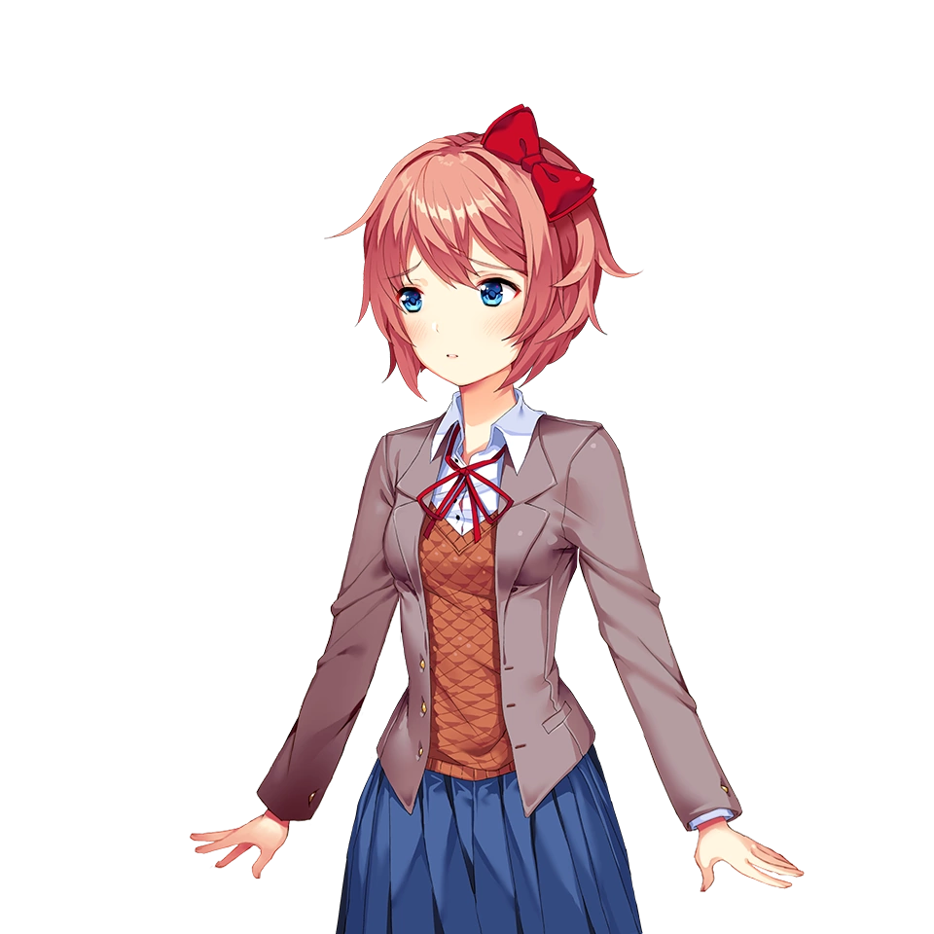= say11 =1k

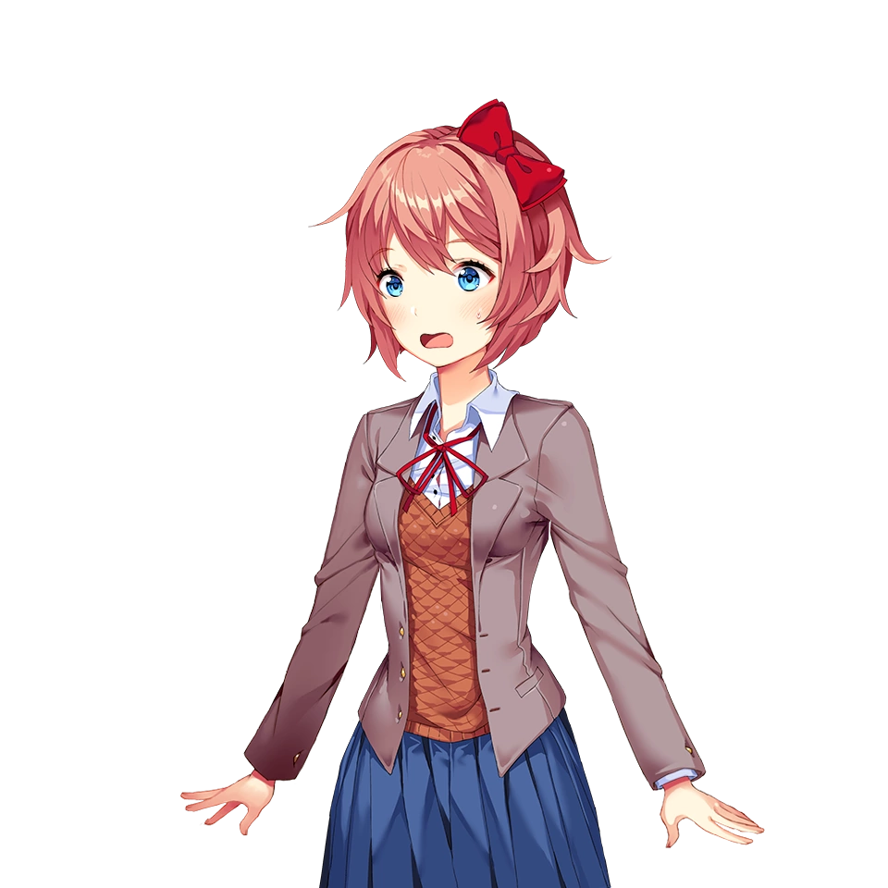= say13 =1m

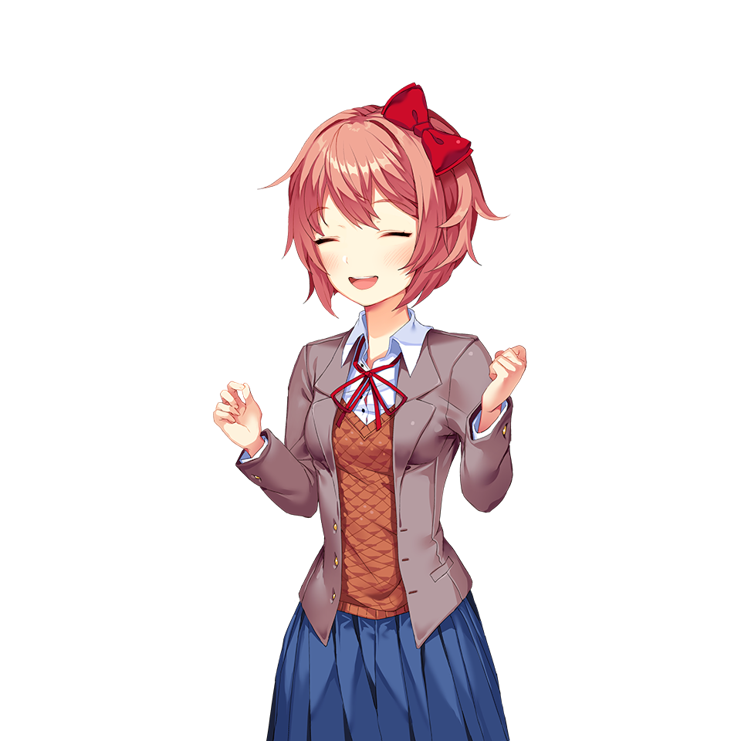=ori18 =4r

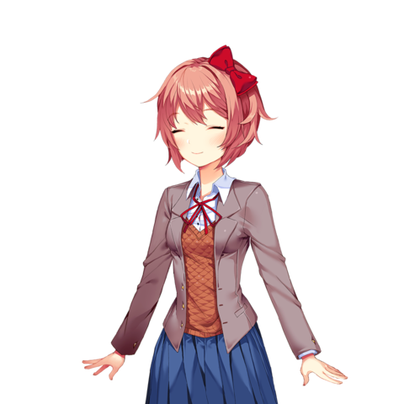=say17 =1q

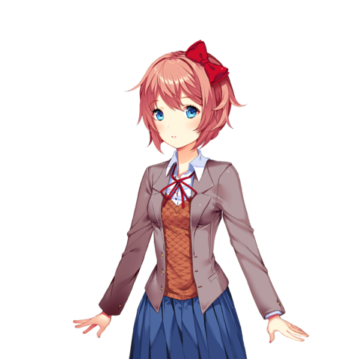=say2 =1b

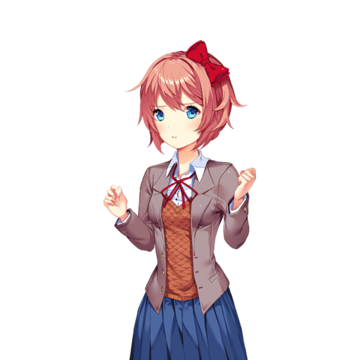=ori9 =4i

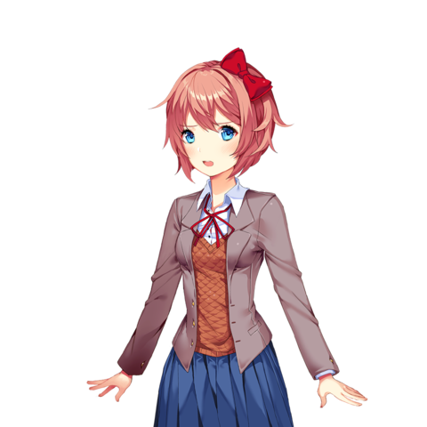=say10 =1j

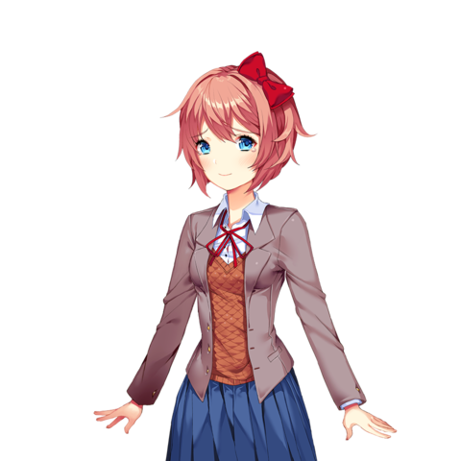=say20 =1t

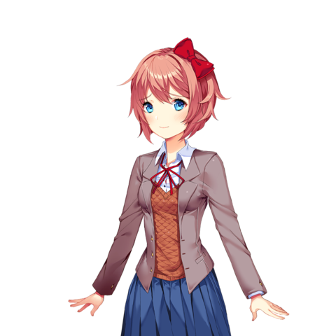=say4 =1d

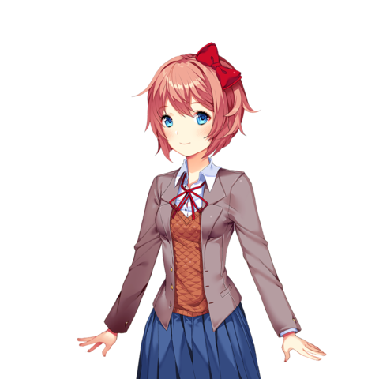=Say1 =1a

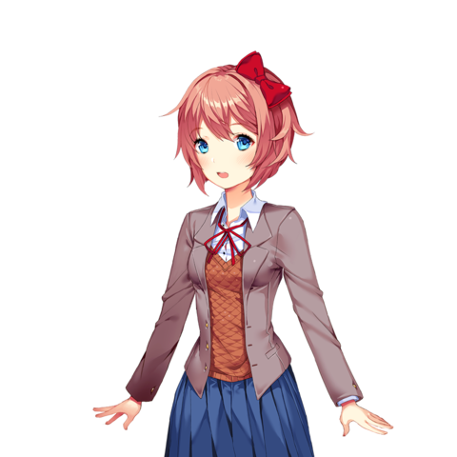=Say3 =1c

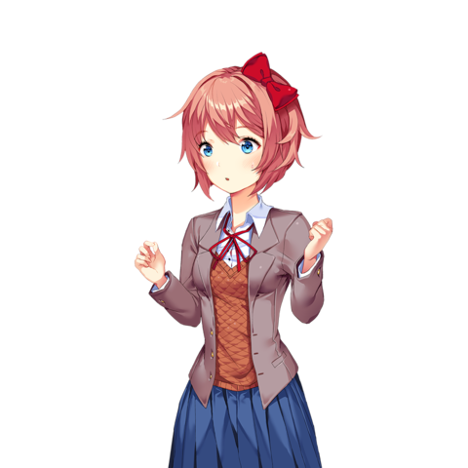=Ori14 =4n

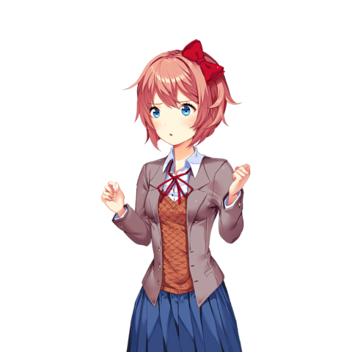=Ori15 =4o

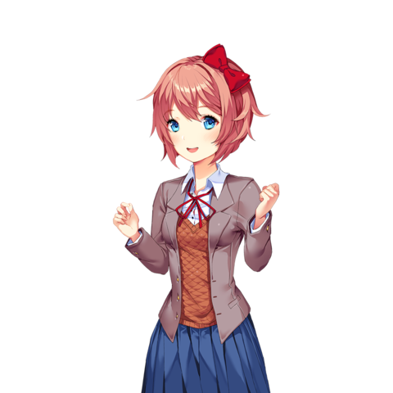=Ori24 =4x

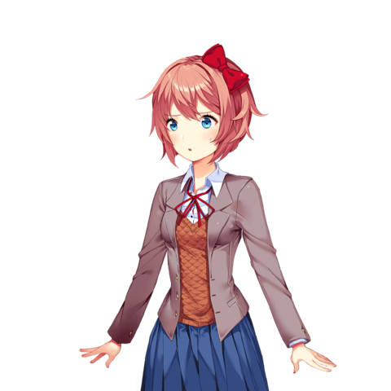=Say15 =1o

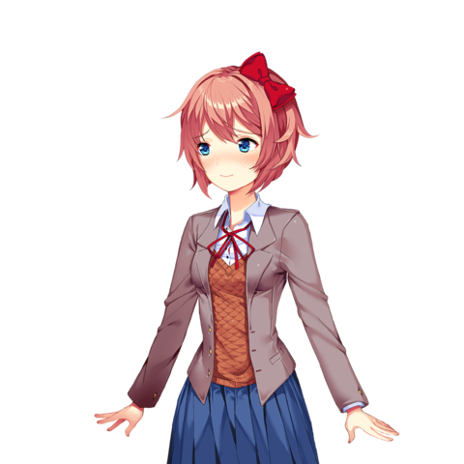=say25 =1y

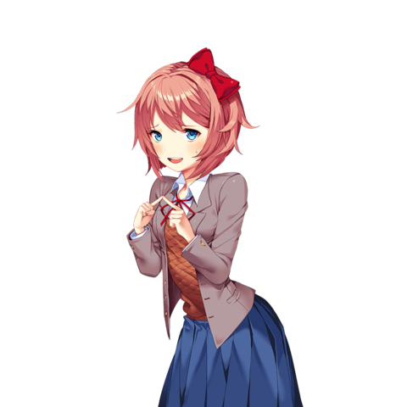=3a =5a

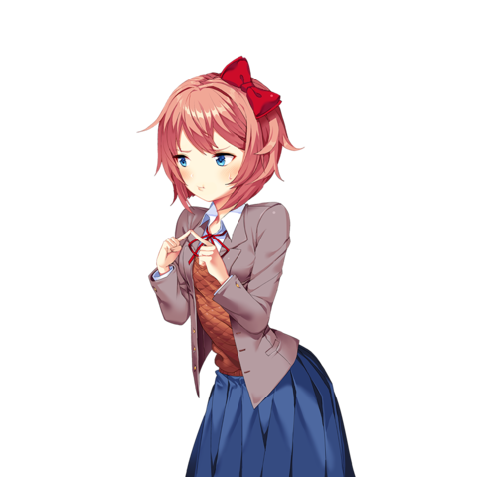=3d =5d

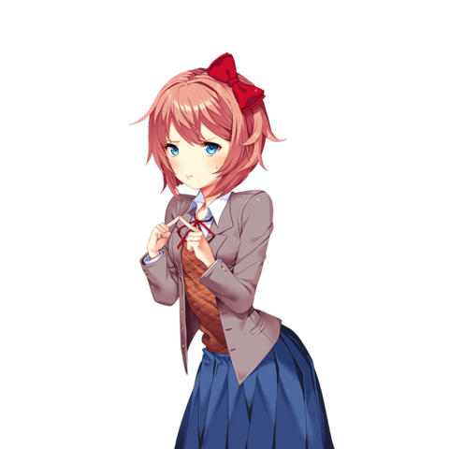=3c =5c

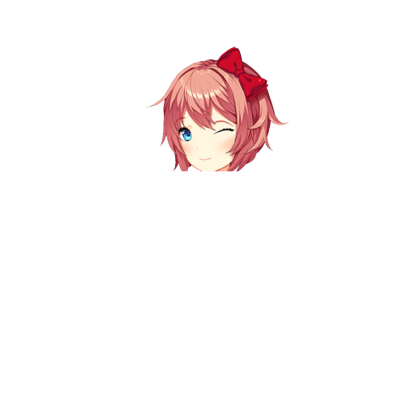Wink face=??

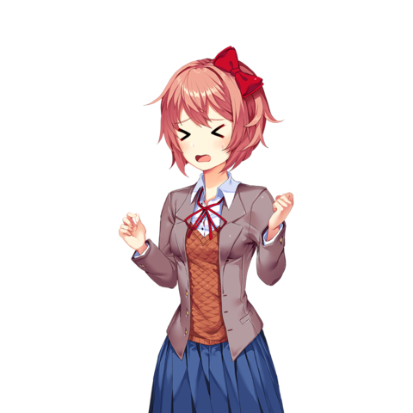=Ori16 =4p

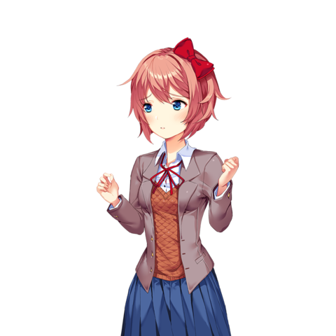=Ori11 =4k

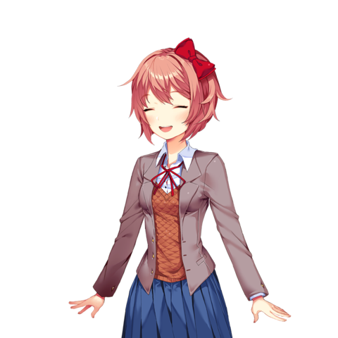=Say18 =1r

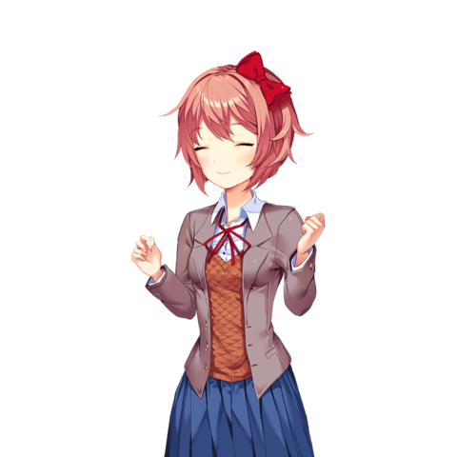=ori17 =4q

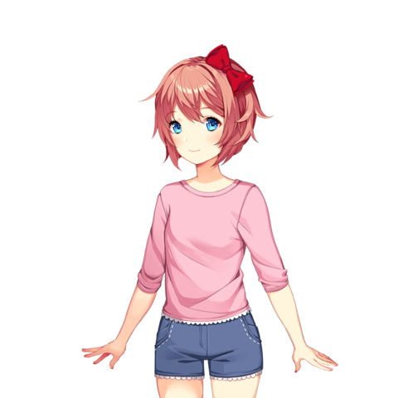=Yori1 =1ba

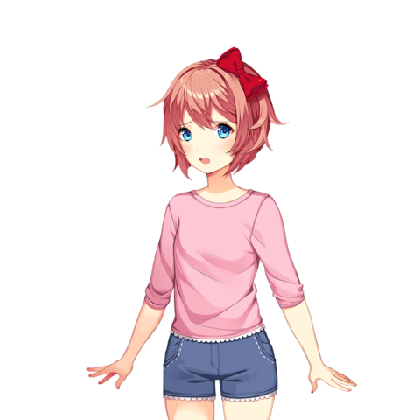=Yori8 =1bh

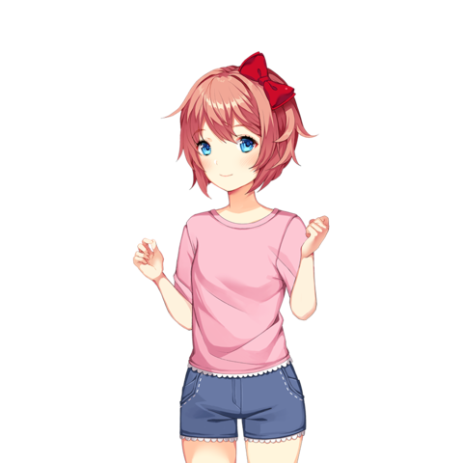=Z1 =4ba

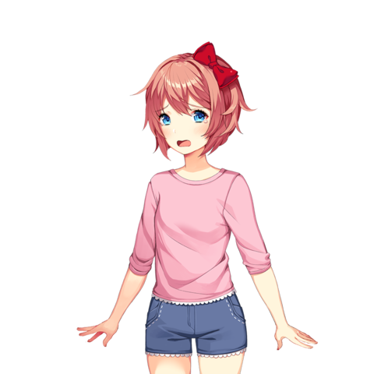=Yori23 =1bw

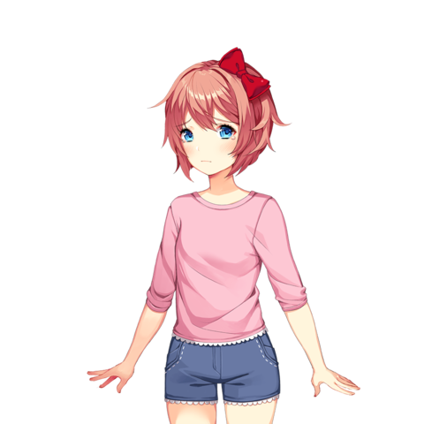=Yori22 =1bf

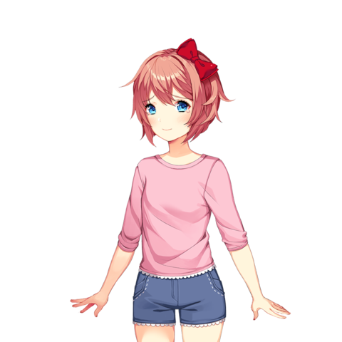=Yori20 =1bd

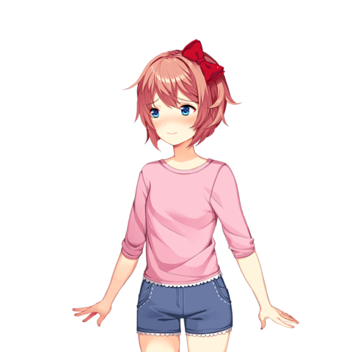=Yori25 =1by

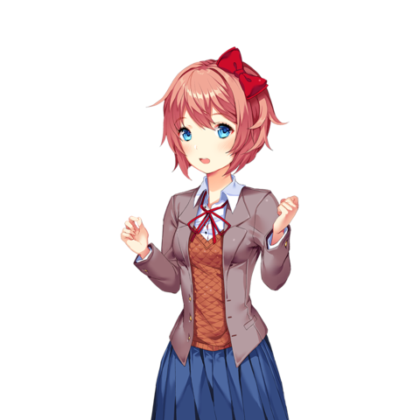=Ori3 =4c

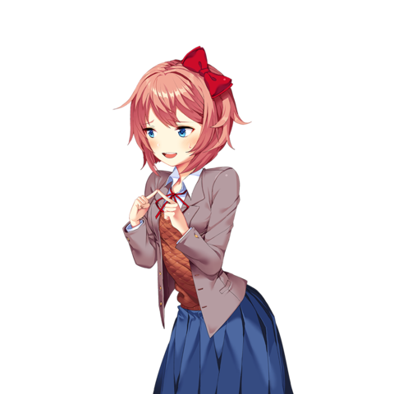=3b =5b

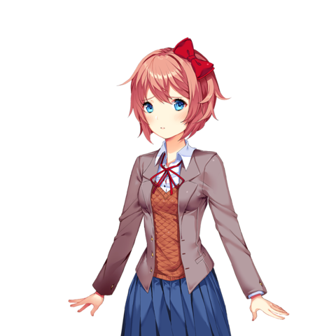=Say7 =1g

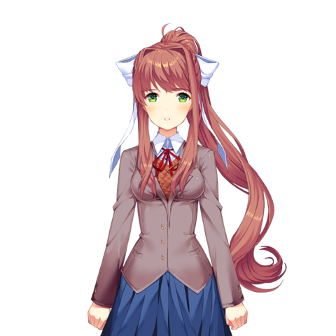=Mon9 =1i

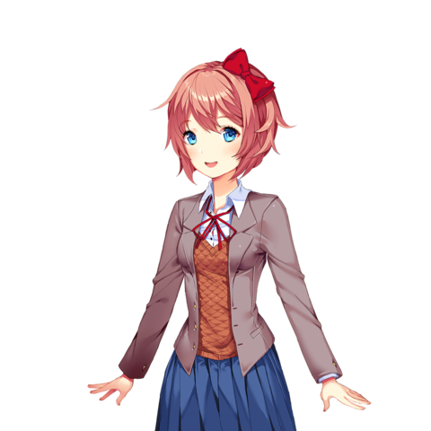=Say24 =1x

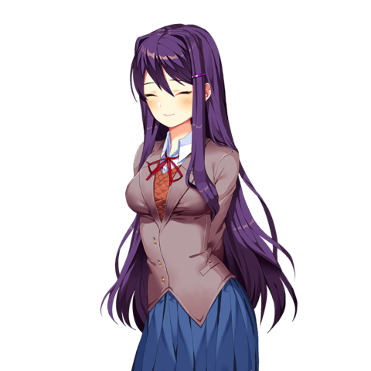=Yuri school 3 =1c

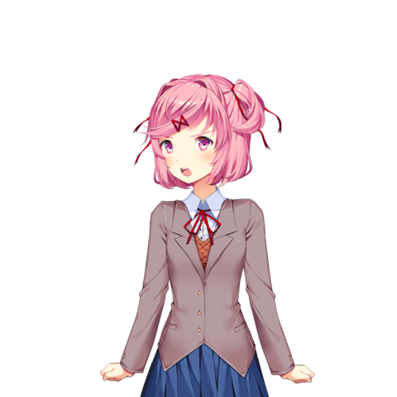=schoold =1e

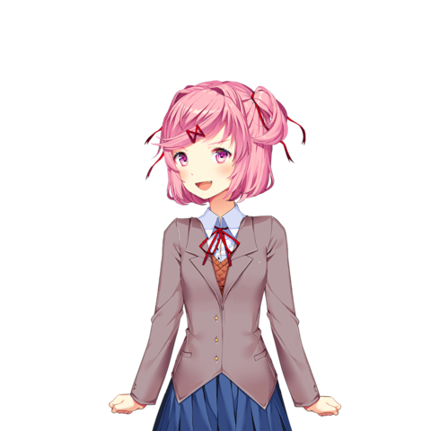=schoolc =1d

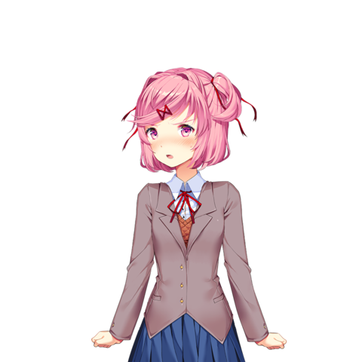=schoolg =1h

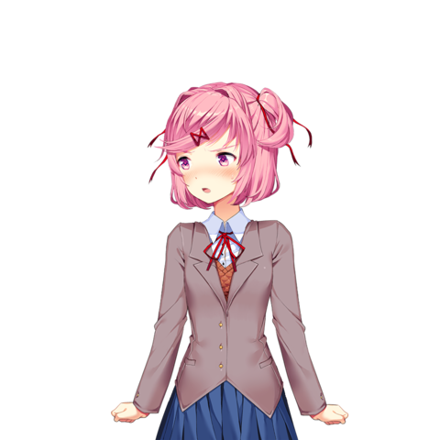=schoolp =1q

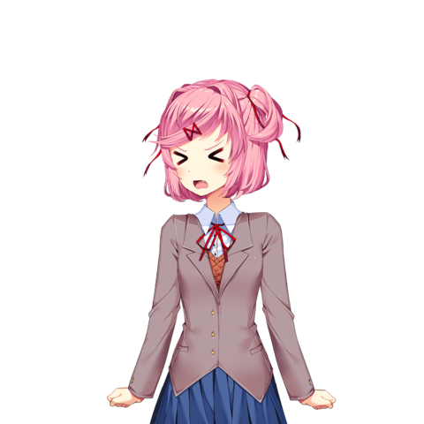=schools =1v

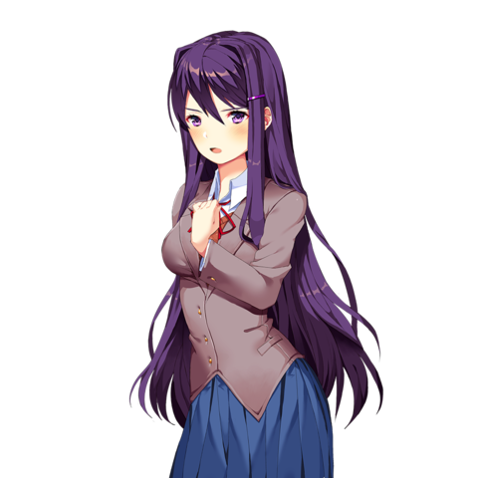=Yangry =2r

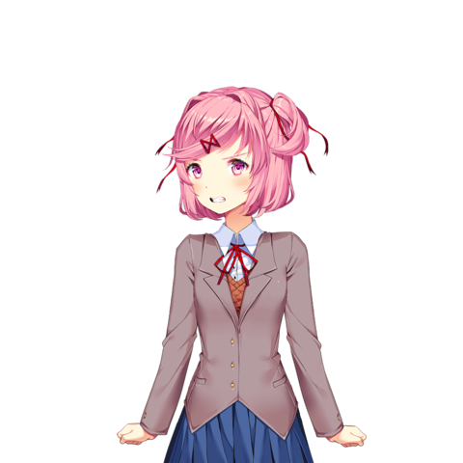=schoole =1f

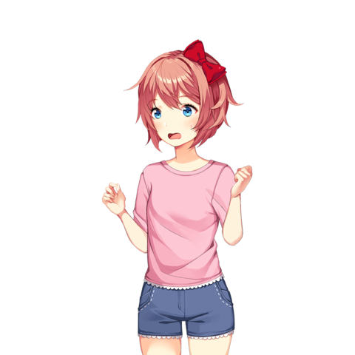=Z13 =4bm

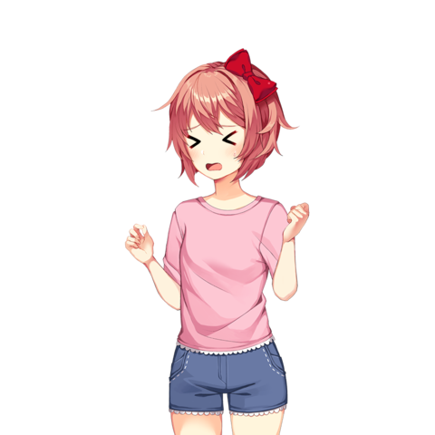=Z16 =4bp

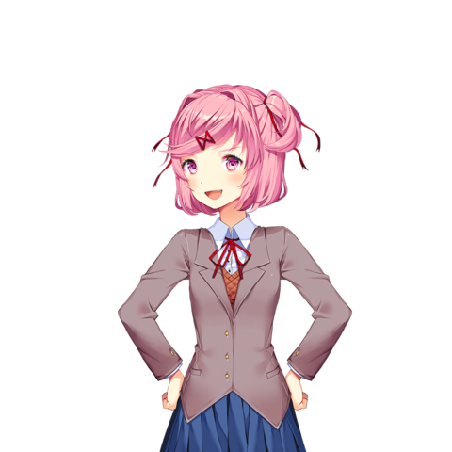=Y15 =4l

=Ika2 =4b

=Ika10 =4k

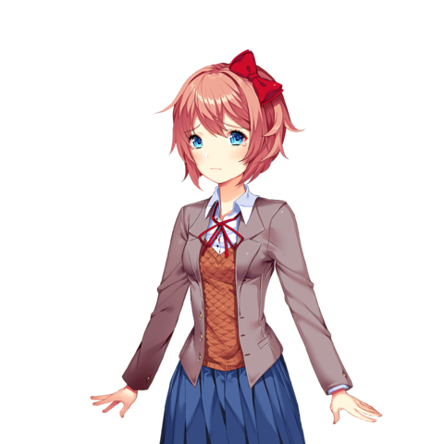=Say21 =1f

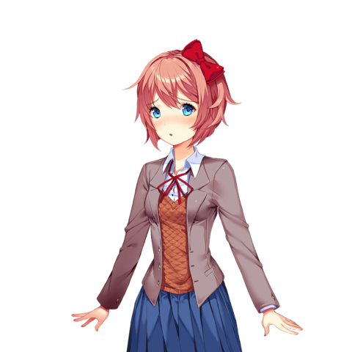=Say5 =1e

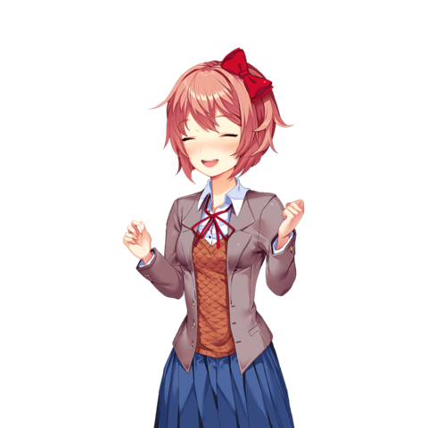=Ori19 =4s n=Say25 =1y